Mountains, Volcanoes and Earthquakes
Assessment

- Name the World’s highest mountain.

- mark)

- How high is this mountain?

(1 mark)

- Who were the first people to successfully reach the summit of the mountain?

(1 mark)

- The Himalayas, The Rockies, The Alps and The Andes are four mountain ranges. Correctly locate them on the map of the World.
(2 marks)
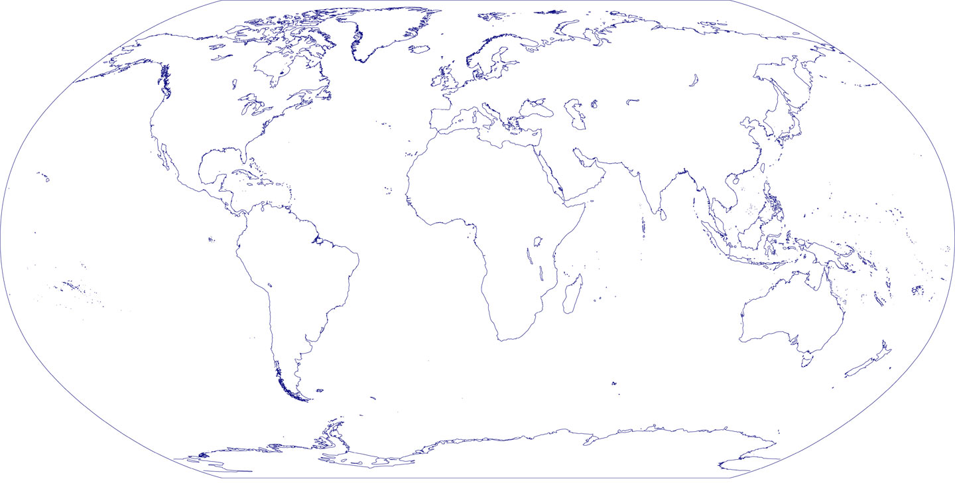

- Name the continent in which each of these mountain ranges is located? (2 marks)
The Himalayas ____________________________________________________________________
The Rockies ____________________________________________________________________
The Alps ____________________________________________________________________
The Andes ____________________________________________________________________

- The following diagram shows a cross section of a volcano. Label the features indicated by the arrows.
(4 marks)
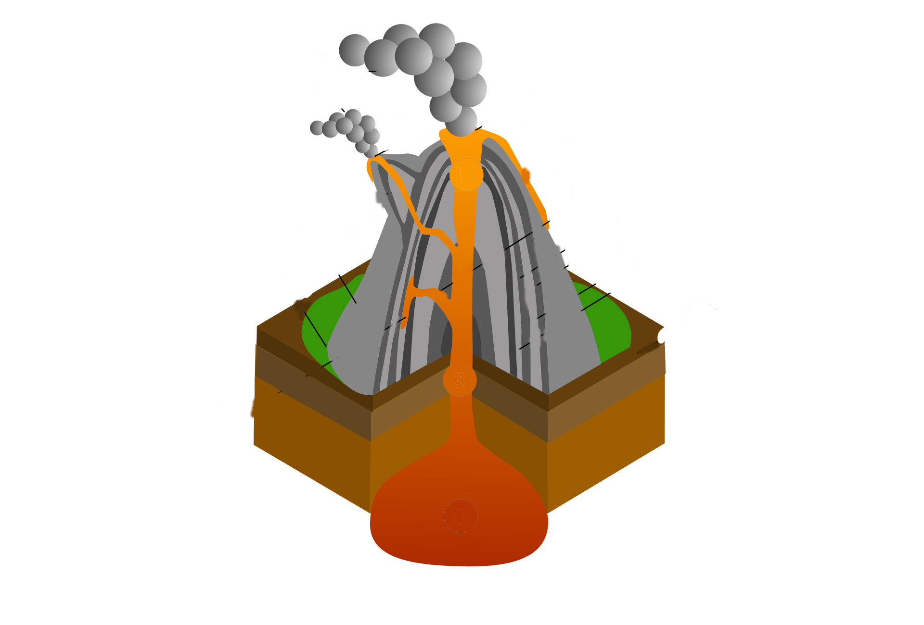

7. Use arrows to join the names of the four highest peaks in the UK to their loyalties.
Ben Nevis England
Snowdon Northern Ireland
Scarfell Pike Wales
Slieve Donard Scotland
(2 marks)

8. Which of the four peaks is the UK’s highest? ________________________
(1 mark)
9.How high is this peak? ________________________
(1 mark)

10.These diagrams show three types of mountain formation. Name each type.
A
B
C
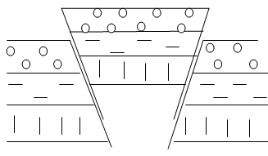
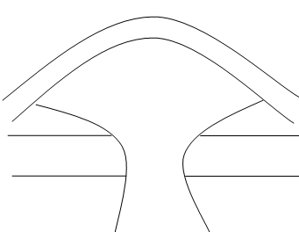
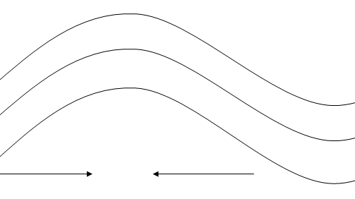

A _________________________
B _________________________
C _________________________
(3 marks)

11.Where would you see these mountain formations in the World? Give a real-life example of a mountain, or mountain range, for each formation shown. (3 marks)
Formation A _________________________
Formation B _________________________
Formation C _________________________

12a.Some people live near volcanoes. Give four advantages that volcanoes bring to an area.
(4 marks)
12b.Give specific real-world examples where you can. (4 marks)

13.What are the disadvantages of living near a volcano? (3 marks)

14.The power of earthquakes is measured on the Richter scale. Tick the box next to the earthquake that is more powerful. (1 mark)

An earthquake with a magnitude of 3 on the Richter scale
OR

An earthquake with a magnitude of 7 on the Richter scale

15.Describe the possible effects of an earthquake with a magnitude of 7 on the Richter scale.
(2 marks)

