Everyday drone stories
KS3.1 Pupil information form

What is this form about?
You are being invited to take part in the Everyday Drone Stories research project.

Drones, like the one pictured below, are small aircraft without a pilot on board, and which can be operated by a pilot on the ground or can be programmed to follow a set route. Some drones have cameras attached to them so they can take photographs or videos from the air. Other drones are used to carry, transport, and deliver things – like medicine or small parcels.

Lots of different people own and use drones. Drones can be flown as a hobby or for fun (perhaps a family member or friend has a drone), can be used by emergency services (police, fire, search and rescue) to help locate people or identify the spread of fires, or can be used by businesses to inspect buildings from the air or to deliver items.

We are interested to learn what you think about drones.
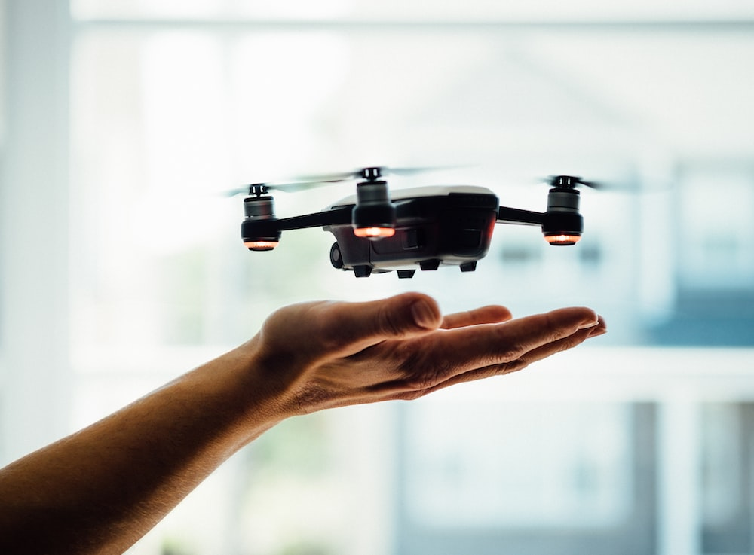
Figure 1 DJI mini drone Spark © Dose Media

Who can take part?
You can take part if you are a pupil in school, year 3 to year 9 (aged 7 to aged 14).

You can take part if you go to a participating school.

What happens if you take part?
Your teacher will provide you with an activity sheet and you will be invited to make a map of a place you know (e.g., your home, local shops, local park) and to mark out where you think drones are used or could be used in the future. You can create this map however you like and there is no right or wrong way to make your map.

Once you have completed the activity and made your map, please return it to your teacher if you would like to share a copy of your map with the researchers (you can have the original back).

If you choose to share your map with the researchers, you will need to fill in a short form which gives us permission to include your map on an online webpage or in an academic article. Your teacher will provide this form for you to fill in.

If we share your map online, no personal data (like your name or the name of your school) will be used or included. Your personal data (your name and the name of your school) will be stored separately from your map, which will be anonymised. The researcher will follow appropriate laws (including UK General Data Protection Regulation; UK Data Protection Act 2018) to ensure that your personal data is collected and stored correctly. Anonymised project data will also be archived, so that it is available for other academic researchers to access and re-use.

It is up to you if you’d like to take part in this activity or not. If you don’t want to take part, you don’t need to provide any reason, and it won’t impact your school record. If you have any questions, you can ask your teacher (who can also contact the researcher, Dr Anna Jackman).

You can read more about the Everyday Drone Stories research project by visiting the project’s webpage online https://www.rgs.org/schools/teaching-resources/everyday-drone-stories/

