Somali diaspora
Activity sheet 5

Somali mobilities
Somali society has been shaped by mobility in important ways. Nomadic pastoralism has been central to the economy for centuries, with families in more arid parts of the country moving regularly as they herd livestock between pasture and water sources, for subsistence and export income. People have also long migrated to Somali cities, to other parts of Africa, and to Arabic-speaking countries to the north, to trade, work and study. Colonisation by the UK and Italy in the nineteenth century shaped politics and the economy in important ways and established migration connections which persisted after Somalia became an independent state in 1960. The oil boom of the 1970s saw a substantial increase in temporary labour migration to the Middle East.

There has also been major displacement. In the late 1980s resistance to increasingly authoritarian rule within Somalia was met with brutal reprisals in the northwest region of the country. Rebel movements ousted the president in 1991 but failed to reach agreement around the formation of a new government and the state collapsed into factional violence. From the mid 1990s to the mid 2000s, there was some stabilisation under fragmented political authorities. But in 2006 international hostility to the prospect of an Islamist state led to an Ethiopian military intervention which ousted the growing Islamic Courts Union. South and central Somalia entered a new phase of conflict, with the militant group Al Shabaab wrestling with the internationally backed central government for control.

The civil war has driven significant displacement at different times, since the late 1980s onwards, with people moving internally, to neighbouring countries, and further afield in search of safety. Politically motivated displacement has been exacerbated by recurrent drought and livelihood challenges. Over time, the consolidation of the central Somali government, regional administrations like Puntland in the northeast and the secessionist government in Somaliland in the northwest has created some stability and has prompted some return, but the political situation remains challenging.

Somalis in the UK

The Somali community in the UK has its roots in the colonial era. The Merchant Navy recruited men from the northwest British Protectorate of Somaliland to work as seamen and some settled in East London and port cities.

Overall, however, migration to the UK remained modest until the Somali civil war, when many people sought refugee status or family reunion. Some people gained citizenship in other EU countries, then moved to the UK. Originally dominated by people from Somaliland, the UK Somali community now has connections in many parts of the Somali territories.

The 2021 Census reported 108,921 people born in Somalia living in England and Wales. Figure 1 shows strong clustering of people born in Somalia in London boroughs, and particular cities elsewhere. However, given the long history of political insecurity in Somalia, many people of Somali heritage were born in the UK or other countries outside Somalia.

Figure 1. Population born in Somalia by Local Authority District in England and Wales

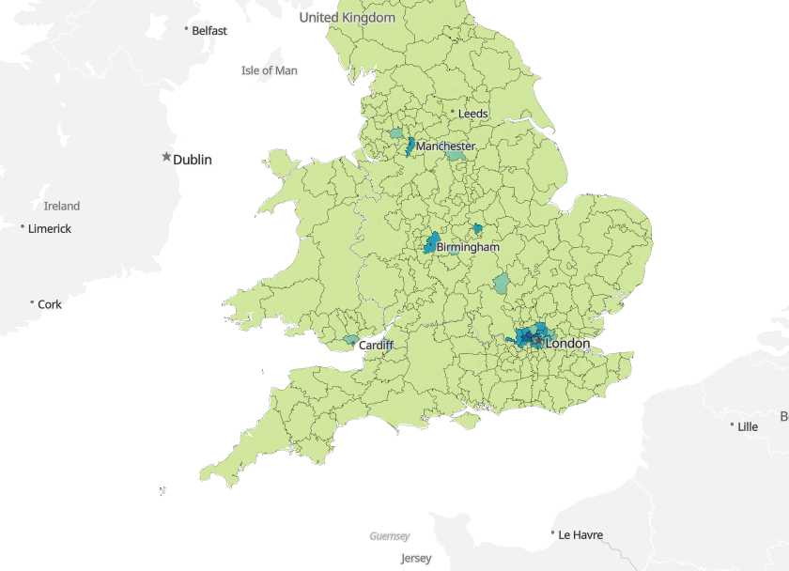
https://www.ons.gov.uk/census/maps/choropleth/population/country-of-birth/country-of-birth-60a/africa-south-and-eastern-africa-somalia

The Somali-born population is younger than the general population, and adults are employed in diverse occupations. There are people of Somali heritage who have been successful in public and community service, politics, business, sport and other fields. There are also indicators of deprivation with relatively high rates of unemployment and reliance on local authority and social housing. Community organisations report that many people work in care, cleaning, as taxi drivers and in delivery services, hospitality, retail and small businesses which are affected by job insecurity and/or physical risk, particularly during the pandemic. A prominent group in need of support is single mothers with dependent children. There are many Somali community groups supporting people with challenges ranging from language, education, training and employment to accessing government services and support.

Transnationalism and remittances
As parts of Somalia have become more stable, people have returned to take up jobs in politics, business, healthcare, education, non-governmental organisations and United Nations agencies. Some people can be thought of as part-time diaspora, spending long periods or parts of each year in Somalia to connect with family, culture and business and work opportunities, without fully leaving their life in the UK. Increasingly, young people raised in the UK have been able to spend time visiting family and exploring their heritage.

Beyond migration and return, there are other forms of transnational exchange. Families stay in touch across the borders that separate them physically. A feature of the Somali diaspora is its wide dispersal. Many people of Somali heritage in the UK have relatives living in several other countries in Africa, the Middle East, Europe and North America, leading to diverse geographies of family communication and support.

Official remittance flows to Somalia were reported of $1.6 billion in 2020, and $1.7 billion in 2020, 2021 and 2022. This is 21% of Somalia’s Gross Domestic Product in 2022. An estimated $214 m (or 12% of total estimated bilateral flows) came from the UK in 2021. Based on the Remittance Prices Index, the average cost of sending $120 from the UK to Somalia at the start of 2023 was 6.43%. There is a busy money transfer sector – for many years, these businesses (known as xawilaad) effectively functioned as the main financial services in Somalia, connecting rural areas, towns and cities with each other and the global economy. Now mobile banking and online services are also very popular.

Connecting During Covid project findings
Somalis are widely recognized to have a strong culture of remitting, with many diaspora members feeling it is a social and religious responsibility to contribute to the livelihoods of family members in need and the wider community where possible. Levels of dependency on remittances are high and high proportions are spent on essential family needs, in the absence of a public safety net or welfare system: as one interviewee put it, remittances are ‘a lifeline for so many people, for their education… their rent… their health… it’s really something, you know, they live on it.’

The Somali territories have been affected by recurrent crises. While the pandemic did have a health impact, the greater concern for many was how it disrupted the vital livestock trade with the Middle East, alongside drought and insecurity, and pressures on international aid budgets. Our online survey of 125 people of Somali origin/heritage found high rates of remitting (59% in 2019) increased during the first year of the pandemic (70% in 2020), although the average amount sent declined from £2,347 to £2,025. This was not a representative survey, but remitting was significantly more common among Somali than Brazilian and Indian respondents in the sample.

At the same time, sending money can be really difficult for some. A mother of school-aged children explained ‘I stopped [remitting during the pandemic] because my financial situation changed, there was no money. I was using all my money on gas and electricity bills.’ Others are able to send but feel like it is never enough, as one participant put it: ‘There is a lot of pressure because the money cannot reach all your family members...’ Sometimes parents encourage their adult children to help out with to sending money to Somali relatives. Anti-Tribalism Movement noted that amongst all the other challenges the Somali community was facing in the first lockdown, the interruption of their ability to send remittances was ‘a very big feature in the anxiety landscape’.

There are also many diaspora community groups that work to support initiatives in Somalia. These range from established charities to more informal networks often based around clan membership. These have supported the development of key educational and health institutions. For example, UK-trained midwife Edna Aden Ismail established a maternity hospital in Hargeisa which continues to receive support from diaspora members and other supporters in the UK. Somali charities and informal networks are also able to mobilise people rapidly in response to crises, pooling money and securing other resources (such as Personal Protective Equipment during the pandemic) to contribute to local organisations and communities. Somali political groups also network with the diaspora to increase their funding and influence. Diaspora investment in businesses is prominent. Overall, through a myriad of engagements, the diaspora plays an influential role in life across the Somali territories.

Further reading
- Anti-Tribalism Movement (2020) https://theatm.org/wp-content/uploads/2020/05/Impact-on-Remittances-From-UK-to-Somalia-.pdf
- Connecting during COVID (2022) The experiences of the Somali Community in Cardiff during the COVID-19 pandemic. https://www.qmul.ac.uk/geog/media/geography/images/research/connecting-during-covid/Cardiff-Research-Brief-23-3-final.pdf
- Video: The Call Centre: the disproportionate effects of the pandemic on marginalised communities https://www.youtube.com/watch?v=MARYRua5E4A
- Hassan, Mohamed Aden et al (2021) Recognising diaspora humanitarianism. https://www.diis.dk/en/research/recognising-diaspora-humanitarianism
- Lindley, Anna, Kavita Datta, Elaine Chase, Laura Hammond, Kaltun Fadal, Iris Lim, Gabriela Loureiro and Saliha Majeed-Hajaj (2023) 'Remitting Through Crisis: Experiences of Migrant and Diaspora Communities in the UK.' Connecting During Covid-19 Research Briefing No. 2. London: Queen Mary University of London. https://www.qmul.ac.uk/geog/media/geography/docs/332_23-Remittances-Crisis-Report-v3.pdf

Questions
- Make a list of the factors influencing Somali migration and displacement.
- Using the Census map (https://www.ons.gov.uk/census/maps/choropleth/population/country-of-birth/country-of-birth-60a/africa-south-and-eastern-africa-somalia), list the main clusters of people born in Somalia in the UK.
- What evidence is provided on how remittance patterns to Somalia changed during the pandemic?
- Access the World Bank’s remittance data webpage (https://www.knomad.org/data/remittances) and download the bilateral remittances matrix. Which countries are the source of greater flows to Somalia than the UK in 2021?
- What have you learned about the impact of the diaspora and remittances in Somalia?

Answer guide
- Make a list of the factors mentioned as influencing Somali migration and displacement

- Nomadic pastoralist livelihoods
- Trade networks
- Labour opportunities
- Education & study
- Colonial connections
- Drought
- Livelihood problems
- Civil war violence

- Check the Census map (see source of Figure 1) and list the main clusters of people born in Somalia in the UK

- London boroughs
- Slough
- Birmingham
- Leicester
- Milton Keynes
- Cardiff
- Bristol
- Sheffield
- Manchester
- Bolton

- What evidence is provided on how remittance patterns to Somalia changed during the pandemic?

- Official inflow data increased somewhat during 2020, and since remained steady.
- The micro-level survey reported that around 20% more people of Somali heritage/origin in the UK remitted in 2020 compared with 2019, but sent less each on average.

- Find the weblink, in the reference list above, to the World Bank’s remittance data webpage, and download the bilateral remittances matrix. Looking at estimated remittances to Somalia, which countries are the source of greater flows than the UK?

- Only Kenya has larger estimated remittances to Somalia than the UK. The US comes in a close third.

- What have you learned about the impact of the diaspora and remittances in Somalia?

Some possible points:
- Returnees prominent in key spheres of work
- Diaspora connected through visits and living transnationally across UK and Somalia
- Remittances used for essential needs as well as developing livelihoods
- Remittances are a significant source of national income
- In the absence of a public safety net, remittances help extended family members deal with crises
- Diaspora support for community initiatives
- Diaspora investment in business
- Diaspora involvement in politics

