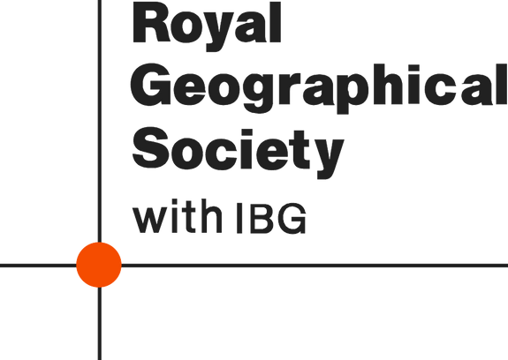
Africa: impact and adaptation

Adaptation?

Adaptation?
Migration impact
Adaptation?

Adaptation?

High temperature climates impact

Biodiversity loss impact

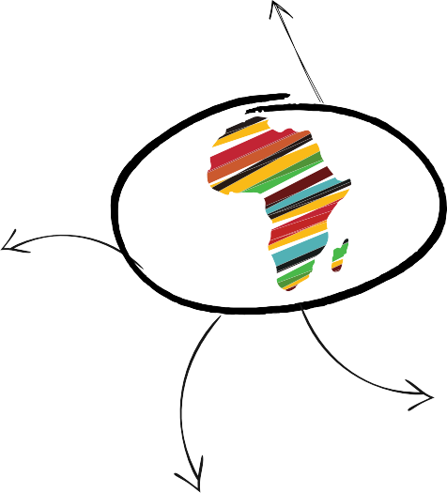
Cultural

Mortality

Morbidity

Food systems

Environmental
Health impact

Rainfall impact

Political
Socioeconomic

Conflict impact

Hydropower Water supply

Adaptation?

Adaptation?
Adaptation?

Source: the IPCC WGII report on Climate Change 2022 Impacts, Adaptation and Vulnerability

