**Mountains**

[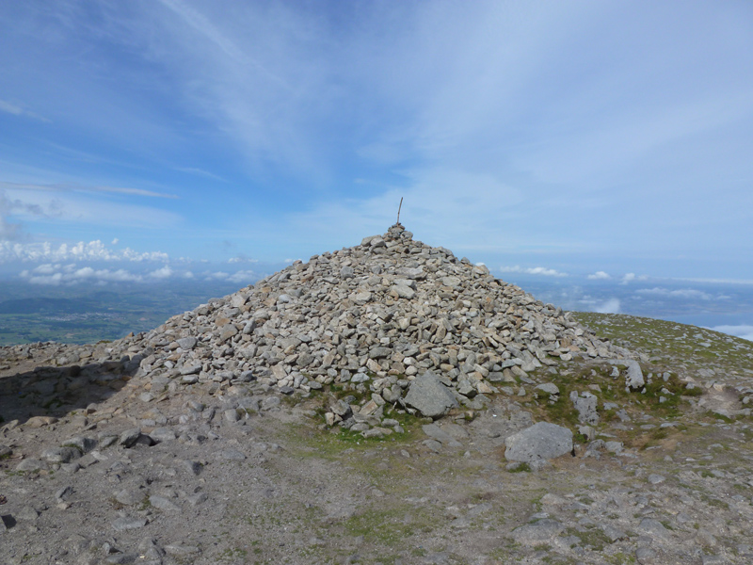](http://www.google.co.uk/url?sa=i&rct=j&q=&esrc=s&frm=1&source=images&cd=&cad=rja&uact=8&ved=0CAcQjRxqFQoTCNm-kpP5jMcCFUEbFAodHcMIyw&url=http://www.megalithic.co.uk/article.php?sid%3D34430&ei=3mK_VdnXMsG2UJ2Go9gM&bvm=bv.99261572,d.eXY&psig=AFQjCNEhEmhkUHft_o_nQNMz-Vf_mFb6uw&ust=1438692435359564)[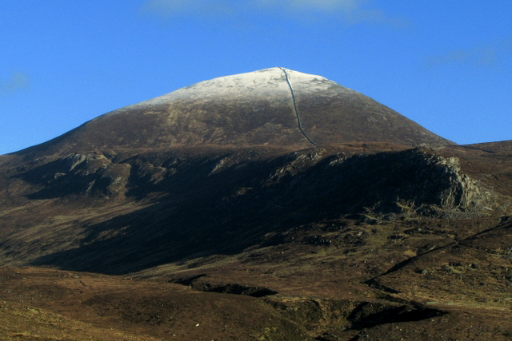](https://www.google.co.uk/url?sa=i&rct=j&q=&esrc=s&frm=1&source=images&cd=&cad=rja&uact=8&ved=0CAcQjRxqFQoTCM-z4on4jMcCFQRAFAodFocBbw&url=https://en.wikipedia.org/wiki/List_of_Irish_counties_by_highest_point&ei=vmG_Vc_cLISAUZaOhvgG&bvm=bv.99261572,d.eXY&psig=AFQjCNFjknWnMA_JXLI2cOg_lCeyGAxMqQ&ust=1438692144069164)

Slieve Donard

**Mountains**

[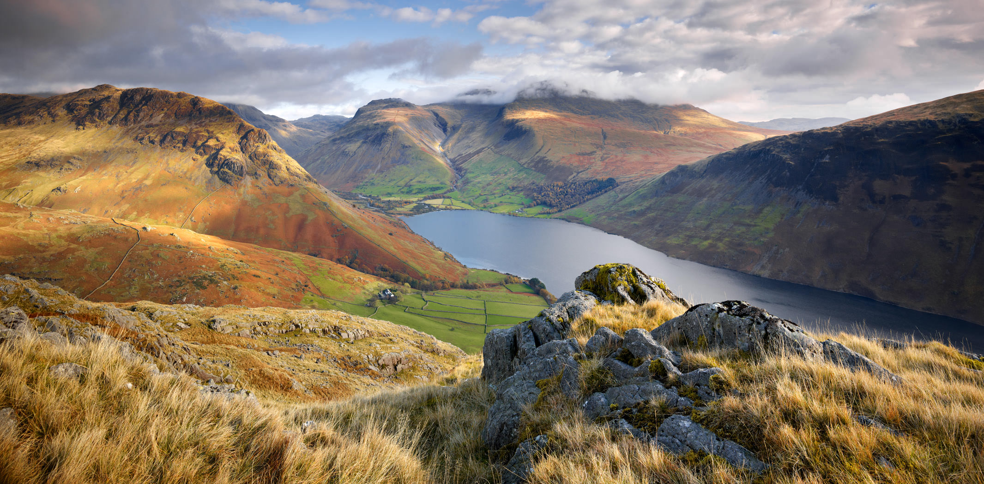](http://www.google.co.uk/url?sa=i&rct=j&q=&esrc=s&frm=1&source=images&cd=&cad=rja&uact=8&ved=0CAcQjRxqFQoTCP_jzZ33jMcCFYJtFAodnW4Bsw&url=http://www.joecornishgallery.co.uk/gallery/item/yew-barrow-scafell-pike-under-cloud-and-wast-water&ei=22C_Vb-KN4LbUZ3dhZgL&bvm=bv.99261572,d.eXY&psig=AFQjCNFVTqXCCiWtMZWpf-AxdTcieSDJfg&ust=1438691929222173)[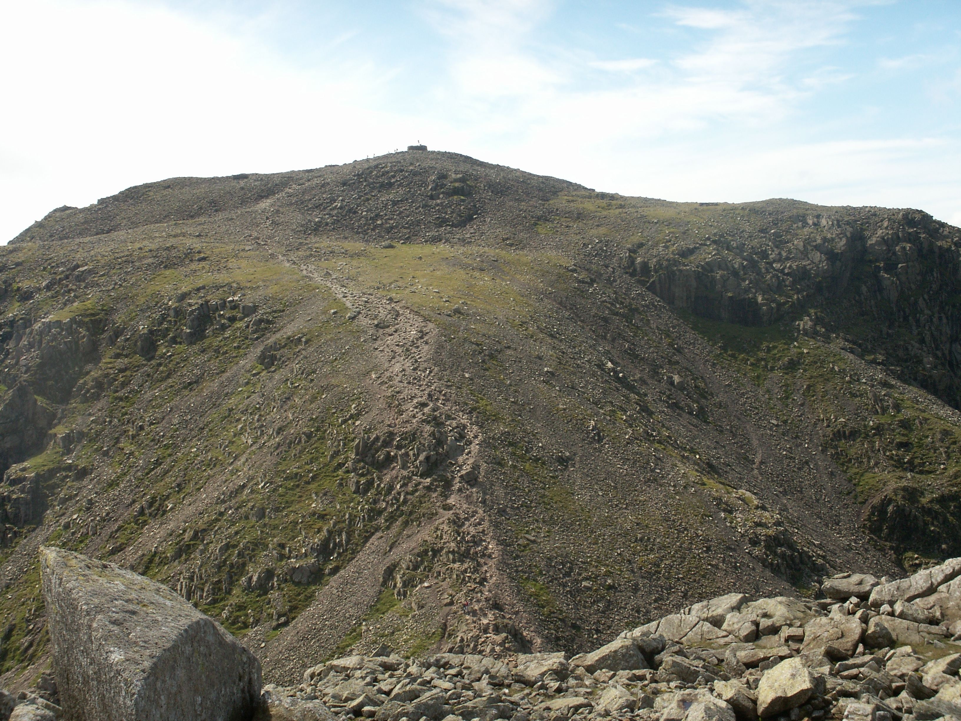](https://www.google.co.uk/url?sa=i&rct=j&q=&esrc=s&frm=1&source=images&cd=&cad=rja&uact=8&ved=0CAcQjRxqFQoTCKmr9ND2jMcCFcQ3FAodqAwFrg&url=https://en.wikipedia.org/wiki/Scafell_Pike&ei=O2C_VemhA8TvUKiZlPAK&bvm=bv.99261572,d.eXY&psig=AFQjCNHpN27JUHL97iF8W1i7xohRASbOjQ&ust=1438691727228647)

Scafell Pike

**Mountains**

[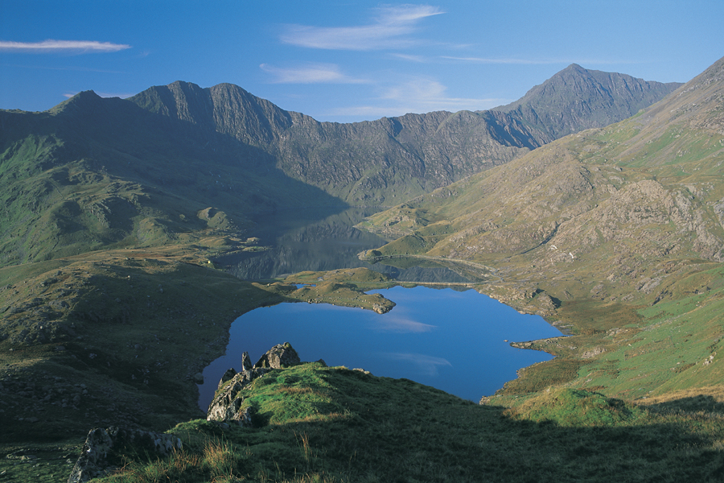](http://www.google.co.uk/url?sa=i&rct=j&q=&esrc=s&frm=1&source=images&cd=&cad=rja&uact=8&ved=0CAcQjRxqFQoTCM2IioD1jMcCFQhxFAodgi8NWA&url=http://www.snowdonrailway.co.uk/photo-gallery&ei=hV6_VY2yBojiUYLftMAF&bvm=bv.99261572,d.eXY&psig=AFQjCNFdNFVh1d4tC39V9Q3562qx1Uy2Tg&ust=1438691283457952)

[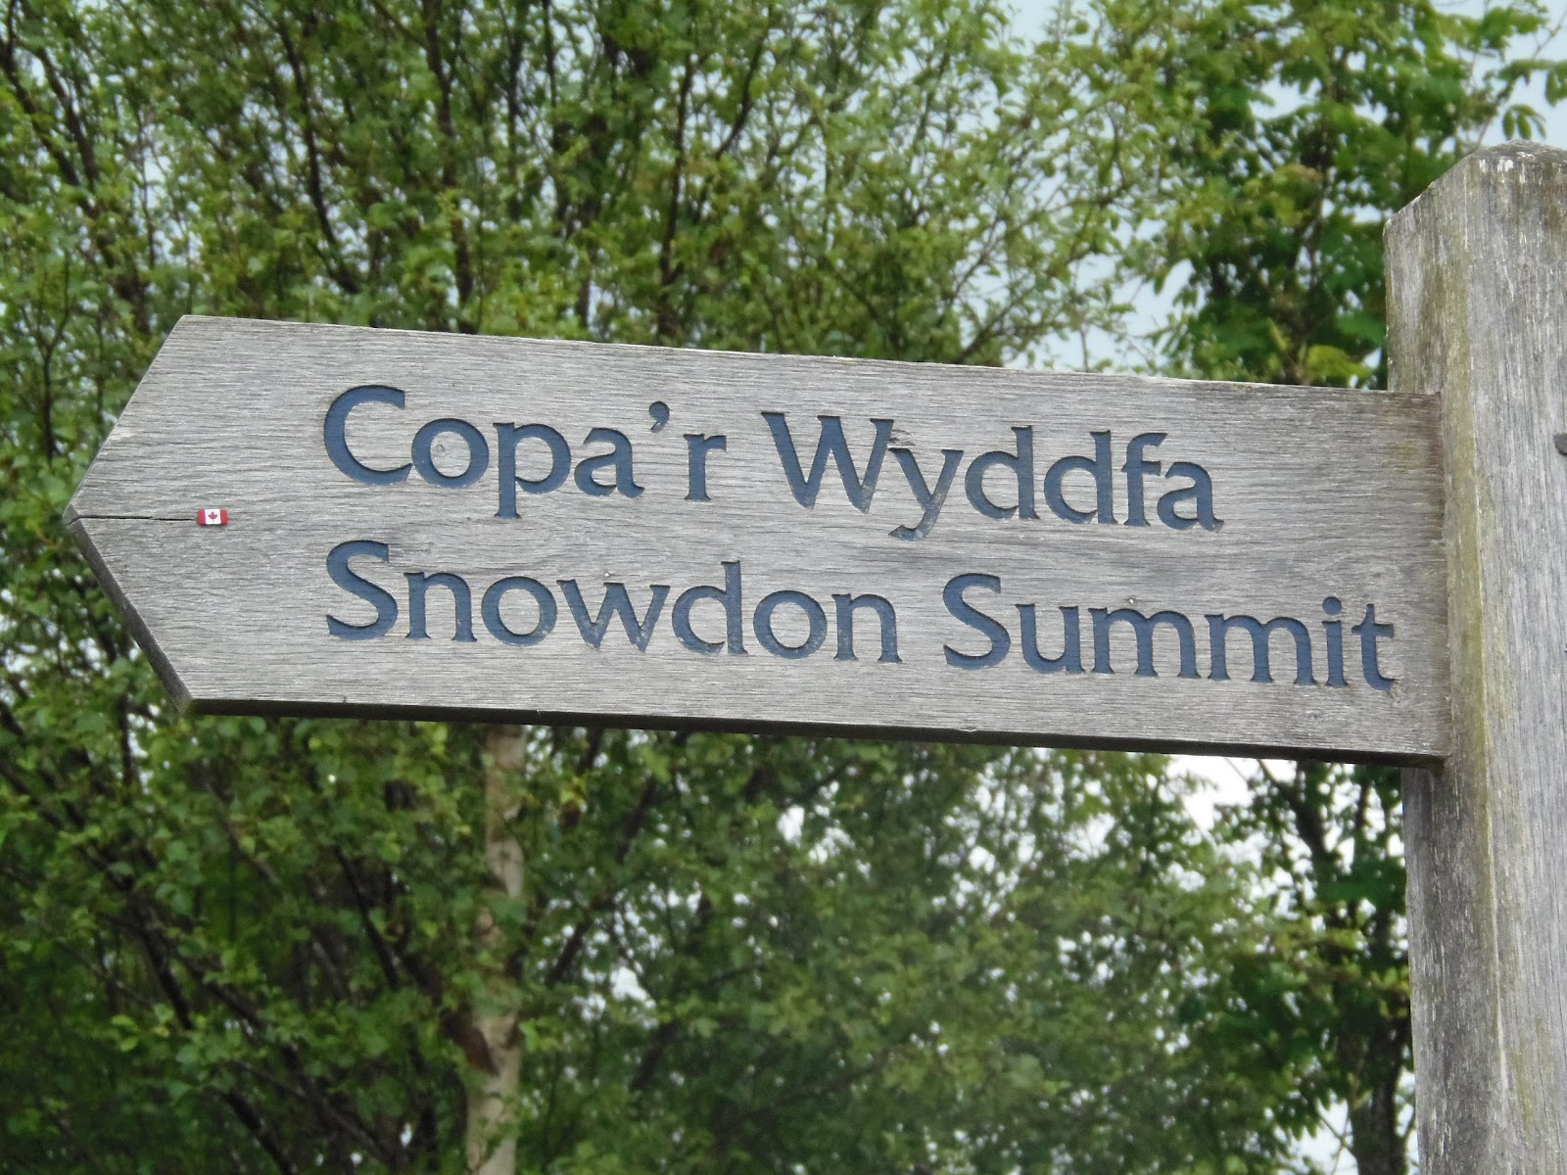](http://www.google.co.uk/url?sa=i&rct=j&q=&esrc=s&frm=1&source=images&cd=&cad=rja&uact=8&ved=0CAcQjRxqFQoTCIG0v_H0jMcCFUnJFAodiH4BpQ&url=http://cooperseverestexpedition.blogspot.com/2012/06/trip-up-snowdon-in-wales.html&ei=Zl6_VYHpH8mSU4j9hagK&bvm=bv.99261572,d.eXY&psig=AFQjCNGEdJZSnS3SbJa3Q2jno3JPh5c7mA&ust=1438691291753008)

**Mountains**

[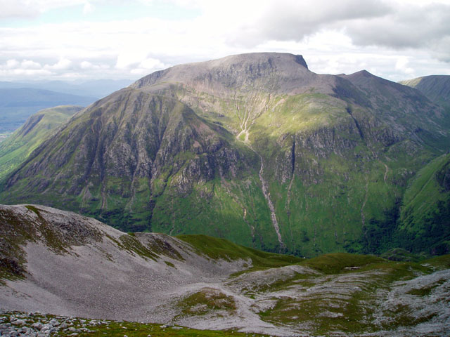](https://www.google.co.uk/url?sa=i&rct=j&q=&esrc=s&frm=1&source=images&cd=&cad=rja&uact=8&ved=0CAcQjRxqFQoTCNqfiJPyjMcCFQlXFAodWQULQg&url=https://en.wikipedia.org/wiki/Ben_Nevis&ei=h1u_VZrAJYmuUdmKrJAE&bvm=bv.99261572,d.eXY&psig=AFQjCNHN85_pKHg7-Lhh9vRMj_XDpavJPg&ust=1438690539168517)

[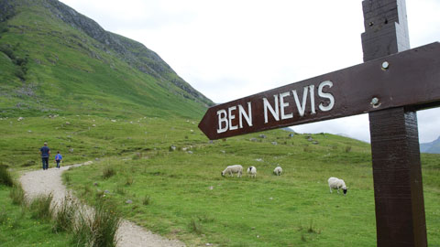](http://www.google.co.uk/url?sa=i&rct=j&q=&esrc=s&frm=1&source=images&cd=&cad=rja&uact=8&ved=0CAcQjRxqFQoTCK-e5eDyjMcCFQG3FAod77YILA&url=http://iyc.org.uk/2015/06/walk-ben-nevis-to-raise-funds-for-its-your-choice/&ei=Kly_Va_hJYHuUu_touAC&bvm=bv.99261572,d.eXY&psig=AFQjCNHN85_pKHg7-Lhh9vRMj_XDpavJPg&ust=1438690539168517)