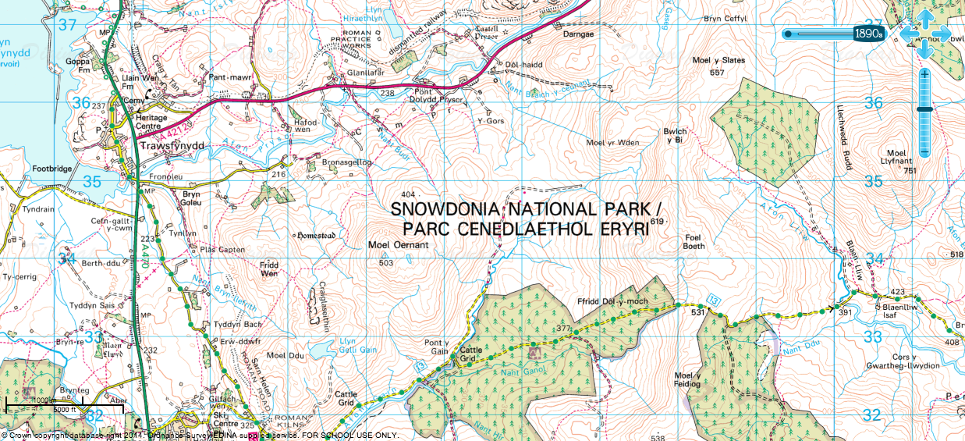

An OS map extract of Snowdonia National Park

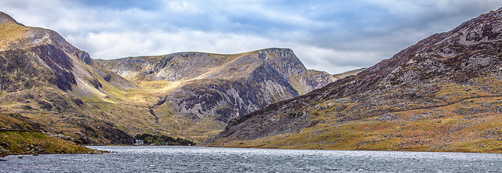
Sunny in Snowdonia © Adrian Kingsley-Hughes, Flickr
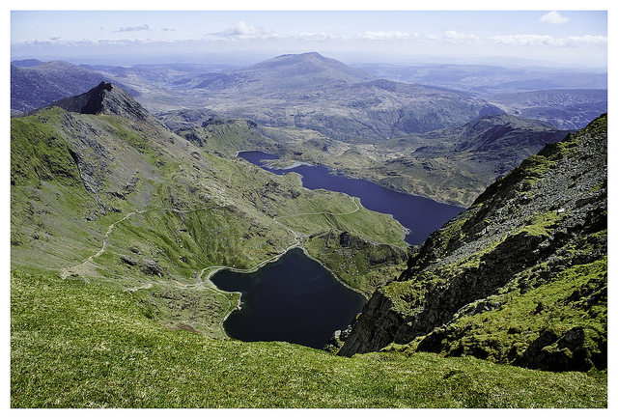
Snowdon National Park- The view © Paul Clarke, Flickr

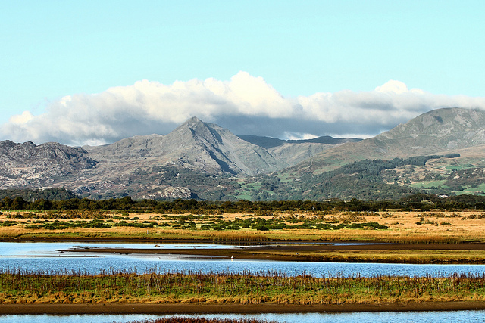

Snowdon National Park- Wales © Airwolfhound, Flickr

