Information Sheet: Tibet
Where is Tibet?
Tibet is in Asia, north of the Himalayas. Its is currently occupied by China. The Tibetan plateau is the source of most of Asia’s major rivers.
How big is Tibet?
Tibet covers an area of 2.5 million square kilometres.
How many people live in Tibet?
Currently 6 million Tibetans live in Tibet as well as 7.5 million Chinese.
What is the religion in Tibet?
The main religion is Tibetan Buddhism.
What language do the Tibetan people speak?
Tibetan is the main language spoken in Tibet.
What is the history of Tibet?
Tibetans claim that Tibet was an independent country from 1913 until the late 1940s. In 1950 Tibet was invaded by China and has been under Chinese military occupation ever since. After a failed protest in 1959, the Dalai Lama and thousands of Tibetans fled to India. The Dalai Lama is the spiritual leader of the Tibetan people. In 1989 the Dalai Lama won the Nobel Peace Prize. There is a Tibetan Government-in-Exile in northern India.
Most of Tibet’s monasteries were destroyed by the Chinese during the 1960s and 1970s.
International attention focused on Tibet in 2008 before the Beijing Olympics in China. There were clashes between anti-Chinese protestors and the police in Tibet, and the Olympic Torch relay in London, Paris and San Francisco was disrupted by protesters.
What problems do the Tibetan people face?
Tibet is currently governed as a part of China. China has encouraged its people to migrate to Tibet. The Tibetan people are no longer a majority in their homeland. Tibet has natural resources such as gold, iron and led but Tibet’s natural resources are being used and the land polluted. Tibet faces a wide range of human rights issues. People do not have freedom of speech.
What do the Tibetan people want?
There have been protests in Tibet since the 1950s as many Tibetans believe they should be an independent country. Some Tibetans have set themselves on fire to put pressure on the Chinese government.

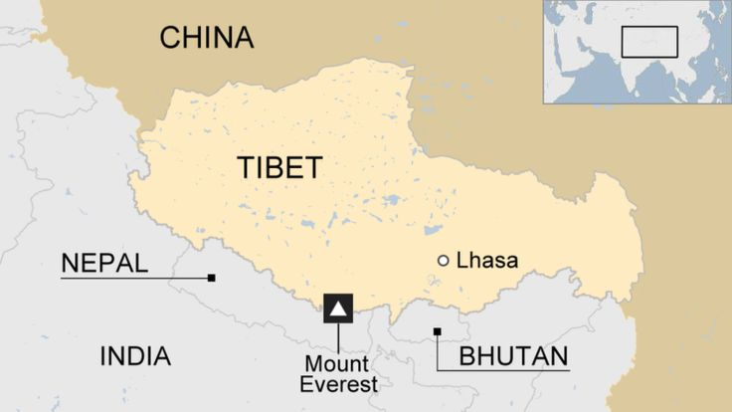
Source: https://www.bbc.co.uk/news/world-asia-pacific-16689779

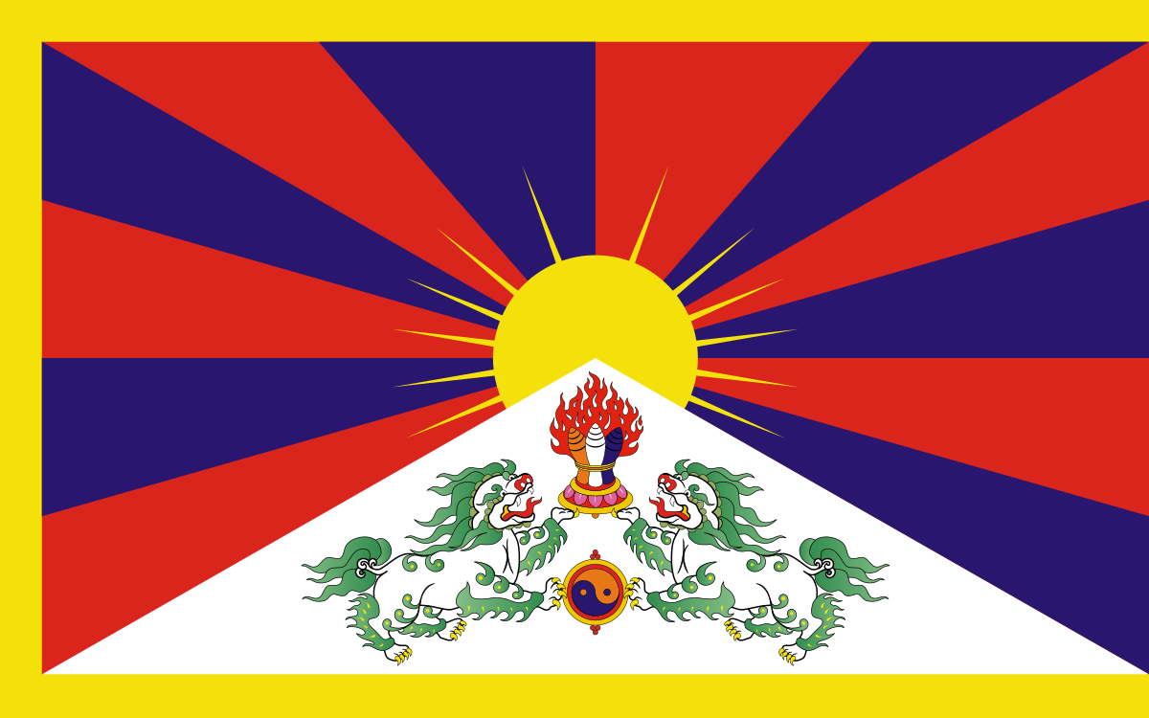
Source: https://en.wikipedia.org/wiki/Flag_of_Tibet

