|  |
| --- |
| Liquid natural gas |

**Curriculum link**

AQA A Level 3.2.5.4 Energy security. Energy supplies in a globalising world: competing national interests and the role of transnational corporations in energy production, processing and distribution.

Edexcel A Level Topic 6: The Carbon Cycle and Energy Security. 6.4 Energy security is a key goal for countries, with most relying on fossil fuels.

WJEC Energy Challenges and Dilemmas. 4.4.4 The global management of oil and gas.

**Situation**

In the early hours of 24 February 2022, Russia invaded Ukraine. This has already had a huge impact on energy security for Europe. Gas prices, in particular, have risen exponentially. This is due to damaged infrastructure, cancelled pipelines, and energy supply seemingly being increasingly used as a political tool.

Russia is led by President Vladimir Putin. It is an autocratic state. The invasion of Ukraine started with air and missile strikes on Ukrainian cities. In April, the OSCE (Organization for Security and Co-operation) stated in a preliminary war crimes assessment that “Russia has engaged in a clear pattern of war crimes” with the use of “unguided bombs” on civilian areas and key infrastructure.[1] For example, news agencies reported earlier this year that missiles hit an oil factory near Khiv and a gas pipeline in Kharkiv, Ukraine’s second-largest city.

Considerable fighting is concentrated in the southeast of Ukraine, in an area called the Donbas. The Donbas is an old coal basin which consists of two provinces, the Luhansk oblast and the Donetsk oblast. The mineral resources of the Donbas are: coal, rock salt, lignite, marl, limestone, clays and other building materials, mercury, and various ores (such as lithium reserves).

In northern Europe the success of a Russia-Germany gas pipeline, Nord Stream 1, was due to be replicated with the opening of Nord Stream 2 in September 2021. Over recent decades Russia and Germany have grown economically and politically closer to one another. However, Nord Stream 2 was cancelled during the certification process in reaction to Russia’s recognition of the self-proclaimed republics in Luhansk and Donetsk (21 February 2022).

A number of countries have suffered issues with energy supply from Russia during the war. Bulgaria, Poland, and Finland have all been ‘cut off’ as they refused to pay in Russian roubles. On 31 May 2022 gas supply was also stopped to GasTerra (which purchases gas for the Netherlands), to the Danish energy firm Ørsted, and to Shell Energy due to their supply contract with Germany. The new Russian payment scheme demands buyers deposit Euros into a Gazprombank account, in order to then convert the cash into Roubles by borrowing from Russia’s central bank. Whilst Gazprom remains sanction-free, this new payment scheme is a safeguard against EU sanctions. This two-step process allows Russia to bypass any future restrictions on Euro payments. In July 2022 Gazprom also cut off gas suppiles to Lativa (although this made little impact as the country had already banned imported Russian gas from January). Russian gas prices surged by 20% in April due to the geopolitical turmoil.

On 6 July 2022 EU President Ursula von der Leyen stated that Europe must prepare for a complete cut-off of Russian gas. In a post on Twitter she called for a “European emergency plan” to counter energy being used as a weapon. Later in the same month the EU voluntarily decided to significantly reduce gas usage in response to ongoing sanctions. Energy ministers across the continent agreed to reduce demand by 15% this winter in response to what the bloc describe as “Moscow’s continuous attempts to use supplies as a weapon”.

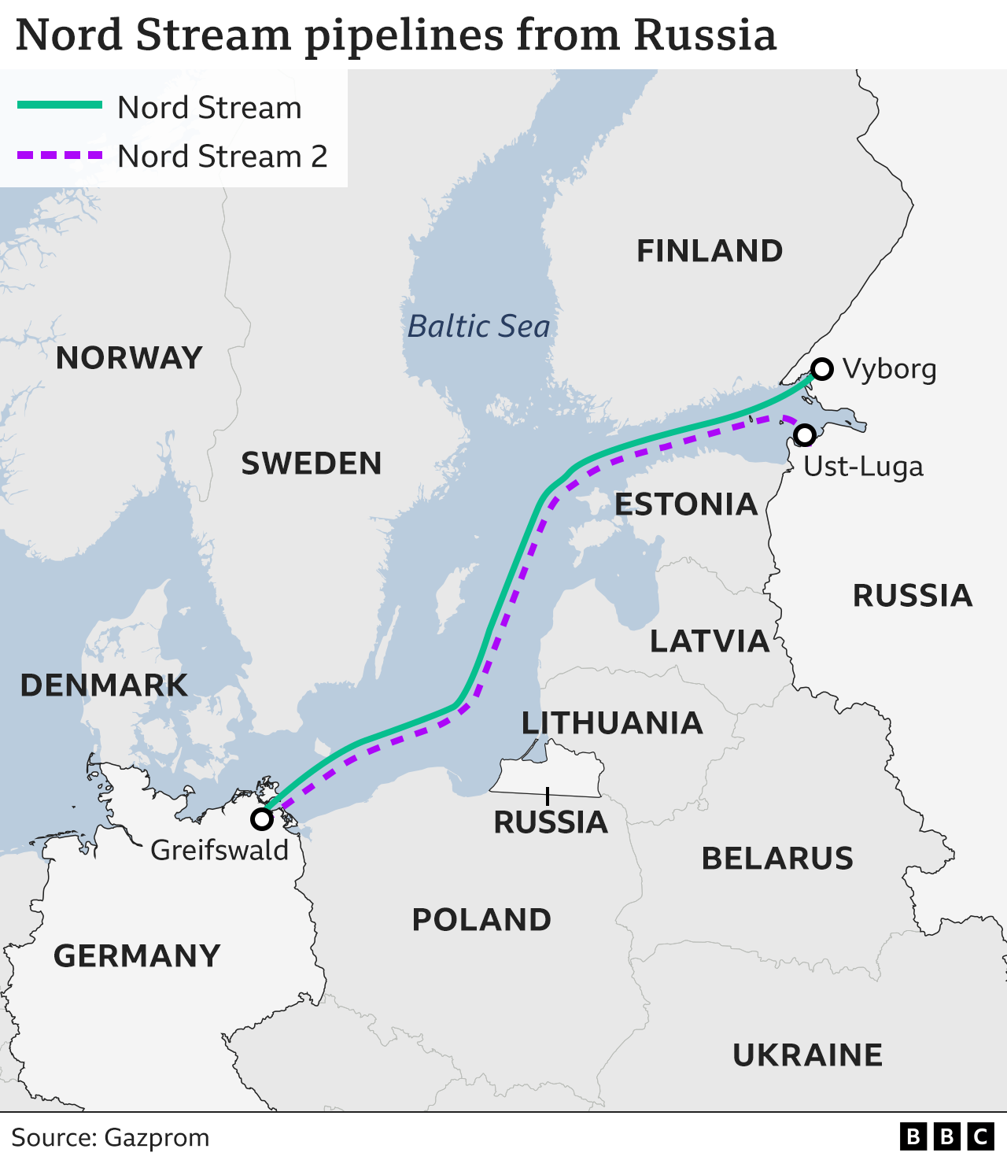

Figure 1 Nord Stream 2 has been cancelled due to the war in Ukraine © BBC

The IEA (International Energy Agency) predicts that Russia will only meet 25% of EU gas demand in 2022, down from over 40% in 2021, and there are now fears that Russia will stop supplies all together. In September, Russia threatened a complete cut off in response to the gas price cap proposed by European Commission president Ursula von der Leyen.

There is hope that liquid natural gas (LNG) will replace Russian pipeline gas. However, problems still remain for European countries, such as Germany, with approximately one-quarter of it’s energy mix reliant on gas. Crucially, Germany also does not have its own import terminal for LNG, which is transported by ship rather than through pipelines.

A summary of the situation is outlined below.

* Before the pandemic, Europe imported 40% of its gas from Russia
* European gas supply is now threated by the war in Ukraine
* Countries build up stores of gas throughout the spring and summer (for high demand in winter)
* By June, Europe’s gas tanks were on track to hit 80% (the minimum needed to get through a typical winter) but gas supplies are slowing
* Europe is now forced to turn to LNG (Liquidfied Natural Gas)
* Globally there is not enough LNG to fill the deficit left by reduced pipeline supply
* There is also not enough European LNG import capacity to bring it in
* There is now a global energy crisis
* There are likely to be curtailments of gas at an industrial level, as a minimum
* In the last week of July, the benchmark for European wholesale gas prices surged once again, up 20% in 2 days
* In the same month, the IMF warned that the UK will experience the slowest growth of any major economy in 2023, apart from Russia, due to the fallout from the war in Ukraine and the pandemic

**Germany vs the UK**

Economic analysts argue the real purpose of the new Russian payment scheme (and the targetted gas cut offs) is to sow division within Europe as some countries adhere to the new US-led sanction system, whilst others circumnavigate it due to energy dependency. Indeed, Ireland, Malta, and Cyprus (all island nations) have already secured exemption from the 15% gas reduction agreement negotiated in July, as they are not connected to other EU countries' gas networks (and therefore cannot share spare gas come the winter).

For a country such as Germany, which has a reliance on Russian gas imports, the effects have already had an economic impact. Figure 2 shows Germany’s energy mix in Exajoules. The energy mix clearly relies hevaily on fossil fuels. Besides renewables, Germany’s only domestic source of power is lignite (a dirty form of coal). Due to energy insecurity it is therefore particularly vulnerable to foreign leverage and geopolitical pressure. Crucially, over half (55%) of gas consumed in Germany was normally imported from Russia before the Ukraine war.

Several other EU member states are also very reliant on Russian gas and say that a collapse of gas trading would lead to severe economic consequences across the bloc.

The UK energy mix is different to Germany. Whilst similarities exist (such as a reliance on gas) the UK imports ~50% of its gas from the international market and only <5% comes from Russia. The majority (77%) of UK gas is sourced from Norway. In 2021, the UK spent £14.5 billion on Norweign supplies, with other sources coming from Qatar, the US, and a small amount from Russia (estimated around 3%). This means the UK is not energy-dependant on Russian imports of gas. However, all prices anywhere in the world are effected by global markets, and gas prices are soaring. Figure 3 shows the energy mix for the UK in Exajoules.

Figure 2 German energy mix in 2021, by final consumption in Exajoules, source [BP](https://www.bp.com/content/dam/bp/business-sites/en/global/corporate/pdfs/energy-economics/statistical-review/bp-stats-review-2022-full-report.pdf)

Figure 3 the UK energy mix in 2021, by final consumption in Exajoules, source [BP](https://www.bp.com/content/dam/bp/business-sites/en/global/corporate/pdfs/energy-economics/statistical-review/bp-stats-review-2022-full-report.pdf)

Below Figure 4 shows the cost of gas from 2020 to 2022. The graph illustrates the steep rise in the spot price of natural gas throughout 2022, using the UK National Balancing Point (NBP) price. The decline in gas price between February and July 2022 is due to a seasonal drop in demand.

Figure 4 gas spot prices in UK NBP (p/therm), source [ERCE](https://www.erce.energy/graph/uk-natural-gas-nbp-spot-price/)

Throughout 2022 global prices have risen due to supply issues caused by the war in Ukraine. Further price spikes are anticipated as countries around the world compete for limited supply going into the winter of 2022. For example, LNG gas supplies are increasingly being fought over and diverted to Europe as a global energy crisis takes hold. As a result the IEA has downgraded global gas market growth to a more modest expectation of 140 billion cubic metres (bcm) between 2021 and 2025.

Figure 5 Henry Hub natural gas price in US$, source [macrotrends](https://www.macrotrends.net/2478/natural-gas-prices-historical-chart)

However, when gas pricing is analysed over a longer time it is clear that there have been other price spikes in recent years. Figure 5 shows the noteworthy peaks in 2005 when much colder-than-normal weather increased demand, and in 2008 after the global financial crash.

In order to appreciate who might be most affected by the war in Ukraine, Figure 6 compares all EU natural gas consumption, including the UK.

Figure 6 a comparison of EU natural gas consumption in 2021, source [BP](https://www.bp.com/content/dam/bp/business-sites/en/global/corporate/pdfs/energy-economics/statistical-review/bp-stats-review-2022-full-report.pdf)

Figure 6 shows that the German economy is likely to be worst hit by reduced Russian gas imports, followed closely by the UK and Italy, on the basis of consumption and market prices. This was compounded by the shutdown of Nord Stream 1 in August 2022. The Nord Stream has been an energy bond between Germany and Russia – starting in Saint Petersburg and ending in Greifswald – marking the reduction in supply as a significant economic and political divergence. The pipeline, which normally tranports approximately 167 million cubic meters of gas per day, dropped to 40% capacity in May, and then 20% in July. As a result, German business confidence fell to its lowest level for more than two years “in the latest sign that Europe’s largest economy is teetering on the brink of recession”[2].

Ultimately, the war in Ukraine and the disruption to Russian gas supply is fueling record European inflation and steeply rising energy prices for businesses and consumers. Ukrainian President Zelensky has accused Moscow of waging a "gas war" against Europe, cutting supplies to inflict "terror" on people across Europe. The response has been a concerted effort across the continent to reduce dependency.

In Italy, prime minster Mario Draghi finalised a major €4bn gas deal with Algeria in July as fears grow of a potential Russian gas cut off. Italy has actively lowered (total consumption of) Russian gas imports from 40% down to 25% this year. This is significant because it makes Algeria Italy’s biggest gas supplier (a position previously held by Russia) and now marks the country as Africa’s biggest gas supplier to Europe.

The Bundestag has also reduced German dependency on Russia by decreasing total gas consumption from 55% down to 35%.

According to the International Monetary Fund (IMF), the German and Hungarian economies are the most vulnerable when it comes to Russian gas supplies. Hungary was the first country to break from the political consensus, and has brokered a deal to increaseimports of Russian gas, due to an application for an additional 700 million cubic metres. This agreement was reached when Peter Szijjarto, Hungaria’s foreign minister visited Russia in late July to “guarantee Budapest’s energy supply and to make clear that the Hungarian government is interested in peace”.

However, this does not neceassirly mean that the UK and Germany will be the worst-affected countries in Europe. In spite of overreliance on gas, there are a number of mitigating factors that protect these European economies. For example, UK ministers have promised to increase domestic fossil fuel production, with iniatitives such as the Jackdaw gas project, and in Germany there is hope that LNG imports (Liquid Natural Gas) will replace some of the lost energy supply.

**LNG**

LNG is a gas which has been cooled to approximately -160°C with a volume 600 times smaller than that of natural gas. LNG is shipped on carriers with large cryogenic tanks.

This makes LNG more transportable, and more cost effective per cubic feet. It is hoped, both in the UK and the EU, that energy dependancy will be reduced with the importation of LNG in the future. There has been a sharp increase in LNG imports into the UK and EU since 2018, mostly from the US which guaranteed in May to deliver at least an extra 15 billion cubic metres of LNG this year.

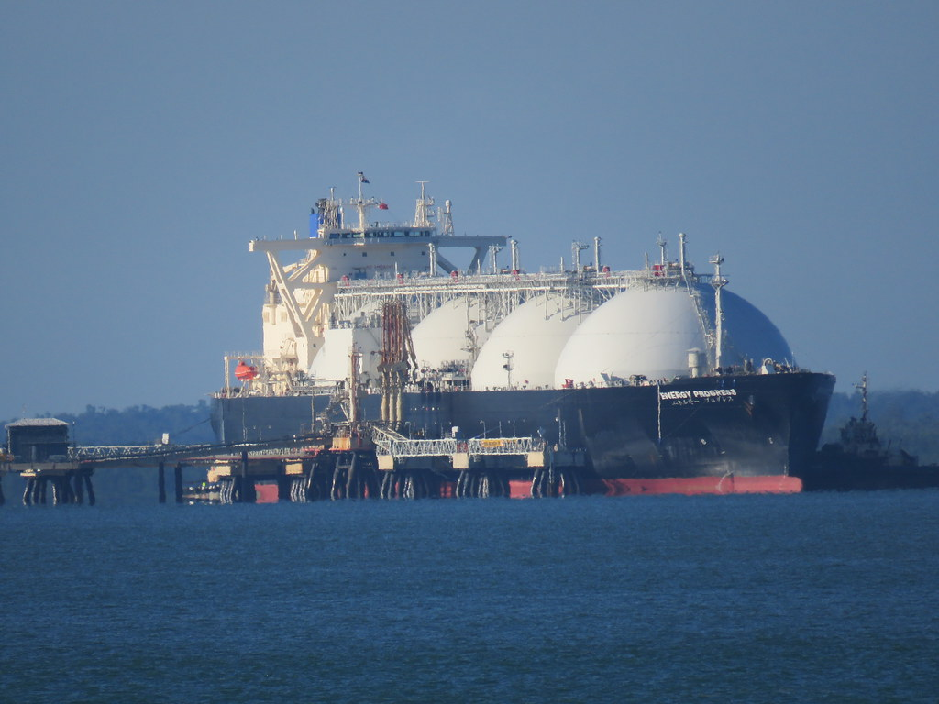

Figure 7 LNG is increasingly exported by the US

The US is significantly increasing its LNG export infrastructure, becoming the world’s number one exporter in 2022. The US has a strong LNG relationship with the UK and Europe. Figure 8 on the next page shows the top destinations for LNG, exported by the US, over a 6-year period to 2021.

Figure 8 US LNG export by country between 2016 and 2021, source [EIA](https://www.eia.gov/dnav/ng/ng_move_expc_s1_a.htm)

Once LNG arrives in port, regasification is required. In total, there are 29 large scale import terminals for LNG regasification across the UK and Europe, with only Norway and Russia possessing export facilities. Europe’s regasification capacity is limited to the coastal western areas of the continent. Central and eastern Europe are largely disconnected from the LNG network. These terminals are sensitive environments with high safety concerns. The 3 sites in the UK are:

1. South Hook, west of Milford Haven in Pembrokeshire
2. Dragon, east of Milford Haven in Pembrokeshire
3. Isle of Grain, Medway in Kent

These terminals are very much a part of an interconnected network around Europe. Of the 29 import terminals, 3 are UK-based, with 21 are across the EU, 4 in Turkey, and 1 in Russia.

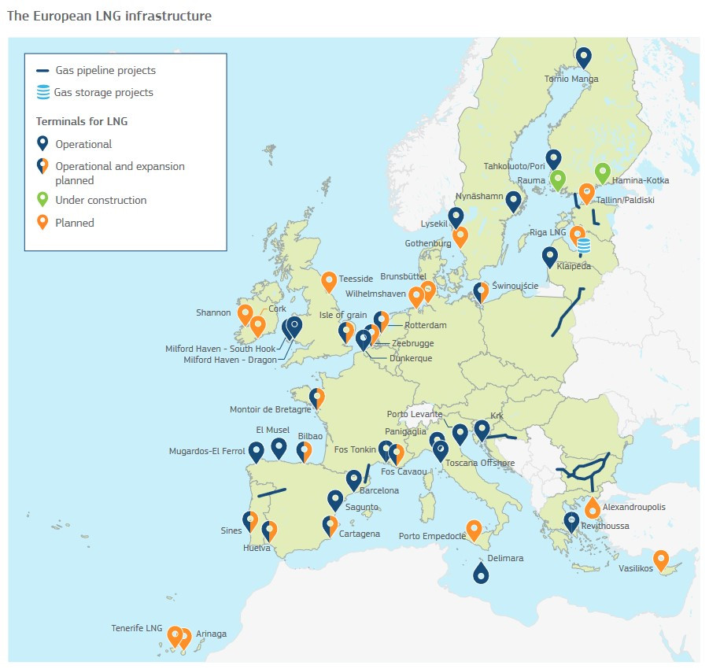

Figure 9 UK and EU LNG terminals in 2022 © European Comission 2022

Figure 9 illustrates the difficulties facing the German economy. Germany currently has no regasification terminals for LNG imports, despite more than ¼ of the country’s energy mix being reliant on gas. Currently LNG comes into Germany via Belgium, the Netherlands, or via road. Due to a lack of terminals the German government has quickly announced co-funding a terminal project at Brunsbüttel, with a short-term floating terminal at Wilhelmshaven, called a Floating Storage and Regasification Unit (FSRU). Construction began in July 2022.

The UK began importing LNG for commercial use in 2005, with a rapid increase from 2008 onwards. There is a strong LNG trading relationship between the UK and Qatar, with several supply and purchase agreements between the countries (SPAs). These agreements oblige Qatar to sell – and the UK to buy – LNG. From 2005 to 2019 the UK has diversified its LNG dependency moving from 2 to 12 source countries (including Russia).

Expanding LNG infrastrcuture is a costly and lengthy process. In response to the imminent need for natural gas EU President Ursula Von Der Leyen stated that the EU wants to expand and diversify supply. New and potential LNG deals are currently being sought by the EU with Qatar, Israel, Egypt, Canada, Nigeria, Senegal, and Angola.

**Activities**

1. Describe the differences in the energy mix between UK and German.
2. Read [this](https://www.cleanenergywire.org/factsheets/germanys-energy-consumption-and-power-mix-charts) analysis on German energy and scroll down to the chart German energy mix 2021: Energy sources’ share in primary energy consumption. What is the breakdown of coal in the energy mix? Explain why this is a problem.
3. Study Figure 6. Who is most at risk of energy insecurity due to the war in Ukraine?
4. Why might Figure 6 not be a true representation of energy insecurity for these countries?
5. Study Figure 8. What were the top 5 destinations for US LNG in 2021?
6. Who are the top 5 countries who have most increased US LNG exports since 2016?
7. Study Figure 9. Why is Germany is such a difficult position when it comes to LNG?

**Answers**

1. Compared to the UK, Germany has a more diverse energy mix. It has near equal weighting for oil and gas (at 33 and 26% respectively) across a broadly balance mix. Nuclear is at 5% and is steadily falling over time as Germany phases out its nuclear power programme. In spite of 18% of primary energy being sourced from renewables, this is not a positive environmental mix because of the consumption of coal. In contrast, the UK consumes more gas but 14% lesscoal. Hydro-generated energy and renewables are very similar between the two countries.
2. The graph offers a breakdown of Germany’s consumption of coal. Lignite accounts for 9.3%. It is the dirtiest type of coal – releasing the highest levels of carbon dioxide and sulphur – making it the most harmful form of coal to human health.
3. Figure 6 clearly highlights Germany and the UK as the top two gas consuming countries in Europe. Closely followed by Italy and Turkey. Both Germany and the UK rely heavily on gas. It accounts for over ¼ of their energy which, in current circumstances, leaves them vulnerable to insecurity, price shocks, and gas market volitility. Italy is equally very dependent on supplies as the country relies on gas to generate electricity, heat and cool homes, and power industry more so than other European counterparts. As a result gas-dependent countries have all attempted to find alternative energy sources with, for example, Italy reaching out to Azerbaijan, Qatar, Congo, Angola and Mozambique.
4. The top importers of natural gas in Figure 6 is not an accurate reflection of at-risk economies due to subtle geographic and economic difficulties for other member states. Hungary, for example, is a landlocked country which is heavily reliant on energy imports. The country currently imports 65% of its oil and 80% of its natural gas from Russia and in July declared a "state of emergency" over supply disruptions.
5. The top 5 export destinations for US LNG are: South Korea (453,483), China (449,667), Japan (354,948), Brazil (307,714), and Spain (215,062).
6. The same top 5 countries: South Korea, China, Japan, Brazil, and Spain. (The UK is ranked 6 increasing US LNG exports from 0 to 195,046 million cubic feet by 2021).
7. Germany has an overreliance on fossil fuels. Figure 2 shows 76% of the country’s energy comes from either oil, gas or coal. With regard to gas, the majority is imported from Russia (approximately 55% pre-2019) rendering the country heavily energy dependent. Germany is in a difficult position because it does not have regasification technology nor the ability to store LNG. Even with the recent surge in LNG infrastructure across the continent, new infrastructure will not be ready until after 2025, due to curtailed investments in the mid-2010s and recent construction delays from COVID-19.

**Further reading**

* Guardian [As Russia continues to bomb Ukraine, are its weapons of choice getting worse?](https://www.theguardian.com/world/2022/apr/14/as-russia-continues-to-bomb-ukraine-are-its-weapons-of-choice-getting-worse)
* Al Jazeera [Russia hits Ukrainian oil and gas facilities in wave of attacks](https://www.aljazeera.com/news/2022/2/27/russia-ukraine-oil-gas-fuel-airport-attacks)
* Guardian [Russia cuts gas supplies to Netherlands and firms in Denmark and Germany](https://www.theguardian.com/world/2022/may/31/russia-cuts-gas-supplies-dutch-state-trader-sanctions-war)
* Guardian [Germany halts Nord Stream 2 approval over Russian recognition of ‘republics’](https://www.theguardian.com/world/2022/feb/22/germany-halts-nord-stream-2-approval-over-russian-recognition-of-ukraine-republics)
* Bloomberg [Russia to Cut Gas to Poland, Bulgaria Until Pay Demands Met](https://www.bloomberg.com/news/articles/2022-04-27/gazprom-says-it-cuts-gas-to-poland-bulgaria-on-non-payment)
* CEW [Germany’s energy consumption and power mix in charts](https://www.cleanenergywire.org/factsheets/germanys-energy-consumption-and-power-mix-charts)
* ONS [UK energy in brief 2021](https://assets.publishing.service.gov.uk/government/uploads/system/uploads/attachment_data/file/1032260/UK_Energy_in_Brief_2021.pdf)
* ONS [Trends in UK imports and exports of fuel](https://www.ons.gov.uk/economy/nationalaccounts/balanceofpayments/articles/trendsinukimportsandexportsoffuels/2022-06-29#:~:text=The%20UK%20imports%20around%2050,heated%20by%20mains%20gas%20supply.)
* FT [UK government approves Jackdaw gas project in North Sea](https://www.ft.com/content/a650f12e-65d7-4cf1-9d95-568d63229597)
* BBC News [Ukraine war: Russia waging gas war with Nord Stream 1 cuts - Zelensky](https://www.bbc.co.uk/news/world-europe-62300684)
* BBC Radio 4 [The Six O’Clock News: EU agrees to cut gas use](https://www.bbc.co.uk/sounds/play/m0019jym)
* Today in Focus podcast [What happens if Russia turns off Europe’s gas?](https://www.theguardian.com/news/audio/2022/jul/27/what-happens-if-russia-turns-off-europes-gas)
* Euronews [Hungary's top diplomat visits Moscow to negotiate gas supplies despite EU bid to cut deliveries](https://www.euronews.com/2022/07/21/hungarys-top-diplomat-visits-moscow-to-negotiate-gas-supplies-despite-eu-sanctions)
* Euronews [Algeria becomes Italy's biggest gas supplier in new €4bn deal to reduce Russian dependency](https://www.euronews.com/2022/07/18/italys-draghi-visits-algeria-for-gas-talks-while-political-crisis-continues-at-home)
* Clean Energy Wire [Ukraine war puts plans for German LNG terminals back on the table](https://www.cleanenergywire.org/factsheets/liquefied-gas-does-lng-have-place-germanys-energy-future)
* National Law Review [LNG In Europe 2021: Current Trends, The European LNG Landscape And Country Focus](https://www.natlawreview.com/article/lng-europe-2021-current-trends-european-lng-landscape-and-country-focus#:~:text=Six%20of%20Europe's%20LNG%20terminals,on%20regulated%20third%20party%20access.)
* GOV.UK [Trends in trade of Liquefied Natural Gas in the UK and Europe](https://assets.publishing.service.gov.uk/government/uploads/system/uploads/attachment_data/file/875383/Trends_in_trade_of_Liquefied_Natural_Gas_in_the_UK_and_Europe.pdf)
* IEA [Global natural gas demand set for slow growth in coming years as turmoil strains an already tight market](https://www.iea.org/news/global-natural-gas-demand-set-for-slow-growth-in-coming-years-as-turmoil-strains-an-already-tight-market)

**Professor Michael Bradshaw on energy security in 2022**

A list of media work from Professor Bradshaw on gas, the Ukrainian war, and UK energy security.

* The Conversation [Energy prices are unlikely to fall in 2022 or beyond – not until major importers get serious about green transition](https://theconversation.com/energy-prices-are-unlikely-to-fall-in-2022-or-beyond-not-until-major-importers-get-serious-about-green-transition-174437#comment_2685607)
* The Independent [Drilling for more gas and net zero targets do not go hand-in-hand](https://www.independent.co.uk/independentpremium/news-analysis/gas-north-sea-energy-net-zero-b2012332.html)
* The Conversation podcast [If Russia invades Ukraine, what could happen to natural gas supplies to Europe?](https://theconversation.com/if-russia-invades-ukraine-what-could-happen-to-natural-gas-supplies-to-europe-podcast-176812)
* The Conversation [Ukraine: Russia probably won’t turn off the gas, but the problem won’t go away any time soon](https://theconversation.com/ukraine-russia-probably-wont-turn-off-the-gas-but-the-problem-wont-go-away-any-time-soon-176817)
* UKERC webinar [The Gas Crisis: What Next?](https://ukerc.ac.uk/news/video-the-gas-crisis-what-next-webinar/)
* Energy News Live podcast on [The impact of Russia’s invasion of Ukraine for UK/EU energy security](https://www.energylivenews.com/2022/03/02/were-all-trying-to-hold-our-breath-about-the-future-of-energy-supplies/)
* The Conversation [Why Shale Gas is not the answer to soaring gas prices](https://theconversation.com/why-fracking-is-not-the-answer-to-soaring-uk-gas-prices-177957)
* Guardian [Energy crisis: UK could learn from Fukushima response, MPs told](https://www.theguardian.com/business/2022/mar/08/uk-energy-crisis-mps-fukushima)
* Daily Motion [When will sanctions help Ukraine?](https://www.dailymotion.com/video/x88vb4o)
* Buzzfeed interview with Zahra Hirji [The War In Ukraine Exposes The World's Utter Reliance On Fossil Fuels](https://www.buzzfeednews.com/article/zahrahirji/russia-ukraine-war-fossil-fuels-climate-change)
* The FT [Boris Johnson has few quick fixes to deliver UK energy security](https://www.ft.com/content/6388e374-780f-48fd-aed6-8a33c0c407ed?desktop=true&segmentId=7c8f09b9-9b61-4fbb-9430-9208a9e233c8#myft:notification:daily-email:content)
* World Today panel podcast [Could a ban on Russian oil end the war in Ukraine? Details to follow](https://radio.cgtn.com/podcast/news/1/Panel-Can-a-ban-on-Russian-oil-end-the-war-in-Ukraine/337076)
* Euronews interview with Lottie Limb [This is what historians want you to know about what does - and doesn't - work in energy crises](https://www.euronews.com/green/2022/03/29/what-can-world-war-two-teach-us-about-tackling-the-2022-energy-crisis)
* UKERC blog [Is the UK being left out in the energy policy cold?](https://ukerc.ac.uk/news/is-britain-being-left-out-in-the-energy-policy-cold/)
* iai news [Clean energy won't end war](https://iai.tv/articles/clean-energy-wont-end-war-auid-2121?_auid=2020)
* WBS [How will Russia's war in Ukraine affect energy supplies and the planet?](https://www.wbs.ac.uk/news/how-will-russias-war-in-ukraine-affect-energy-supplies-and-the-planet/)
* The We Society podcast for the Academy of Social Sciences [You Can't Build a Plan Around Armageddon](https://audioboom.com/posts/8121276-you-can-t-build-a-plan-around-armageddon)
* Guardian [Government failure to boost energy efficiency ‘inexplicable’, says IEA](https://www.theguardian.com/environment/2022/jun/08/government-failure-to-boost-energy-efficiency-inexplicable-says-iea)
* The Conversation [Energy crisis: why the UK will be at the mercy of international gas prices for years to come](https://theconversation.com/energy-crisis-why-the-uk-will-be-at-the-mercy-of-international-gas-prices-for-years-to-come-186069)

1. OSCE release <https://www.osce.org/files/f/documents/f/a/515868.pdf>
2. Reports the FT in the article [Russia cuts gas deliveries to Europe via Nord Stream 1](https://www.ft.com/content/b193dc11-5069-41f5-ba86-2a83ea78f911)