The Russian Arctic: Arctic ecology activity sheet 3

This is a worksheet for Key Stage 3 geography. There is only 1 question, which is a food web reorganisation task. It is designed to complement a wider scheme of work either on climate change or on Russia specifically.

Curriculum relevance
Understanding food webs is essential because:

- Students need an understanding of food webs: producers, consumers, and nutrient cycling
- Russia has the most amount of Arctic coastline out of the 8 Arctic nations
- The effects of climate change will be seen first in the Arctic

The Arctic Ocean
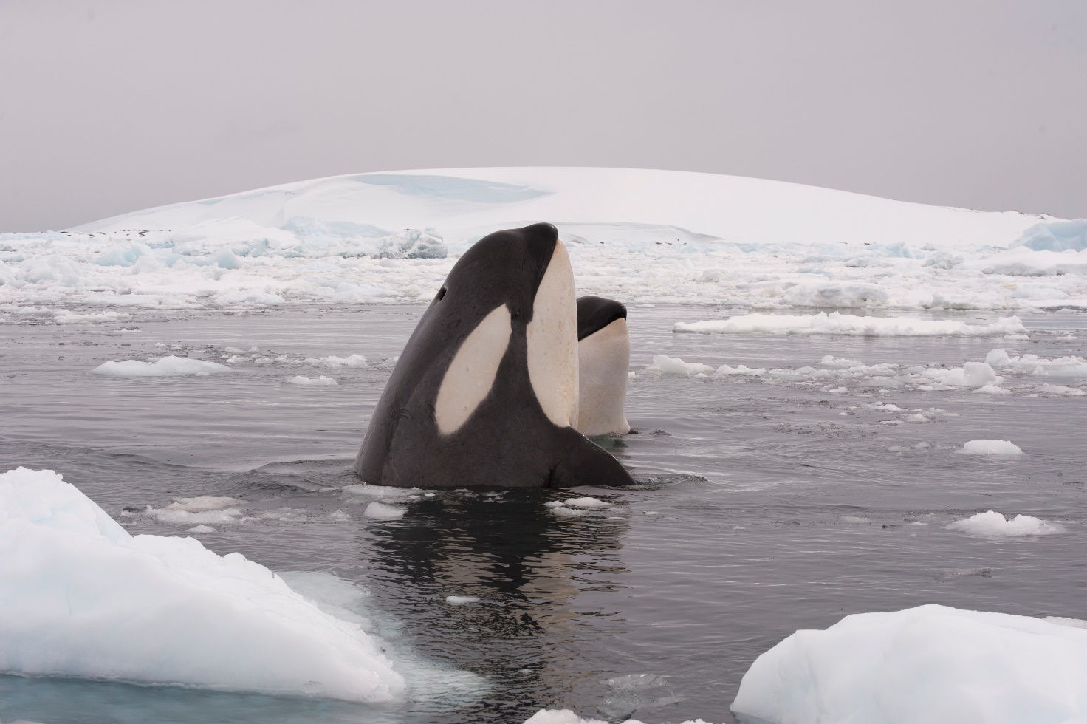Figure 1 killer whales — the Arctic Ocean apex predators © vladsilver Pond5

What is a food web?
The Arctic has a diverse range of unique and endangered species. You can read about the range of animals found in the Arctic on this Arctic wildlife page.

There are recognisable mammals such as the polar bear — and the very unusual toothed narwhal and some less-well known species like caribou and the beluga whale.

The Arctic is rapidly warming with some of the fastest changes to climate on the planet. For example, Arctic sea ice extent (the area of ocean with at least 15% sea ice) had over 2 million km² less sea ice in July 2020 compared to the 1981-2010 median average — a trend set to continue in the twenty-first century. As a result, computer models are now virtually unanimous in showing the occurrence of seasonal ice-free conditions there by mid-century.

These changes are already having a huge impact on atmospheric circulation and Arctic wildlife in the tundra. When monthly totals of Arctic sea ice extent are compared to the 1981-2010 median more than 2 million km² of sea ice has disappeared from the Arctic. This is extremely significant as the whole Arctic food web relies on sea ice, ice sheets and glaciers. The reason sea ice in particular is so important is because it provides a surface for the most basic material to grow on, an organism which underpins the whole food web — algae.

Below is an Arctic food web showing the degrees of separation for each animal from phytoplankton.

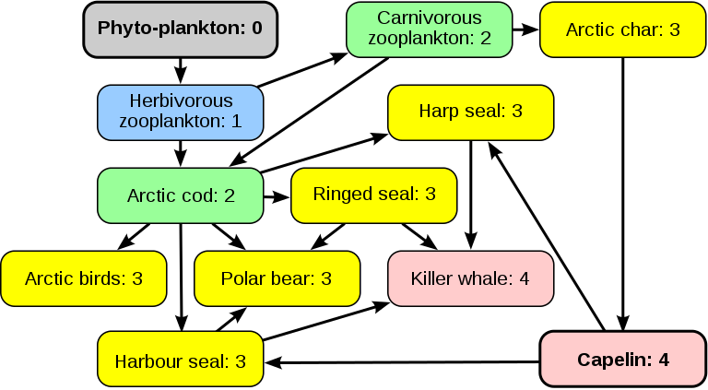

Figure 2 the Arctic food web © Cmglee www.commons.wikimedia.org/w/index.php?curid=89093708

- How many degrees of separation does a Killer whale have from phytoplankton?

- Below are twenty images of different Arctic organisms — from large fauna (animals) to microscopic flora (plants). Can you correctly reorganise them into a food web?

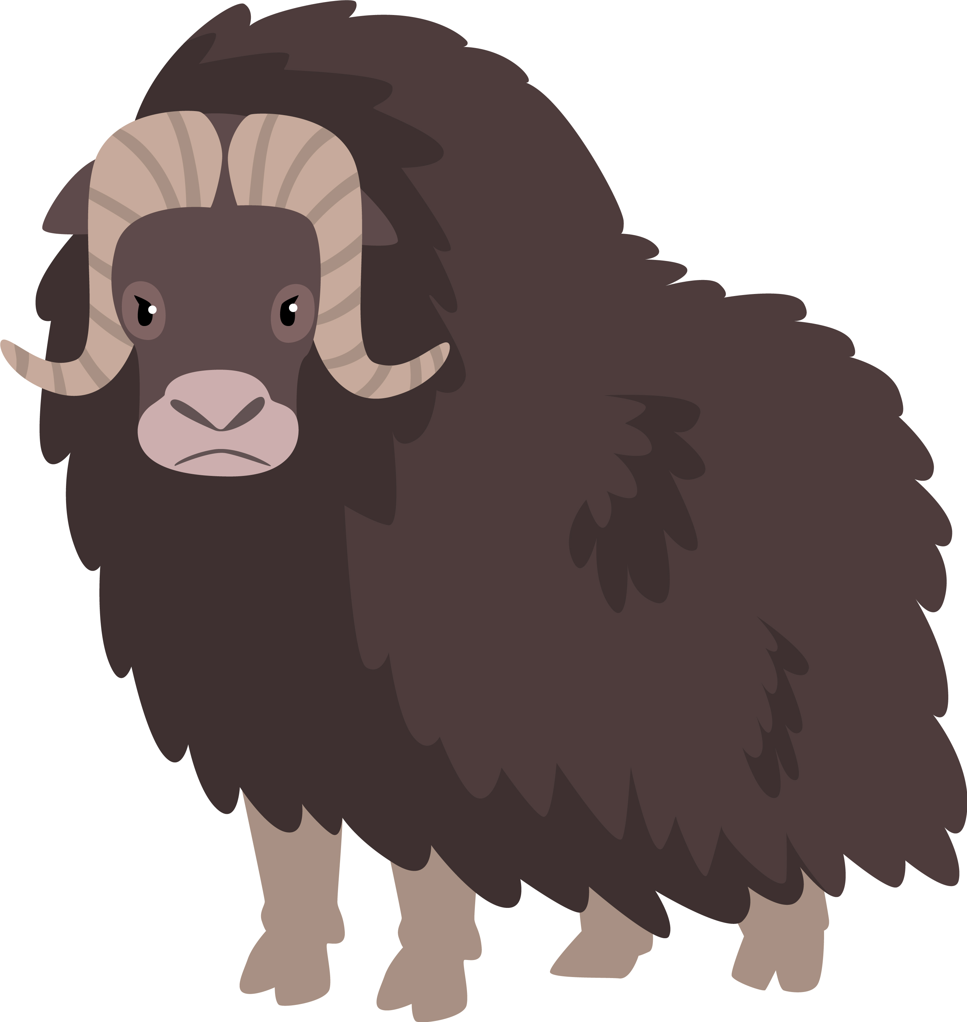

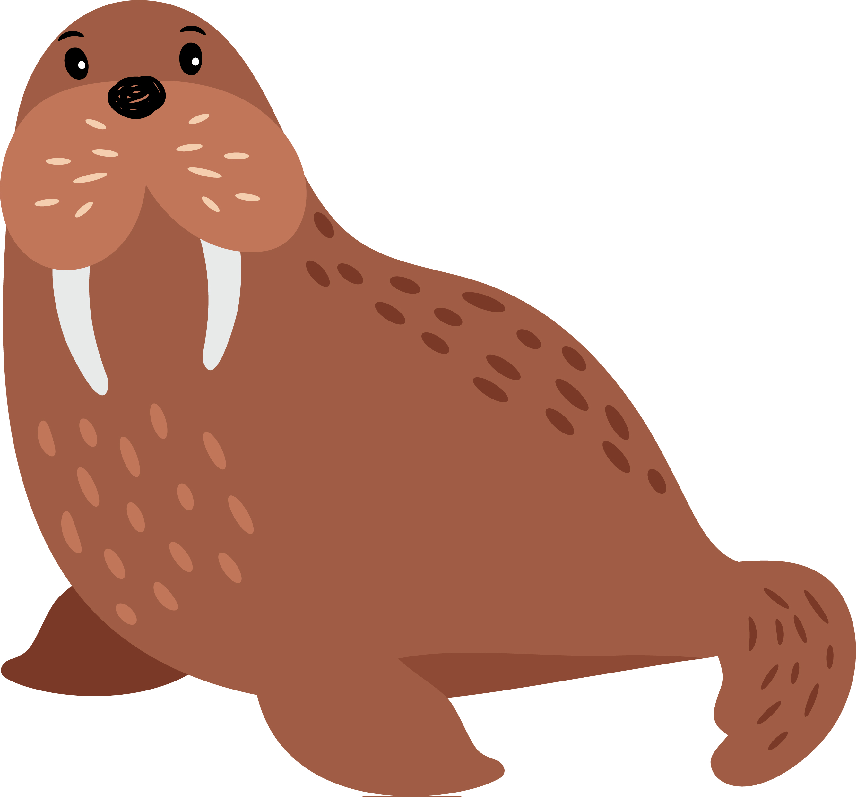

Arctic Char
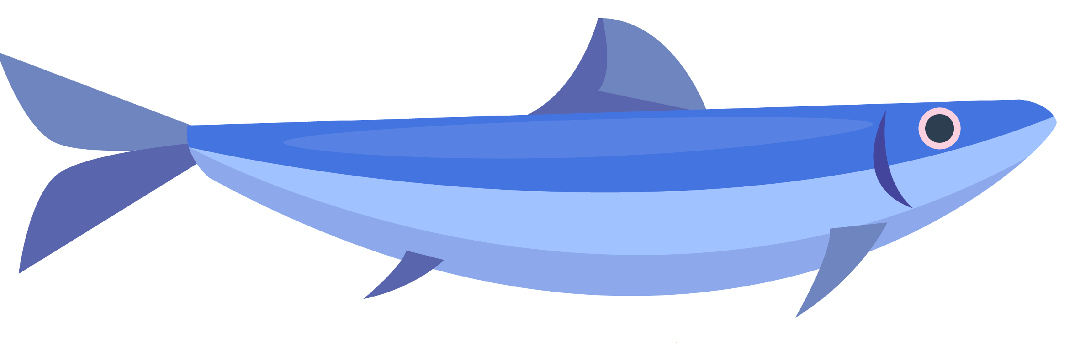

Capelin Walrus Musk Ox

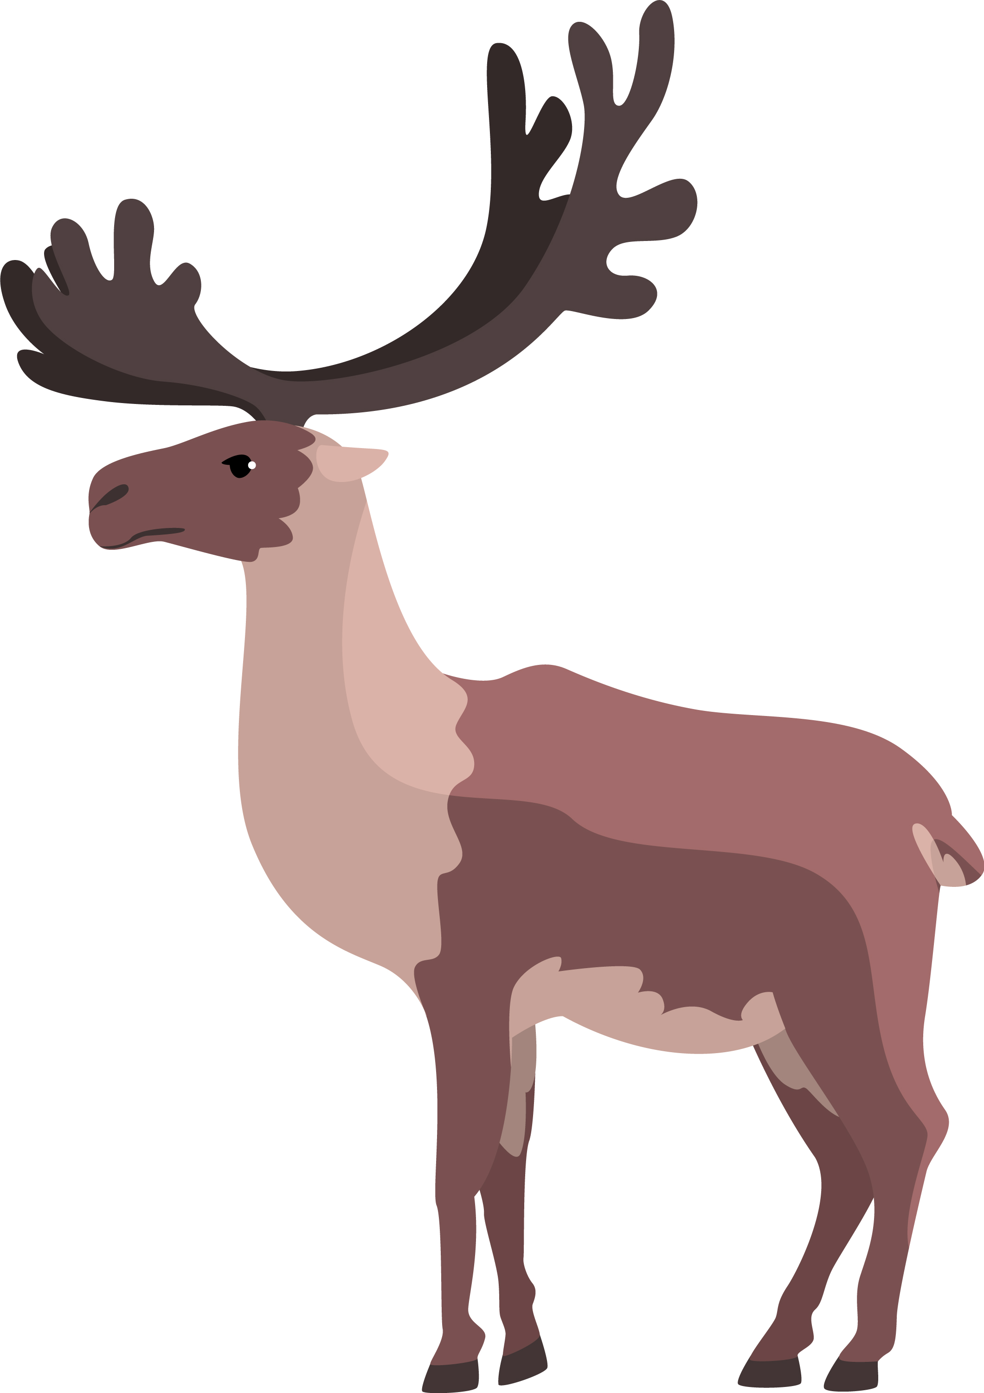
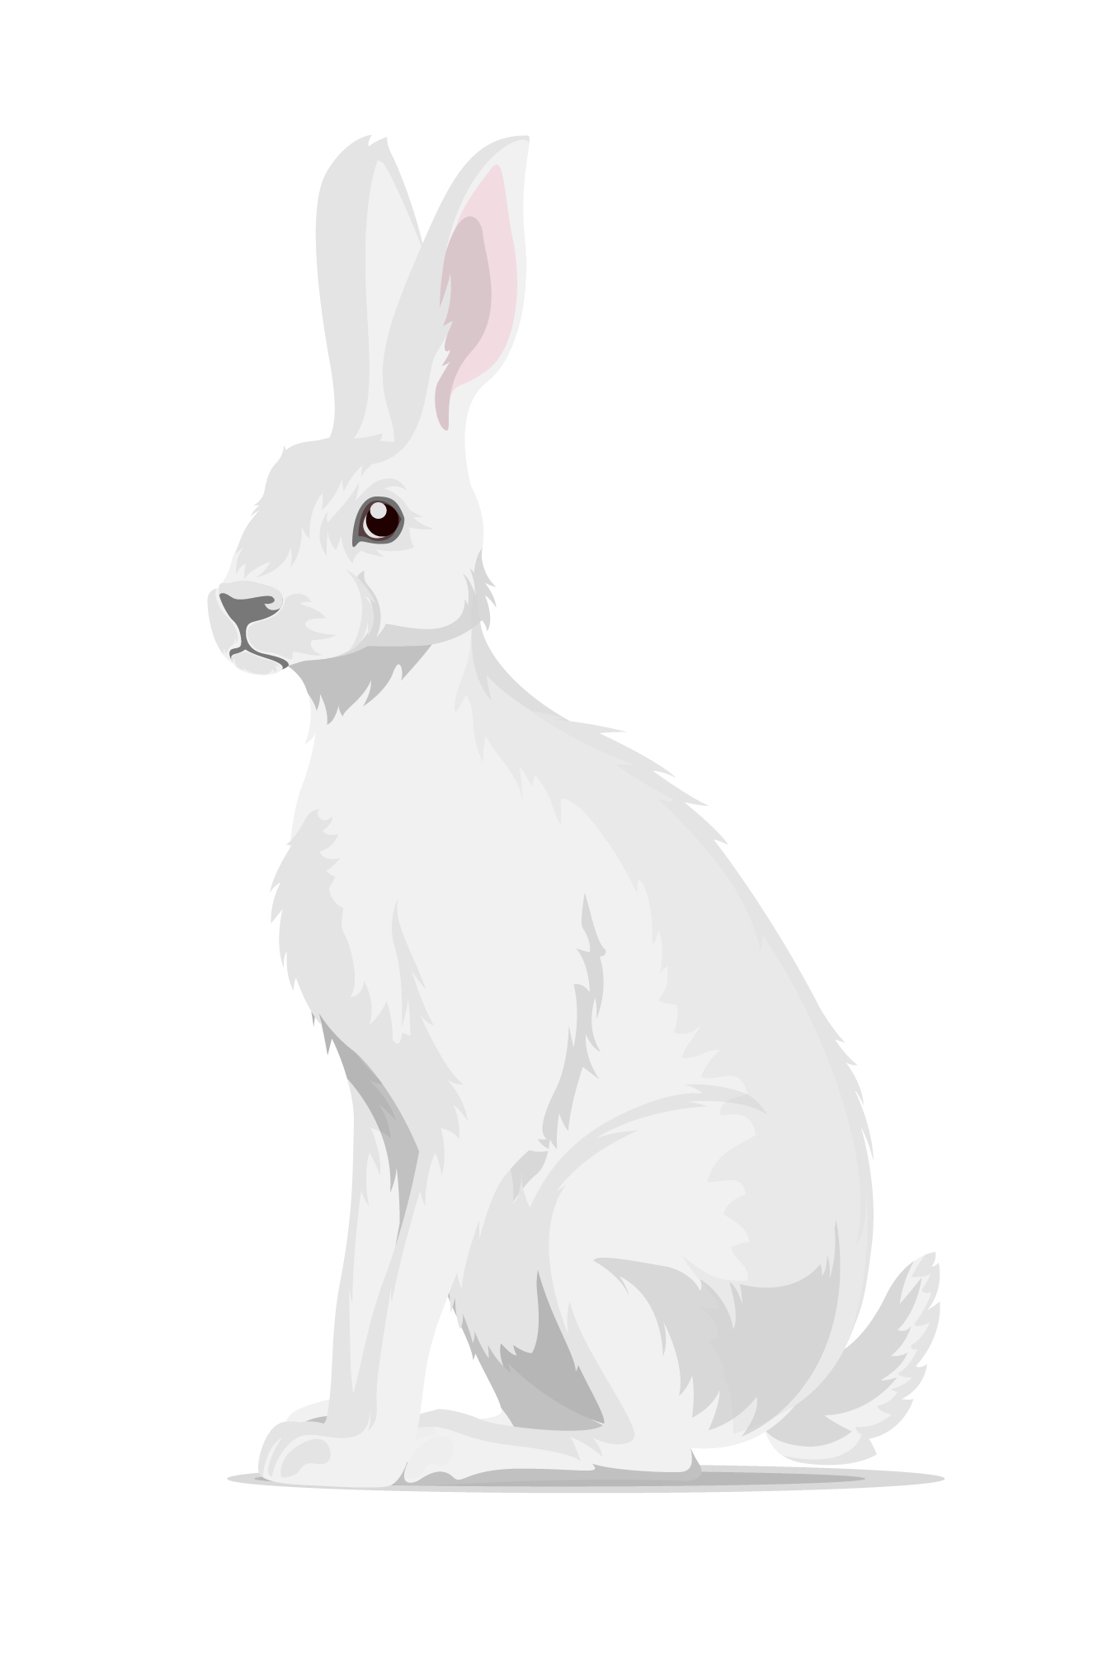
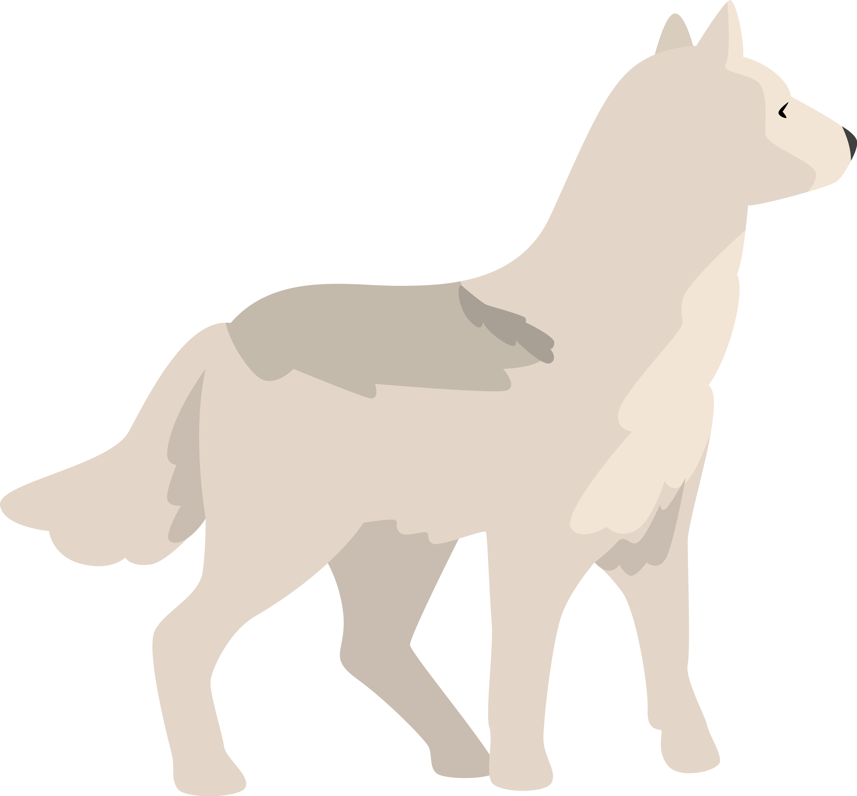

Arctic hare Wolf Caribou

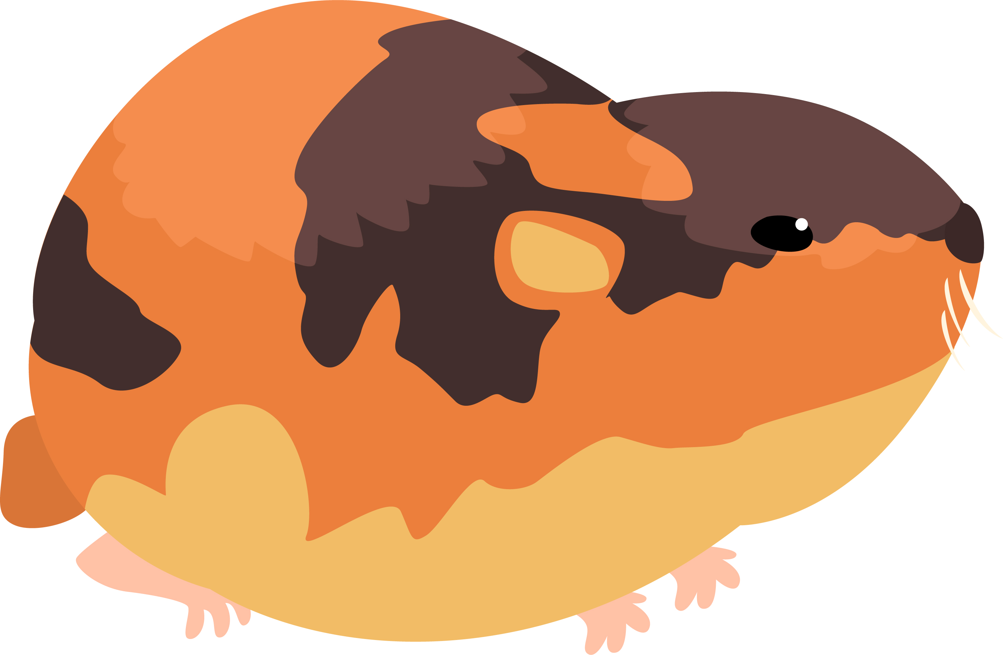
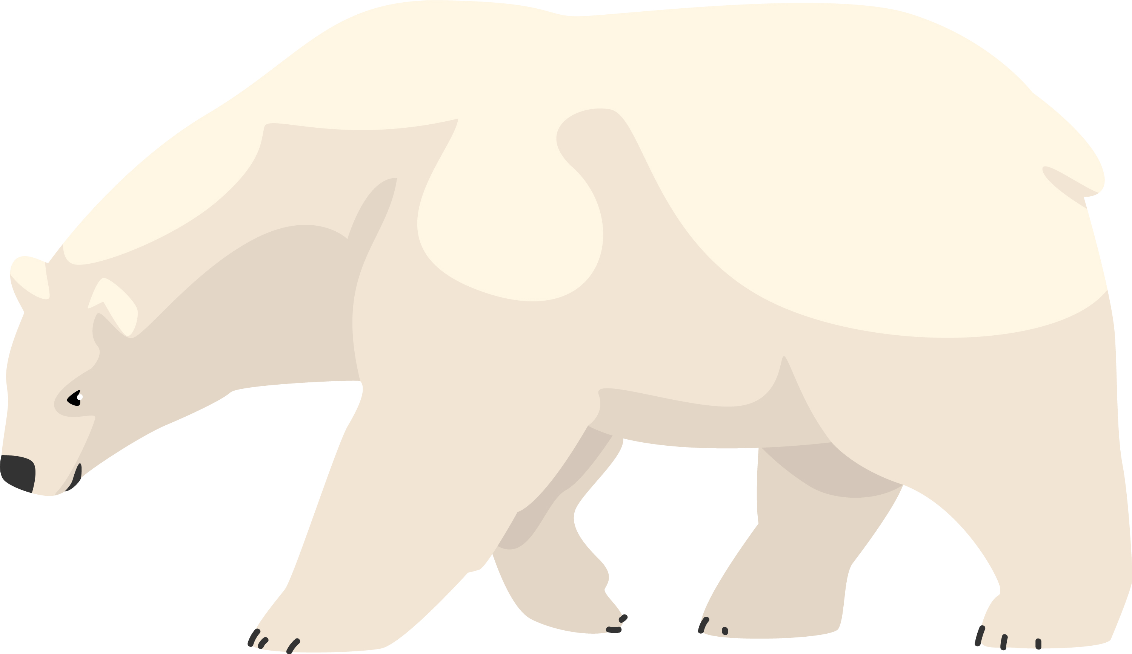
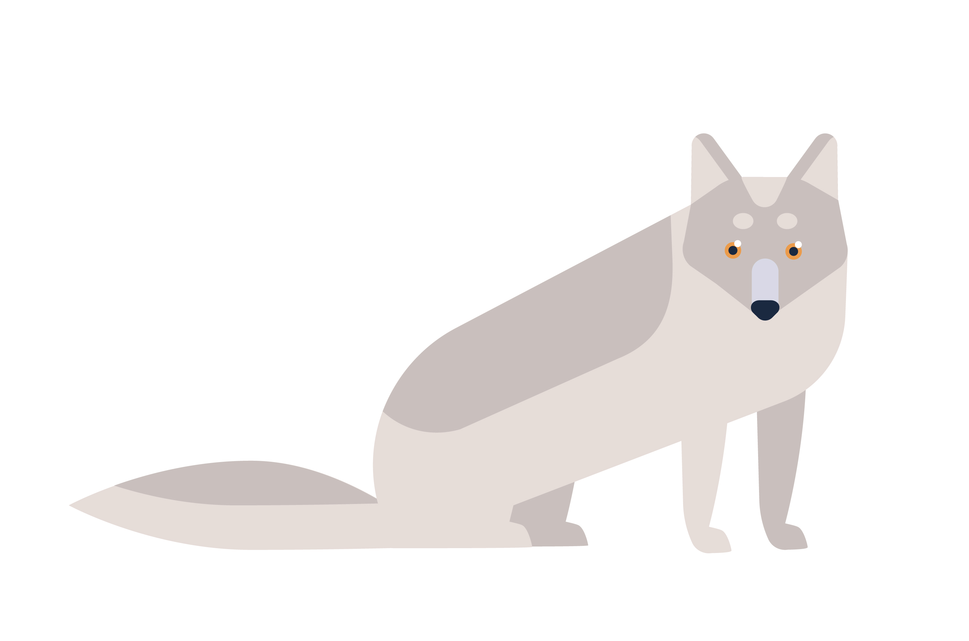

Arctic lemmings Polar bear Arctic fox

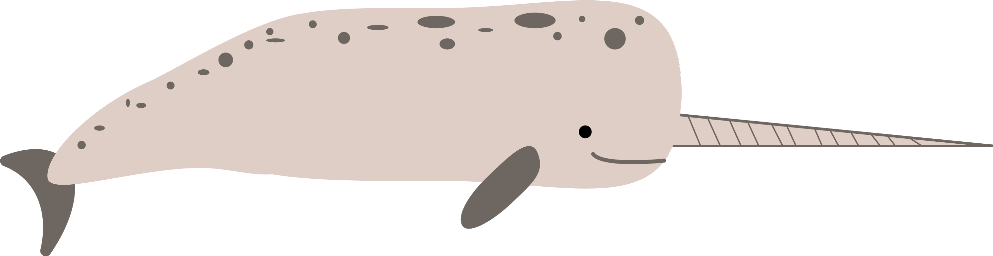
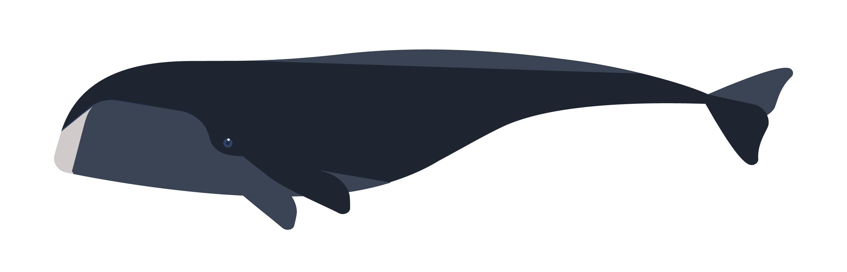

Narwhale Bowhead whale
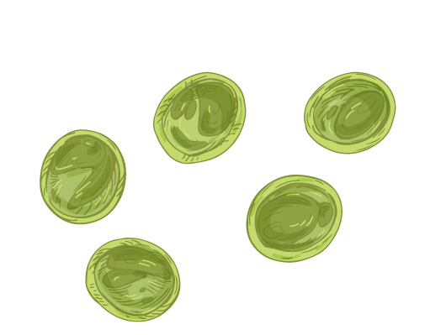
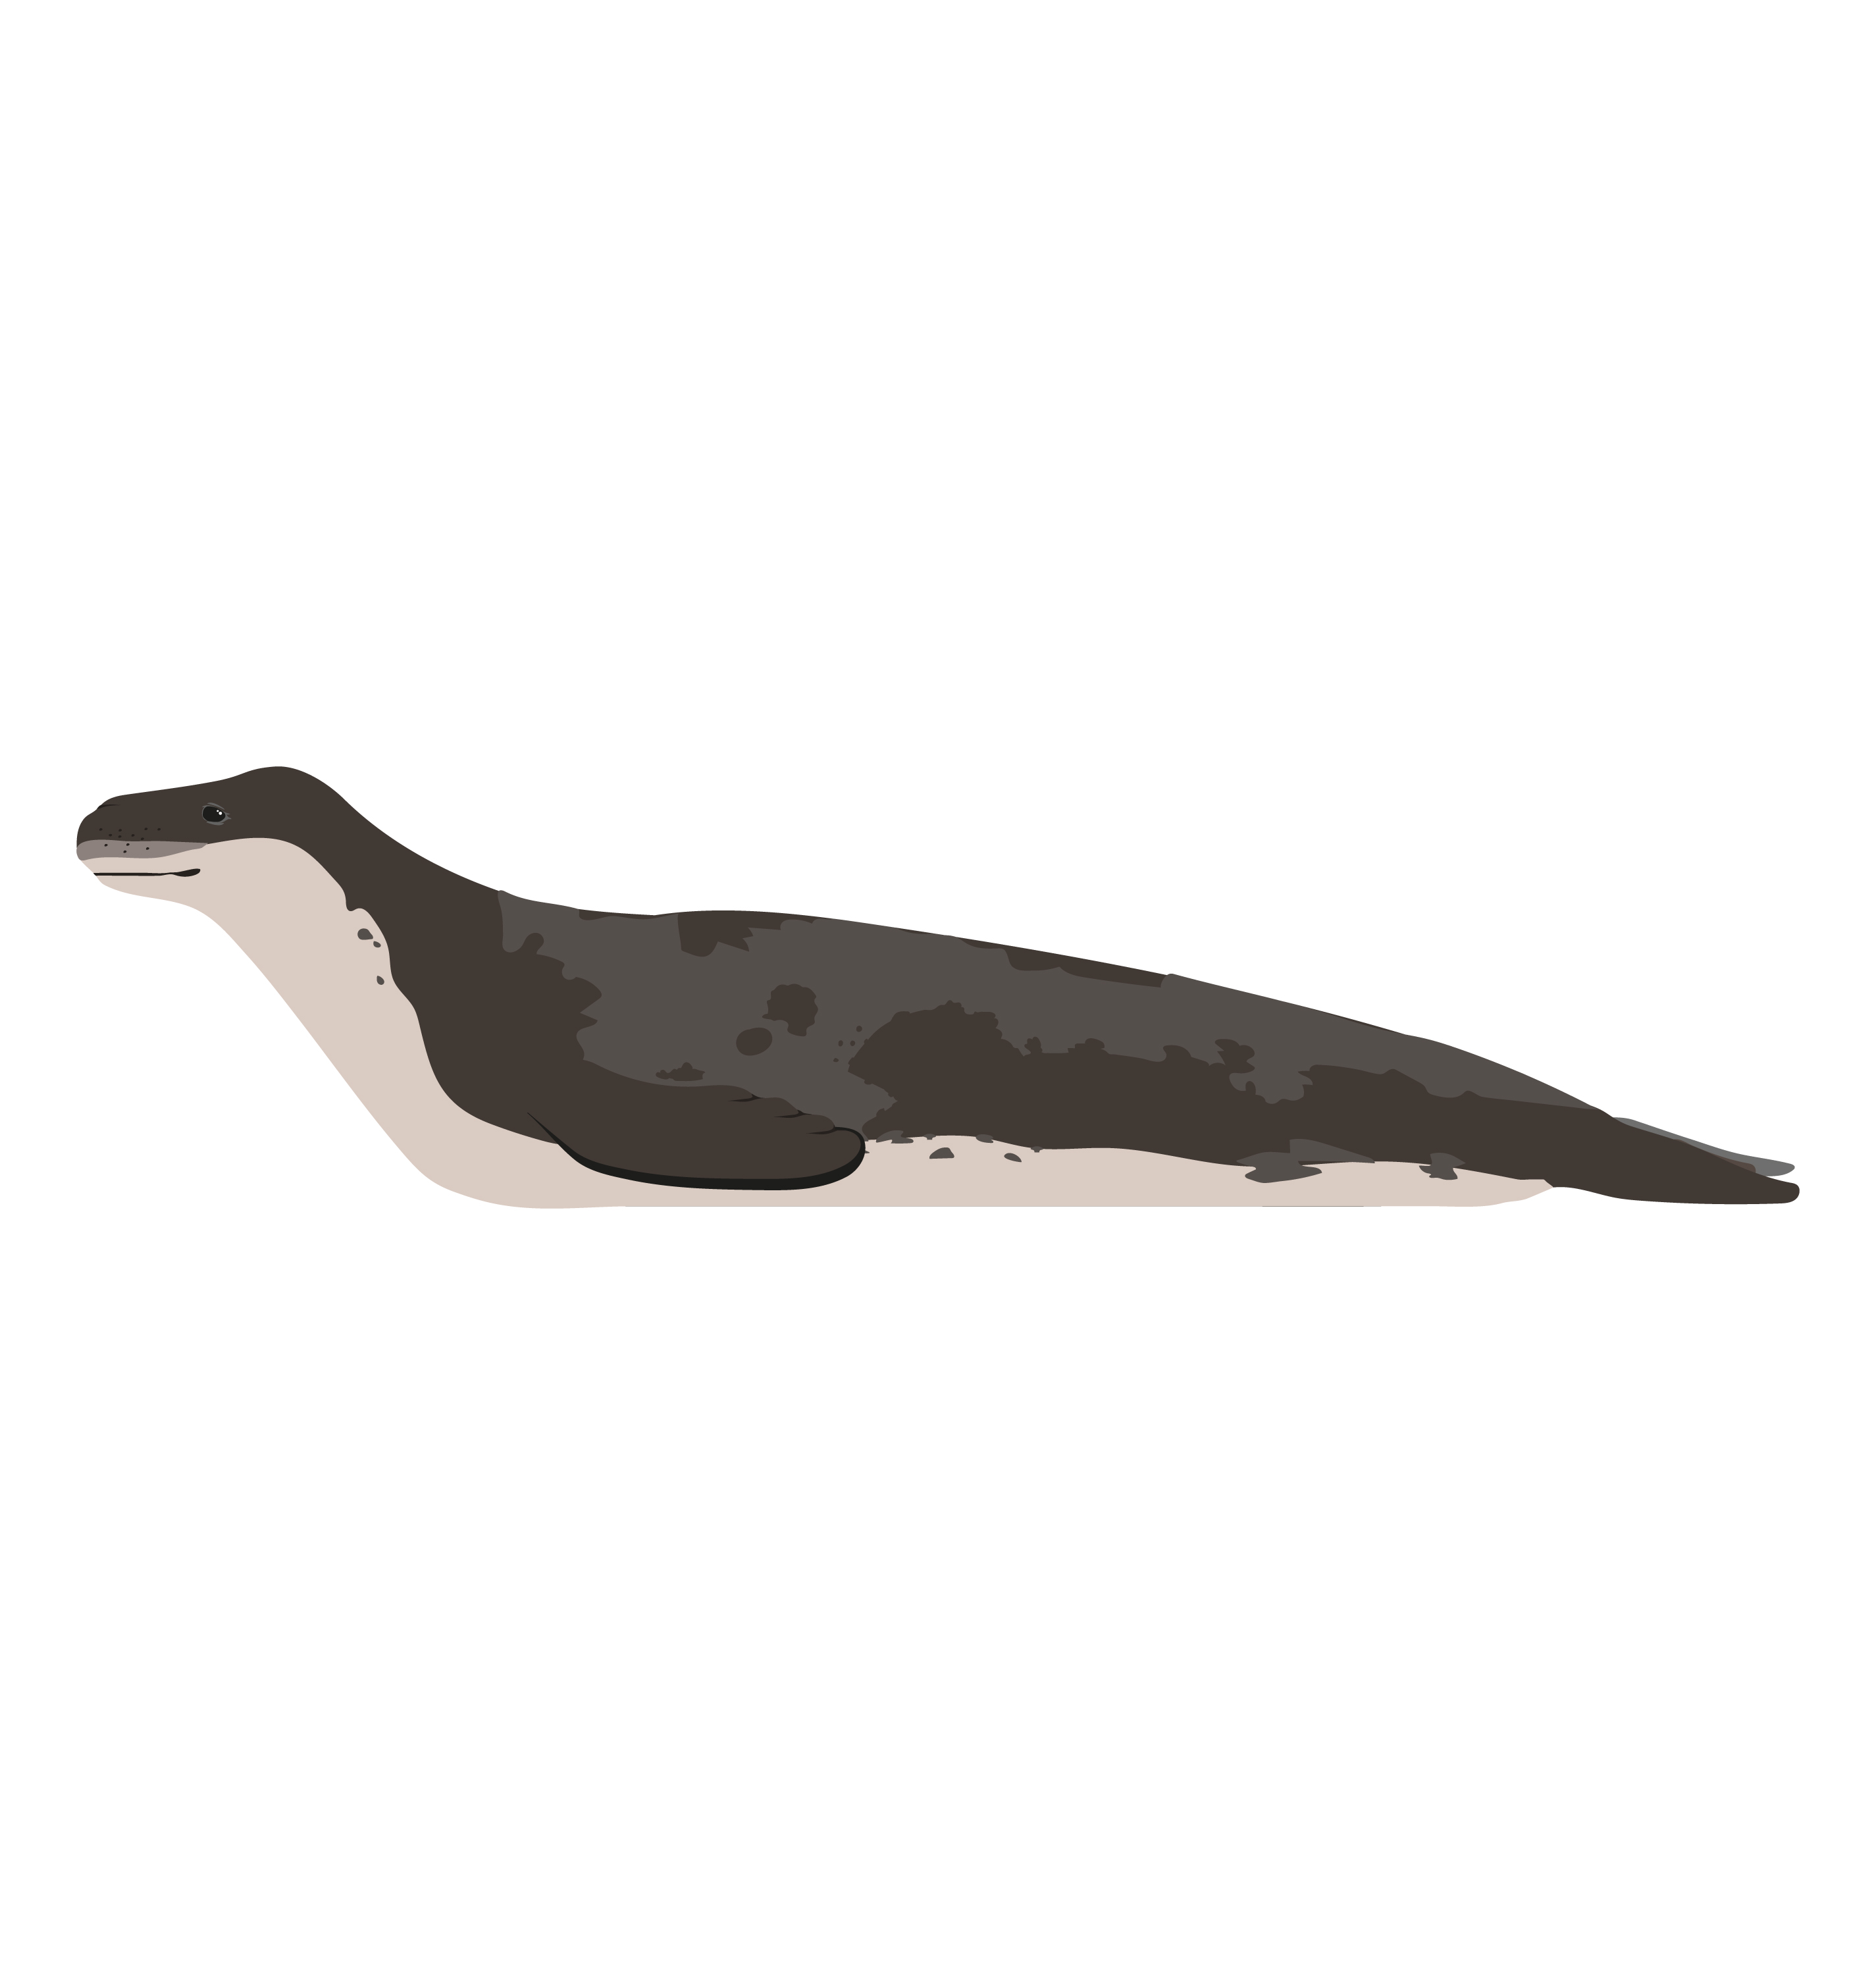
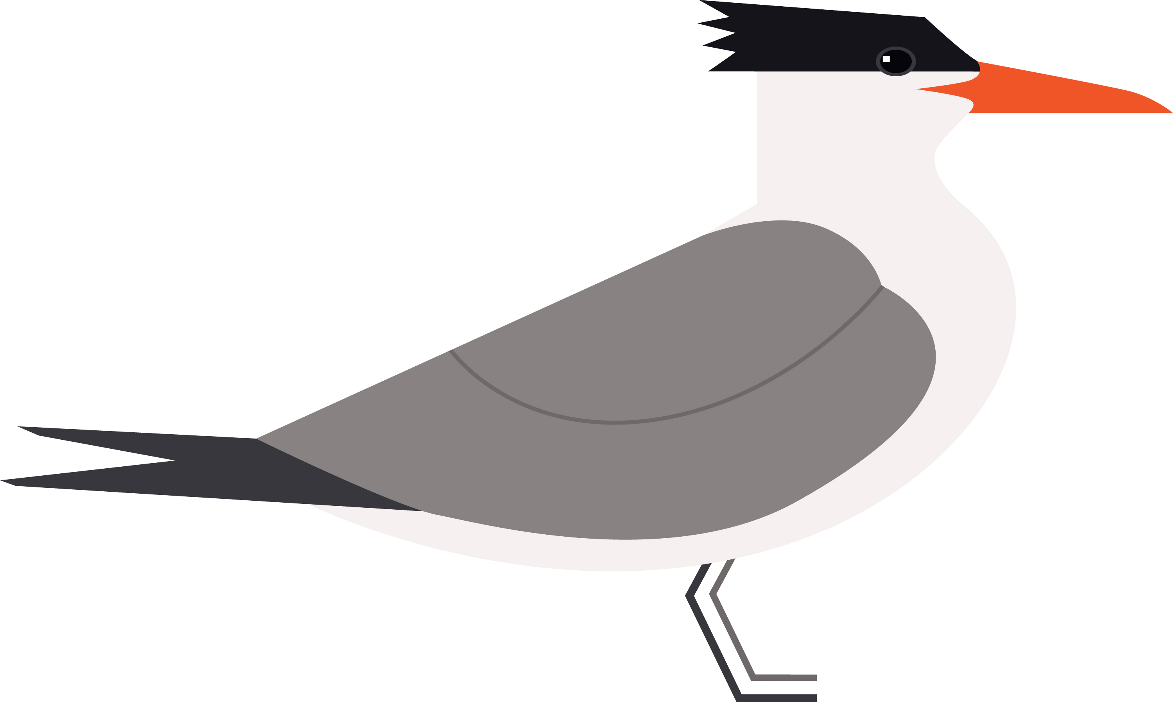
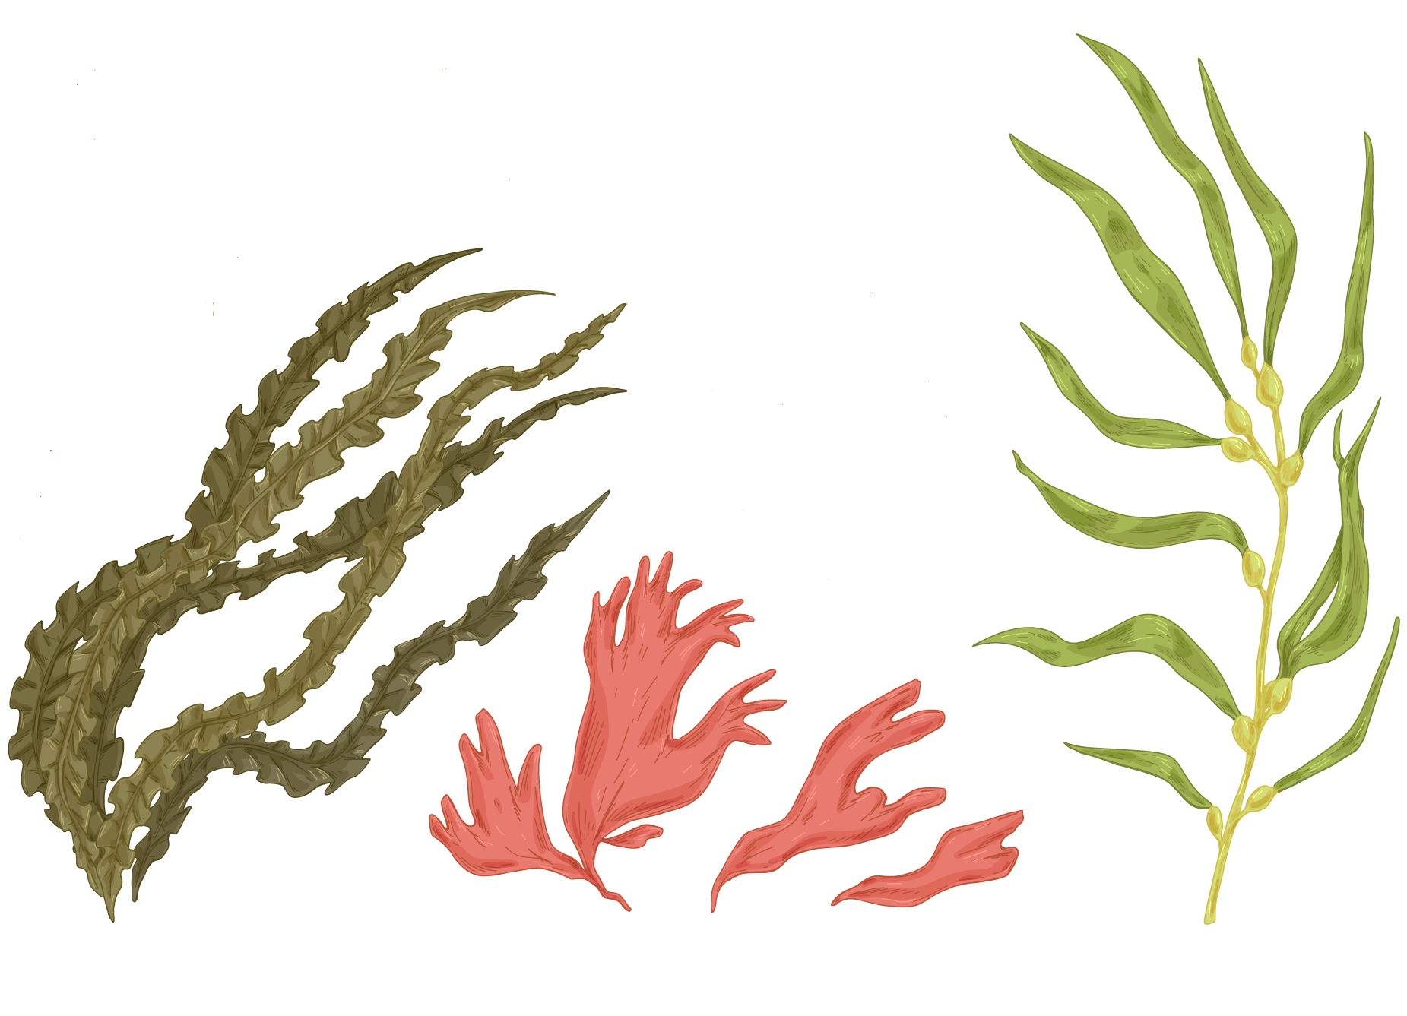
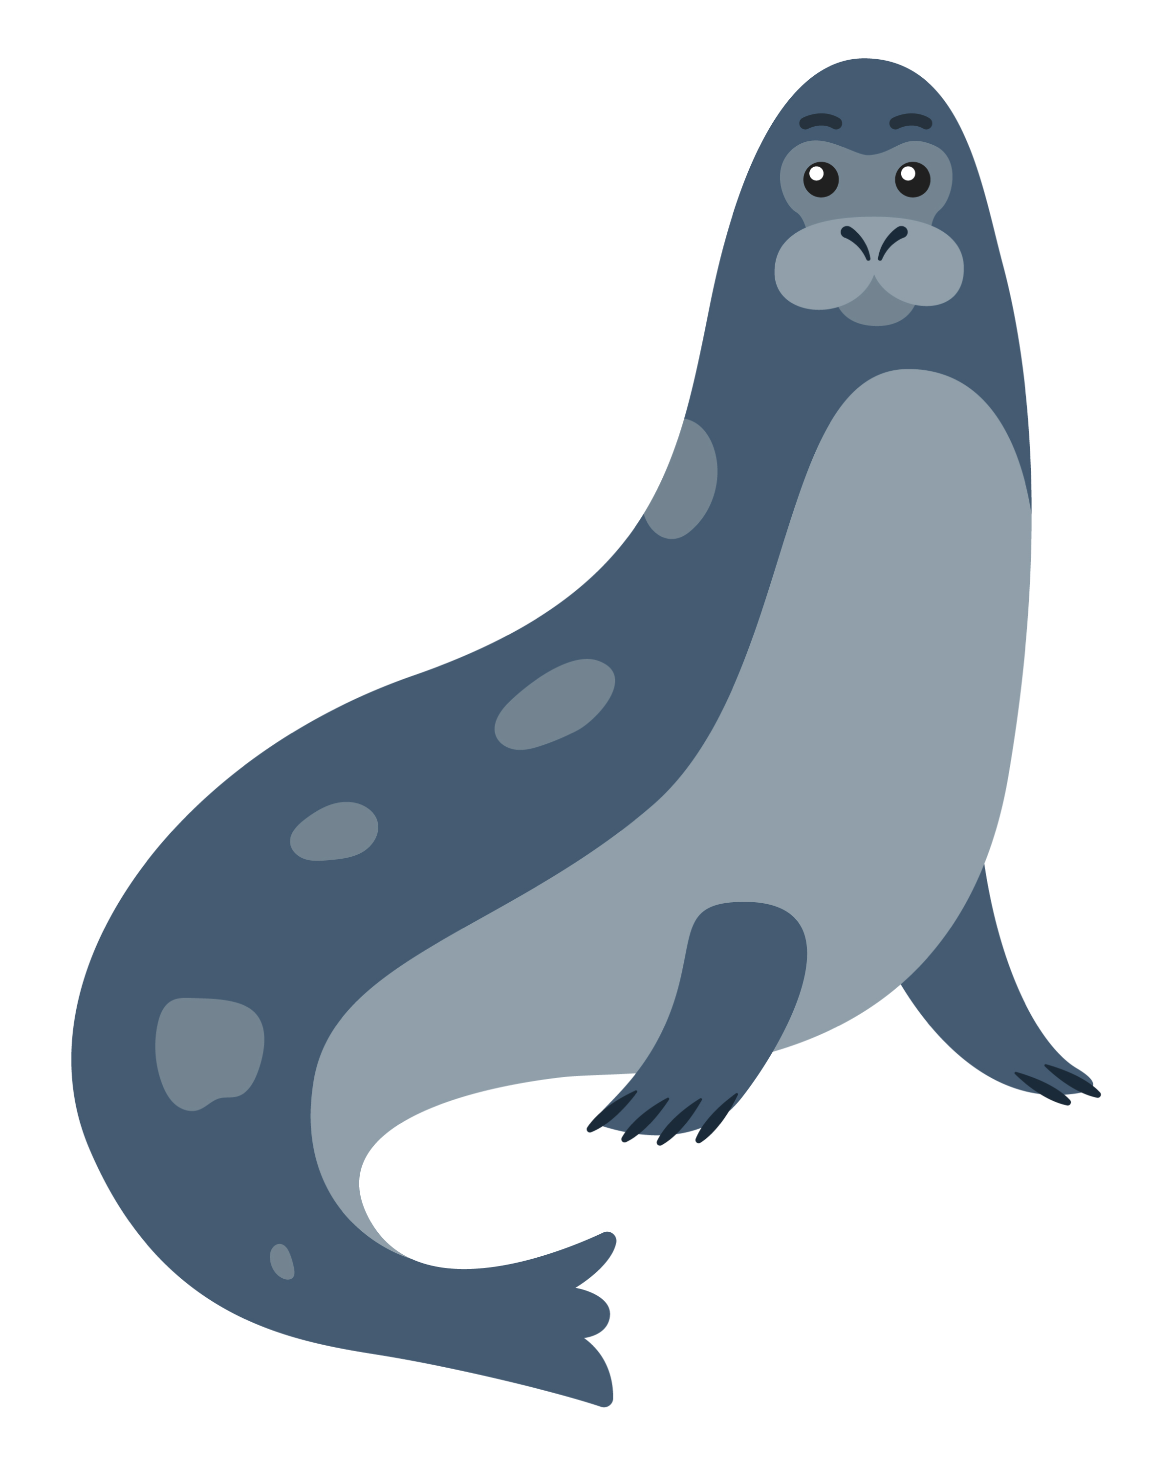

Phytoplankton Arctic Tern Harp seal
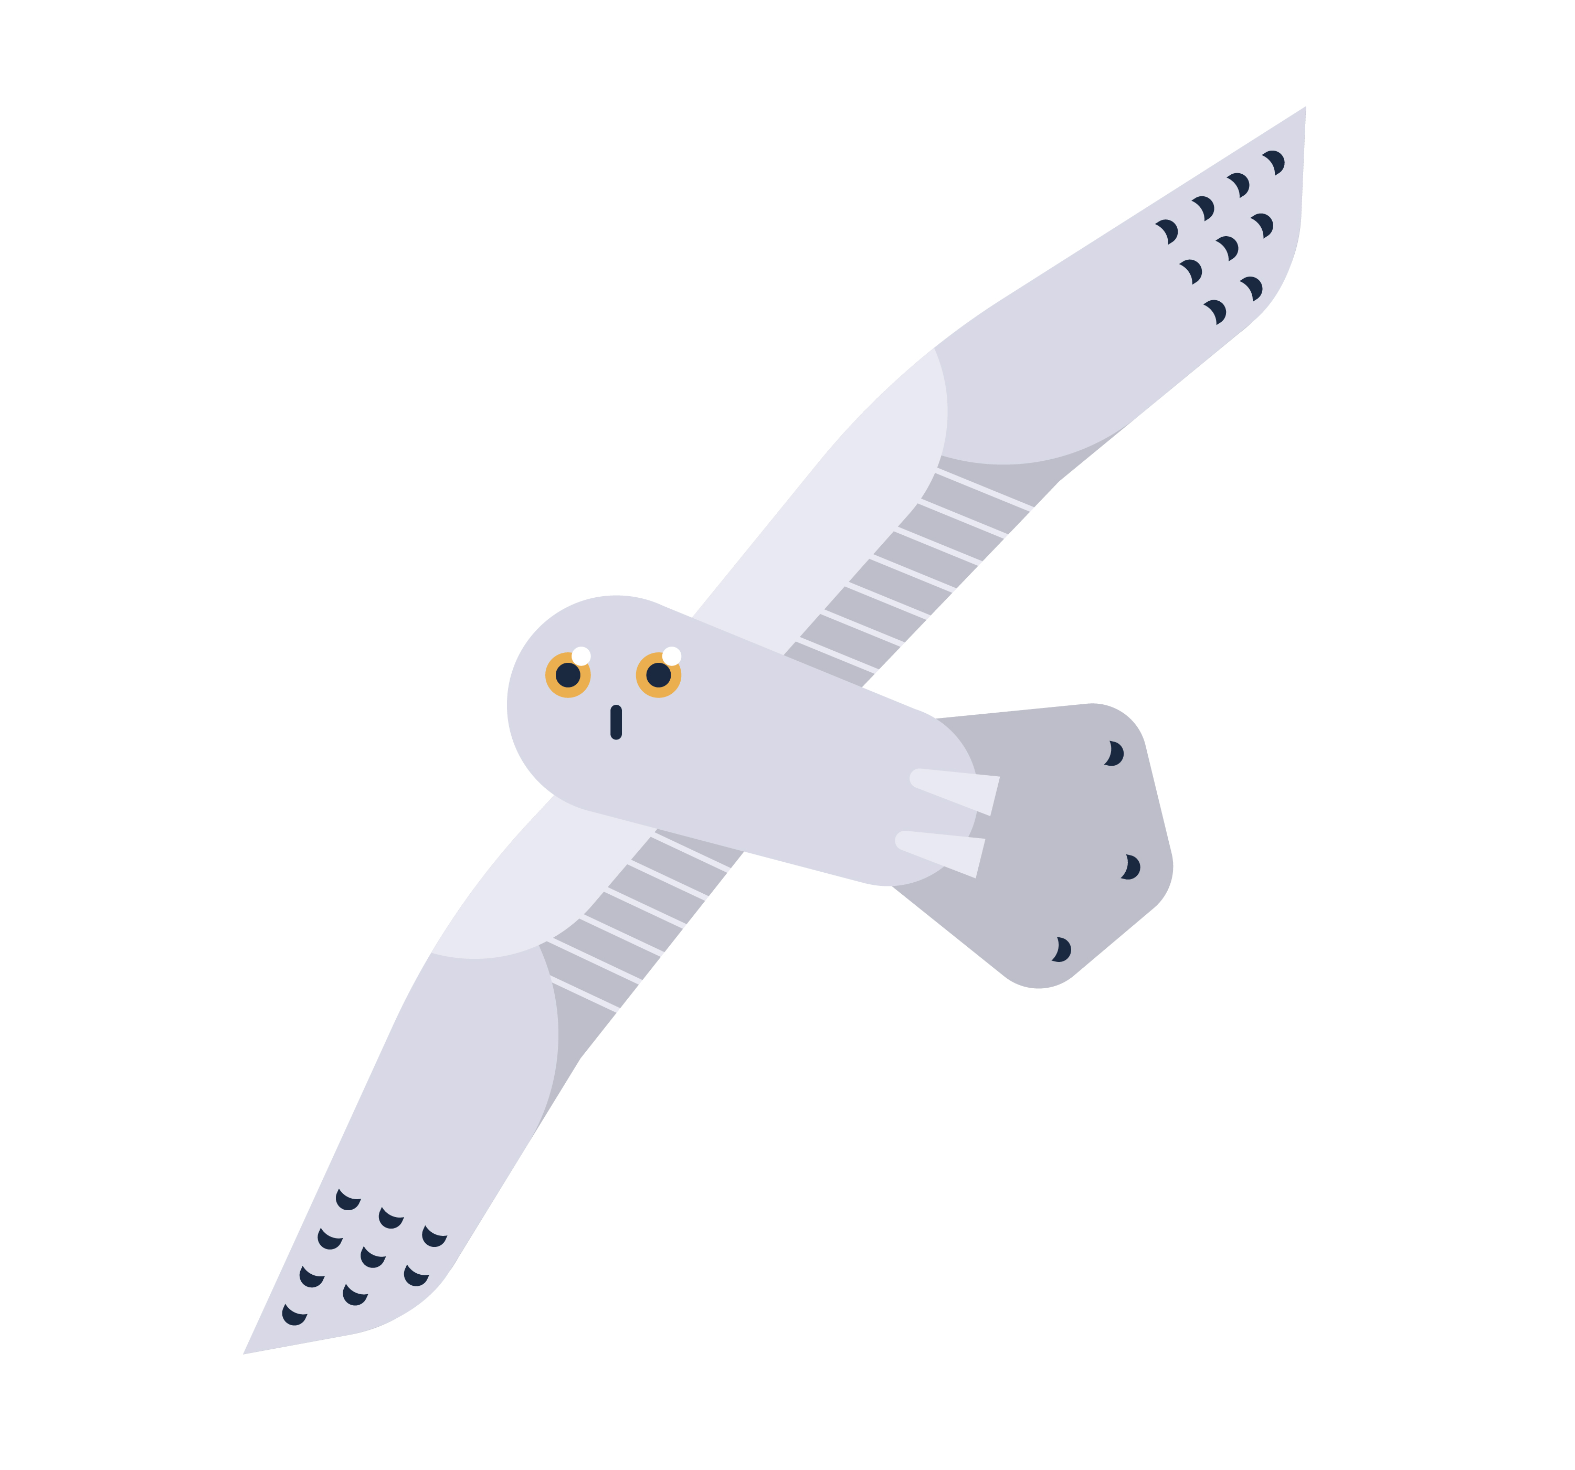

Arctic owl Leopard seal Algae
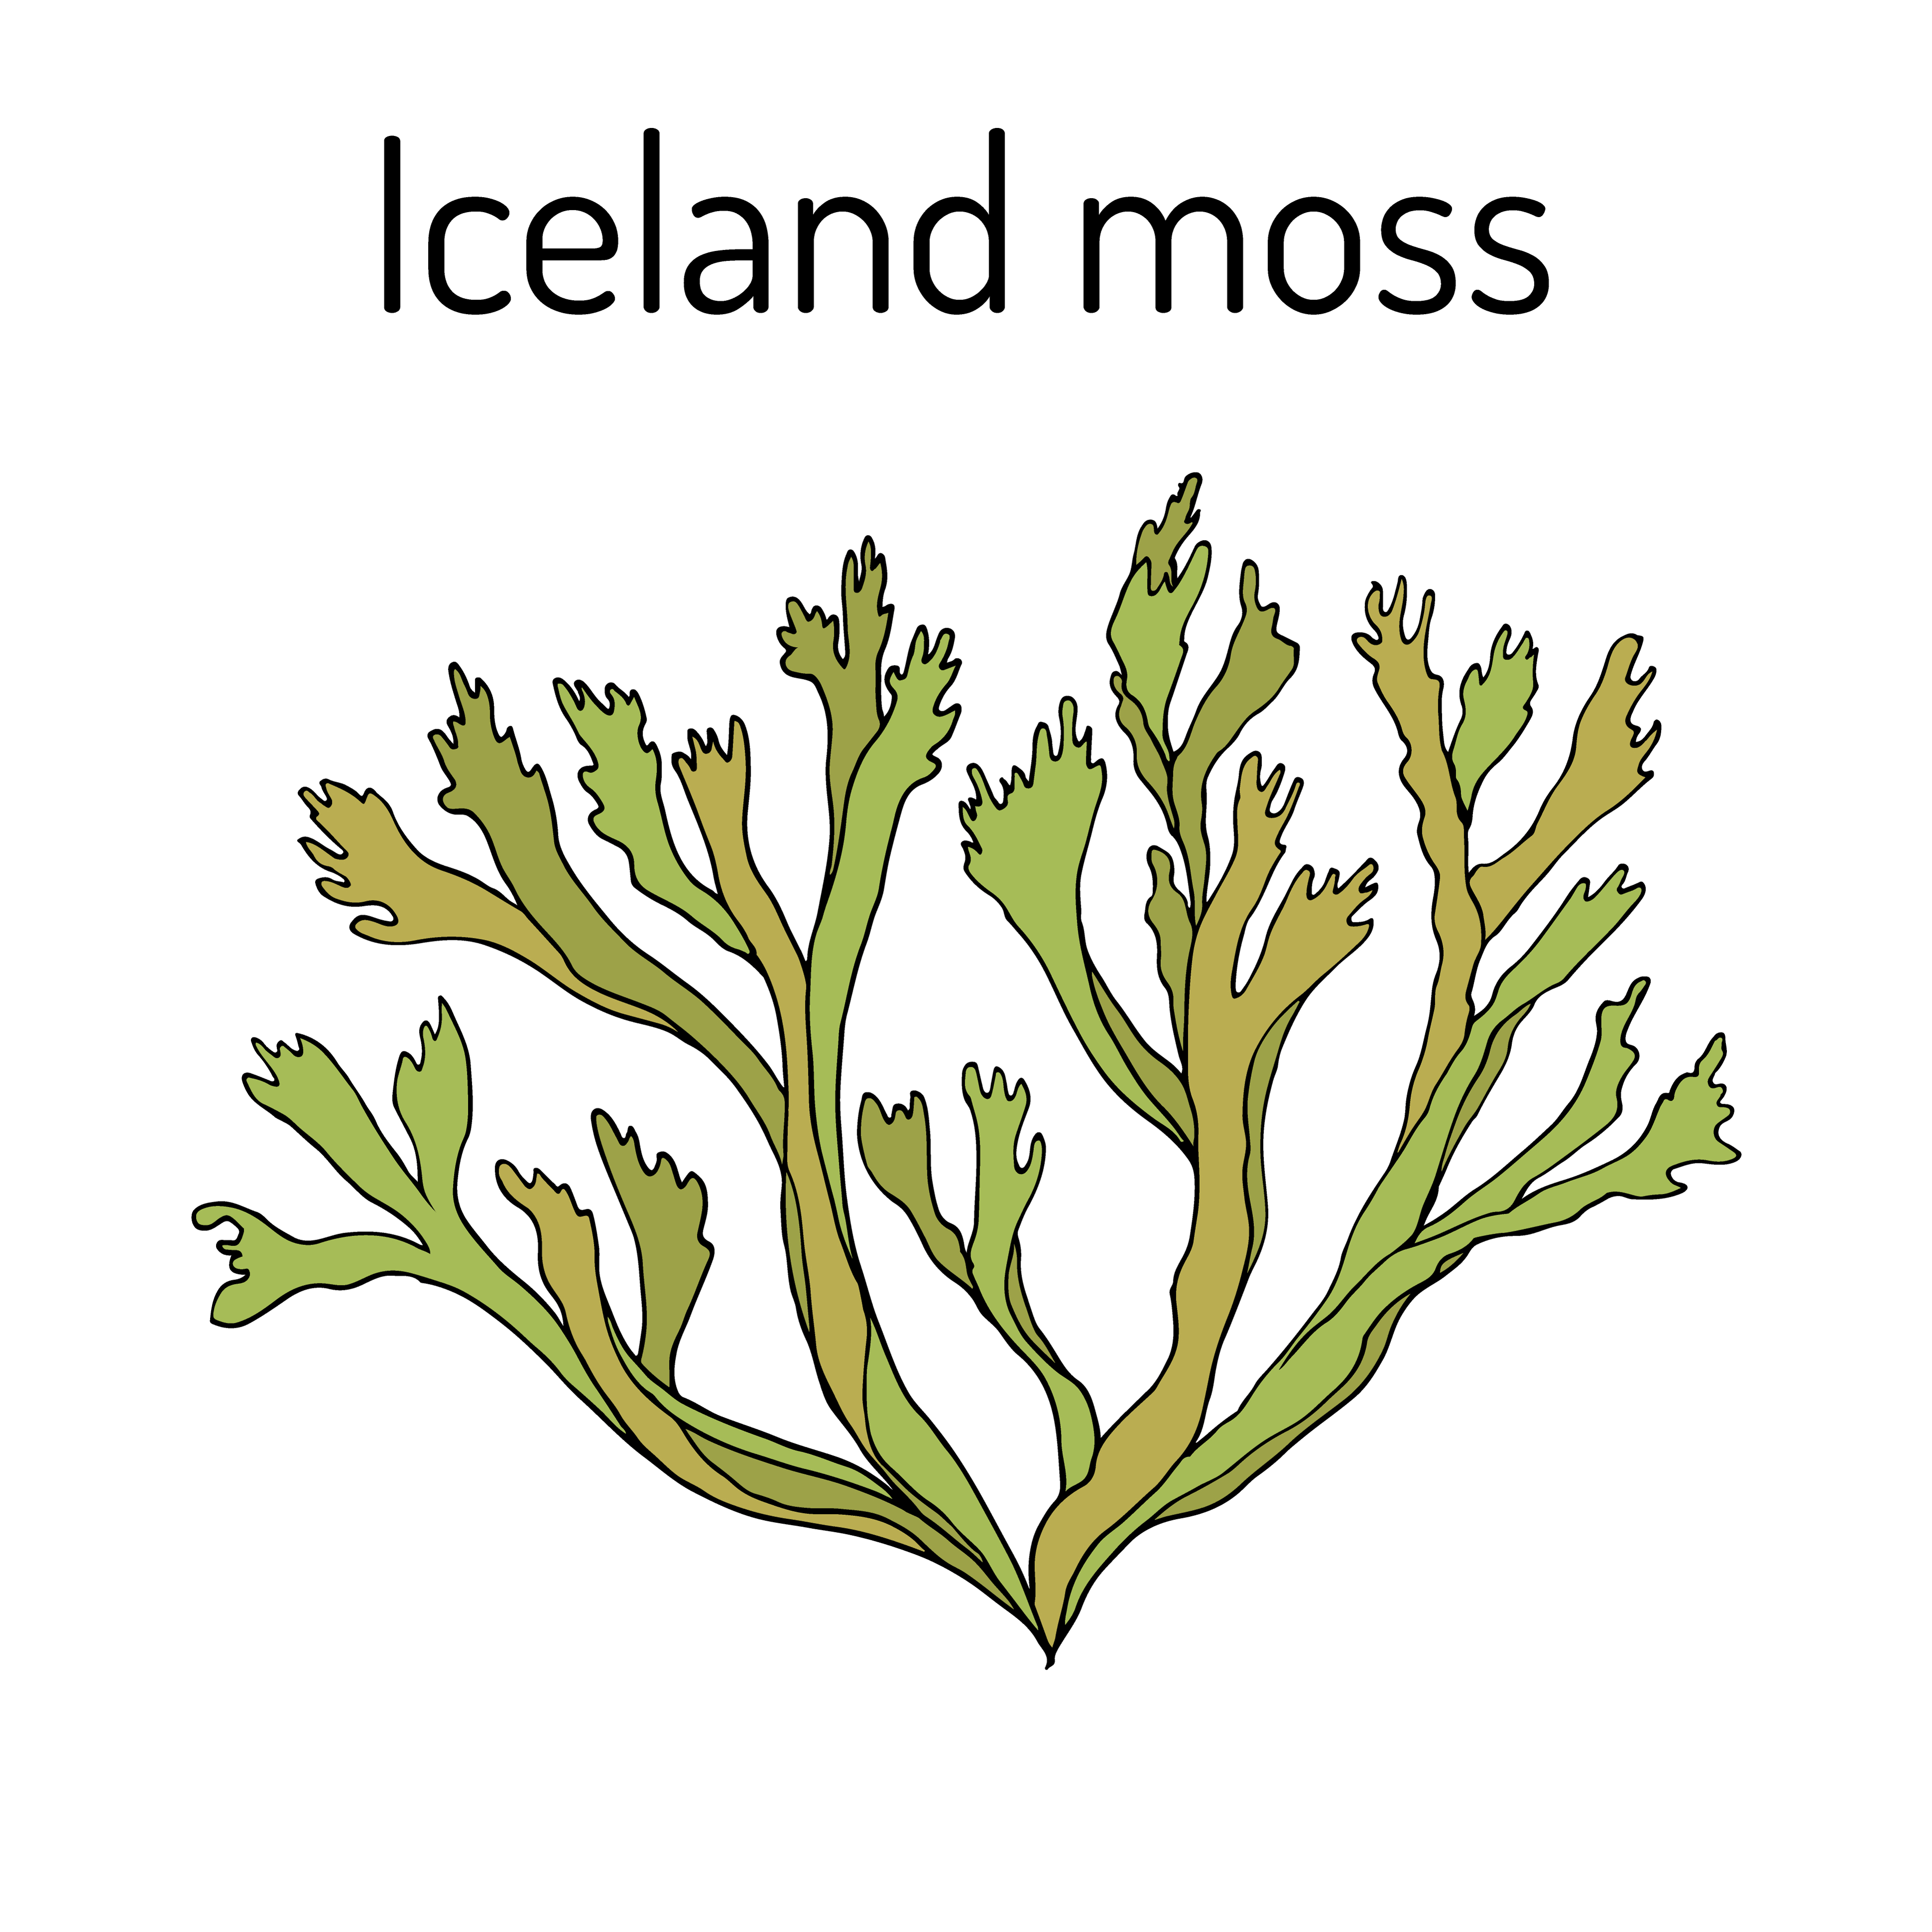

Killer whale Lichen

What might the effects of Arctic climate change be?
There are several knock-on effects from climate change in the Arctic. As permafrost continues to thaw there will be reduced albedo, increased erosion rates around estuaries and at the coast — as shown in the image below, and an increase in methane and carbon emissions.

The Arctic is very important in the fight against climate change because as more sea ice melts there is less and less reflection of incoming solar radiation, due to a reduction in the white polar landscape. This continues to push up temperatures, amplifying the whole process…indefinitely.

Further information
- BBC Teach Science key stage 2 and key stage 3 food chains and food webs in animals

- Cool Australia Arctic food web and climate change

- Frontiers The Bottom of the Arctic’s Food Web Is of Top Importance

- WWF Arctic Science 2a & 2b Arctic food chain

- ZSL Whipsnade Zoo Ecosystems and food webs, Use the example of the Arctic tundra

Thank you to Dr Caroline Coch, Polar specialist at WWF-UK, for helping with the production of this resource

