Analysis of entries and attainment in GCSE geography

Report for the Royal Geographical Society (with IBG)

Philip Nye

Dave Thomson

October 2019

Contents

1. Introduction 2
Acknowledgments 2
2. Summary 2
3. Pupil characteristics 2
3.1 Gender 2
3.2 Disadvantage 3
3.3 Ethnicity 3
3.4 Prior attainment 3
4. School characteristics 4
4.1 Region 4
4.2 Area type, Coastal, Opportunity area 4
4.3 School free school meals quintile 4
4.4 Admissions policy, Governance 5
4.5 Inspection rating 5

1. Introduction

This report presents output from a project completed for the Royal Geographical Society analysing entries into, and attainment in, GCSE geography for the period 2009/10-2017/18. Analysis has been completed for a range of pupil and school characteristics, building a detailed picture of participation in geography at Key Stage 4 over this time period.

A separate document is available which describes the methodology followed and definitions used.

Acknowledgments
This publication includes analysis of the Department for Education National Pupil Database. Inferences or conclusions derived from the NPD in this publication are the responsibility of FFT Education Datalab and not the Department for Education.

Navigation

Titles used in sections 3 and 4 of this report correspond to worksheets in the Excel document provided showing all of the results of this project. This workbook also includes charts showing trends in entries and attainment for each of the student and establishment characteristics looked at. Sections 3 and 4 of this report are best read as an accompaniment to these charts.

2. Summary

At a national level, entries into geography GCSE have increased strongly since 2010 – from roughly 169,000 in 2010 to 239,000 in 2018, at a time when the age 16 population decreased.

Entries received a boost from 2016 onwards with the introduction of the Progress 8 accountability measure, with geography counting in the three slots reserved for English Baccalaureate subjects.

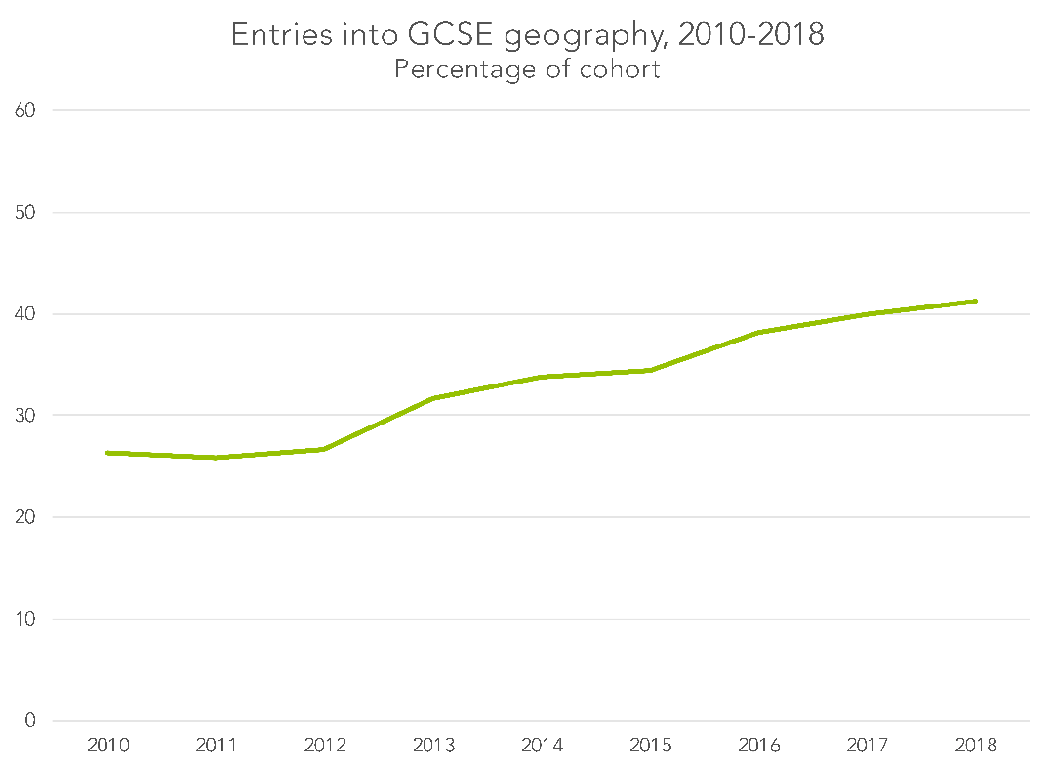

This increase in entries came predominantly from groups who had been less likely to take geography GCSE previously – notably, disadvantaged pupils and those with lower prior attainment.

Increasing entries in the state sector more than offset declining entries in the independent sector between 2010 and 2017. GCSE entries in the independent sector recovered slightly in 2018, which may be explained by independent schools returning to the reformed, 9-1 GCSE, after having moved over to international GCSEs.

Attainment in geography GCSE fell as the range of pupils entering the qualification increased – visible at both the 9-7 (formerly A*-A) and 9-4 (formerly A*-C) attainment levels.

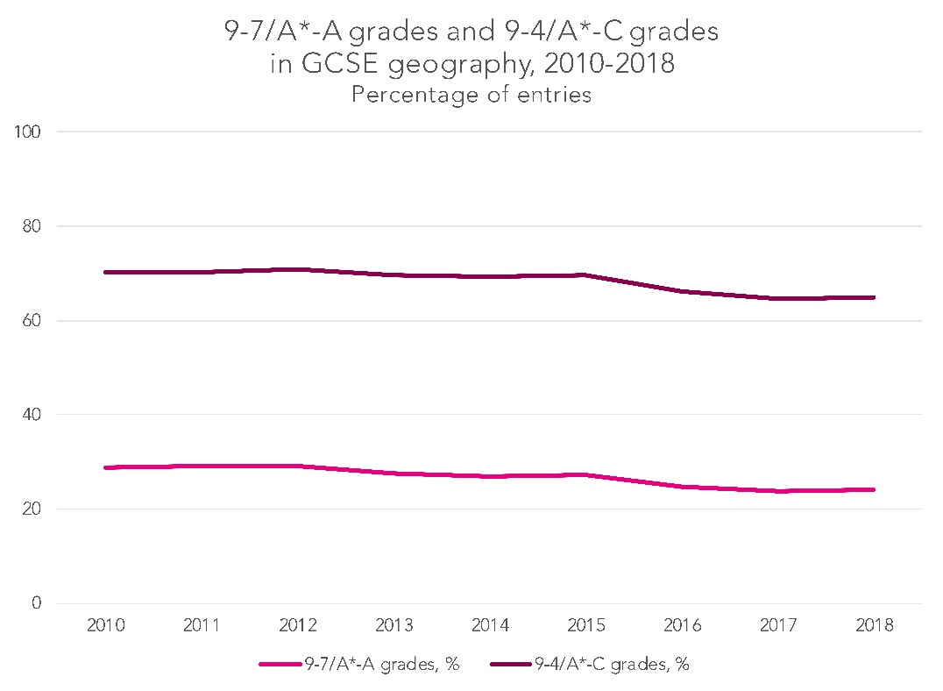

Attainment in geography GCSE is strongly associated with factors such as disadvantage status, prior attainment, school admissions policy and school inspection rating – with gaps in many cases increasing with the growth in uptake of geography at Key Stage 4.

Looked at regionally, there is now greater stratification in grades awarded in geography GCSE than was the case in 2010, with London, the south east, the south west and the east of England now showing performance consistently above that of other regions.

3. Pupil characteristics

3.1 Gender
A gender gap in geography GCSE entries has existed – and remained reasonably stable – over the period looked at. In 2018, 43% of boys and 39.4% of girls took geography GCSE.
The gap is reversed when considering attainment, though. When looking at the grade 4/C or above threshold, the gap of 6.6 percentage points in girls’ favour in 2018 is almost identical to that seen in 2010 – though the gap has been some way larger in all intervening years.
At the grade 7/A or above threshold, a gap of 6.7 percentage points in girls’ favour existed between the sexes in 2018 – lower than the gap of 8.7 percentage points present in 2010, and some way lower than that seen in all intervening years.
To some extent, this apparent narrowing of the gap at the grade 7/A threshold may simply be explained by the fact that these are threshold measures, however. Threshold measures are always susceptible to apparent closings of the gap – as there tend to be more pupils who start off just below the threshold in the group with lower performance (boys, in this case).
Looking at the trend in average point scores – where the gap of 0.46 of a grade in 2018 matches that seen in 2010 – perhaps suggests the gender gap that existed in 2018 is fairly similar to that observed in 2010 across the ability range, but lower than that seen in all of the intervening years.

3.2 Disadvantage

GCSE geography entries are lower for disadvantaged pupils (those who have not been eligible for free school meals at any point in the last six years) than for non-disadvantaged pupils. This gap has narrowed, however – from a high of 14.4 percentage points in 2013 and 2015, to 11.1 percentage points in 2018.
This narrowing has happened from 2016 onwards – when the introduction of the Progress 8 performance measure gave schools a strong incentive to enter pupils for English Baccalaureate subjects.
Entries from those for whom no disadvantage information is available (who will almost exclusively be in the independent sector) have fallen for much of the period looked at, before reversing this trend a little in 2018 – something that may be explained by independent schools returning to the GCSE from unregulated international GCSEs, with the introduction of the reformed, 9-1 GCSE.
Disadvantage gaps in attainment at both the grade 7/A or above and the grade 4/C or above thresholds had narrowed to some extent in the years up to 2015, but have subsequently widened as more disadvantaged pupils have taken geography GCSE, standing at 34.6 and 27.3 percentage points respectively in 2018.

3.3 Ethnicity

Analysed by ethnicity, there are some clear differences in entries and attainment.
Those of Chinese ethnicity have the highest entry rate into geography GCSE – most likely reflecting that this is a high attaining group, who are more likely to be (and always have been) taking academic subjects such as those which count in the English Baccalaureate.
With the exception of the Chinese group and the group for whom ethnicity data is not available (who will almost exclusively be in the independent sector), the only group with notably different levels of attainment to other groups is the black/black British group. Again, this reflects a picture that exists in other subjects, and is in part explained by higher levels of disadvantage for black/black British pupils.

3.4 Prior attainment

Prior attainment is a strong predictor both of pupils’ likelihood of studying geography at GCSE and their subsequent attainment.

The percentage of pupils with Key Stage 2 attainment below Level 4 stood at 12.2% entry rate in 2010. This had been increasing up to 2015 – but then was boosted considerably with the introduction of Progress 8. A similar, though slightly less dramatic, trend is also true of those with prior attainment at Level 4.

The breakdown of GCSE geography attainment by prior attainment is as would perhaps be expected, with the most notable feature being the fact that, despite a considerable increase in the number of pupils taking the qualification, results for the group with prior attainment below Level 4 ended the period looked at higher than they began it. Average point scores for this group of 2.26 and 2.23 in 2017 and 2018 respectively were the highest seen in the period from 2010.

Entry and attainment figures are not as high for the group for whom characteristic data is not available as is the case with other pupil characteristics being looked at, owing to the fact that those without prior attainment figures are a combination of those in independent schools and those newly arrived in England since Year 6.

4. School characteristics

4.1 Region
Entry rates have equalised a little when broken down by region, with the overall growth in entries post-2015 at least one factor in this.
When attainment is considered, the most notable trend is the separation of the regions into two distinct groups, with London, the south east, the south west and the east of England having attainment at least some way above that of all other regions in the years from 2016 onwards.
In the case of the south east, the south west and the east of England, these were regions that started with higher levels of entry in 2010 – so there may have been less of an increase in the number of lower attaining students in these regions post-2015 than has been the case in other regions. This is not true of London – but the high level of Key Stage 4 attainment overall for the capital over the last decade and more is by now a well-documented phenomenon.

4.2 Area type, Coastal, Opportunity area

Broken down by these different measures of geography, a number of patterns in entries and attainment stand out.
The proportion of GCSE entries in coastal areas has effectively matched that for non-coastal areas from 2016 onwards, closing a small gap that had been present since at least 2010. (It is worth noting that while coastal areas are worthy of attention, with low attainment known to be an issue in some coastal communities, there are also a large number of coastal communities in which this is not the case.)
The effect of the expansion of geography GCSE post-2015 is seen most starkly in the analysis by opportunity area – areas identified by the Department for Education in which social mobility is particularly poor. While attainment started below that for non-opportunity area parts of the country, these attainment gaps have particularly increased since 2015 for all three of the measures looked at – attainment at the grade 7/A or above threshold, attainment at the grade 4/C or above threshold and average point score.

4.3 School free school meals quintile

In the period since 2010, GCSE geography entry rates have increased for schools in all quintiles when analysed by free school meals eligibility rates, but the increase post-2015 is most noticeable for schools with the highest free school meals rates (Q4 and Q5). This reflects the observation made above about entry rates for disadvantaged pupils since this point.
(Those establishments with no free school meals classification consist mostly independent schools – with the same trend observable as when looking at entry rates by admissions policy).
Attainment rates follow what are very predictable patterns, with one of the notable features being the size of the gap between the schools with the fewest pupils eligible for free school meals (Q1) and the next group (Q2). Also notable is the drop off in attainment from 2016 onwards in the quintiles representing schools with the highest proportion of pupils eligible for free school meals. This is where there has been the biggest expansion in geography entries, suggesting that in these schools it is likely to be lower attaining pupils who are now newly sitting GCSE geography.

4.4 Admissions policy, Governance

Analysed by admissions policy, entry rates for all elements of the state sector have increased since 2010 – with the greatest increase post-2015 in comprehensives and secondary moderns, where there was the greatest scope for increase. (An entry rate of 50% or above in grammar schools perhaps suggests that almost all students in grammar schools take one of the humanities.)
The entry rate for independent schools had been decline since 2010, but increased again in 2018 – the likely explanation being a switch to GCSEs, after years of increasing international GCSE entries.
Attainment patterns show grammar schools and independent schools achieving much higher results than secondary moderns and comprehensives, as would be expected given the high prior attainment of their intakes.
When looked at by governance rather than admissions policy, declining attainment levels are a feature generally. Attainment appears to have held up relatively well for community schools – but it needs to be borne in mind that the community schools with the lowest Key Stage 4 performance will in many cases have converted to sponsored academy status over the period looked at.

4.5 Inspection rating

Entry patterns and attainment analysed by inspection rating show a very similar picture to that when analysed by schools FSM quintile – not surprising in itself, given the relationship between disadvantage rates and inspection ratings.

Schools with outstanding Ofsted ratings have the highest geography GCSE entry rates – albeit by a smaller margin than has been the case until recently. The gap in attainment is large – 32.5 percentage points between a school rated outstanding and one rated inadequate at the grade 4/C or above threshold in 2018 – and has increased over the period looked at.

Qualifications included in this analysis are full course GCSEs and regulated international GCSEs. More detail on this is provided in the methodology document.
Throughout this report, years refer to year in which the academic year finished – that is, 2010 refers to 2009/10, for example.
See a note on the definition of secondary moderns in the methodology document.

