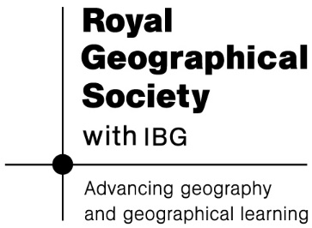
Trade in Oman – card sort
1. Cut out all the boxes.
2. Sort the information into the following categories:
People – everything to do with how the people made trade easier in Oman.
Place – how the location made trade easy in Oman.
Products – what did Oman have that other people wanted?

Traders from Oman carried frankincense to Egypt and other places thousands of years ago. | By the 9th century, Omani sailors were travelling as far as China. They traded goods like silk, ceramics, and ivory.
Ships could stop in Oman to rest and get supplies like food and water. This made it a popular place for sailors and traders. | The region of Sohar in northern Oman has archaeological evidence of products from China making it an important part of the Eastern-Western trading route.
Oman was also part of the Silk Routes. | Oman’s southern region, Dhofar, was famous for producing frankincense, a special tree sap used in perfumes and mummification in Ancient Egypt, and religious ceremonies.
The Chinese port of Quanzhou was a popular destination, and Omani merchants brought back Chinese treasures to sell in Oman. | Oman has a long coastline with many inlets from the mouths of rivers (Wadis) where boats could safely stop.
Oman served as a crossroad between Africa, South-East Asia and the Middle East due to its connections at sea and over land. | The people of Oman built strong ships using wood they brought from India.
Omani sailors also travelled to East Africa, bringing goods from Asia and setting up communities. | Oman is on the eastern Arabian peninsular with direct access to the Indian ocean via the Arabian Sea.


Produced for, and in association with

