Wildfire: impacts and adaptation

Adaptation?

Increase burn area impact

Heat

Aridity and drought impact
Adaptation?
Adaptation?

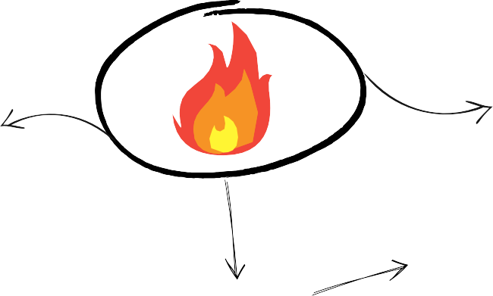
Non-forested areas impact

Adaptation?

Fuel

Anthropogenic causes

Natural factors
Inter-decadal climate cycles impact

Vegetation aridity impact

Ignition

Non-climatic factors
Deforestation impact

Unnatural fuel accumulation from fire suppression impact

Adaptation?

Adaptation?

Urban areas and roads impact

Adaptation?
Peat draining impact

Adaptation?

Agricultural expansion or abandonment impact

Adaptation?

Source: the IPCC WGII report on Climate Change 2022 Impacts, Adaptation and Vulnerability

