Arctic challenges

GCSE specification links

AQA
3.1.1.4 Climate Change. Climate change is the result of natural and human factors and has a range of effects.
3.1.2.4 Cold environments (polar and tundra) have a range of distinctive characteristics.

Edexcel A
3.2 The biosphere is a vital system.

Edexcel B
1.3 Global climate is now changing as a result of human activity, and there is uncertainty about future climates.

OCR
4.3a What is it like in Antarctica and the Arctic?

WJEC and Eduqas
5.3.2 What are the key processes of ecosystems at different scales?
5.4.1 How do people use ecosystems and environments?
5.4.2 How do human activities modify processes and interactions within ecosystems?
5.4.3 How can ecosystems be managed sustainably?

Key terminology
- Food security – reliable access to affordable, nutritious food.
- Paradox – a contradictory idea or proposition.
- Epicentre – the central point of something.
- Invasive species – an organism not native to the area.
- GDP – Gross Domestic Product: monetary value of goods and services in a country.
- Circumpolar – around one of the Earth’s poles or can be found within one of the Earth’s poles.

Arctic paradox
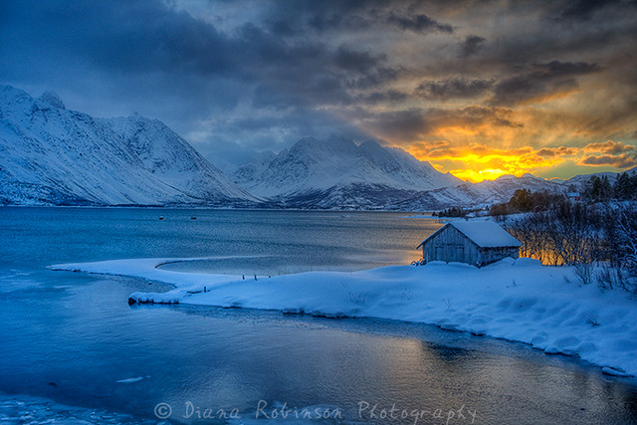

Figure 1. The Arctic sunrise near Ullsfjord in Norway © Diana Robinson

The Arctic is an area unlike any other in the world. Its natural beauty brings wonder to all who have the privilege to experience it. From steep mountain ridges, fjords, diverse wildlife to the extreme temperatures, midnight sun and unique vegetation the Arctic is truly a magical place.

However, amidst this captivating beauty lies a stark contrast, as it is also considered as the epicentre of climate change. The resources within its terrain contain the very ingredients that could continue to exacerbate the increase in temperatures threatening to change this wilderness forever.

In addition, the remoteness and strained political relationships between some of the Arctic nations makes decisions over how best to manage the area complex.

Consequently, the Arctic faces challenges not only from environmental shifts but also the intricate web of human intervention and governance to ensure it has a future.

Environmental challenges
The Arctic Council has now warned that the Arctic is warming three times faster than the rest of the planet. This not only has consequences for the Arctic but also has repercussions for the rest of the world.

The Arctic is home to over 21,000 species of specially adapted flora and fauna. With most areas inaccessible to all but a few humans, this ecosystem has developed with little direct interference from humans. This seclusion over many thousands of years has ensured that the regional ecology is highly adapted to the environment.

However, the rapid increase in temperature does not allow sufficient time for these species to adapt to new conditions. While the plight of some of the most famous Arctic residents is evident; most of us have seen media images of polar bears unable to hunt large distances due to ice loss, there are other species equally under threat in the Arctic. For example, as the climate warms, invasive species from more southern latitudes move into the Arctic environment changing the dynamics of the existing food chain. Species such as the red fox, moose and North American beaver all compete with native species for producers in the Arctic.

Furthermore, climate shifts have adversely affected native species who once thrived there. Increased precipitation in the form of rain and warmer seasons bring an abundance of black fly which decreases the success of breeding peregrine falcons. Reindeer numbers have been in decline since the 1990s. This trend, in addition to the unreliability of berry growth in the summer, has a detrimental effect on indigenous populations creating a concern over food security and the intake of vital vitamins for people.

Finally, the extensive loss of permafrost and extended ice-free seasons have encouraged mining activities in previously inaccessible areas. Some countries, for example the USA (in Alaska) and Canada, have increased extraction of minerals from the ground through mining activity. Not only does this permanently remove any vegetation for habitats but it also threatens wildlife through air pollution and potential toxins leeching into the water cycle, further threatening the ecological balance of the area.

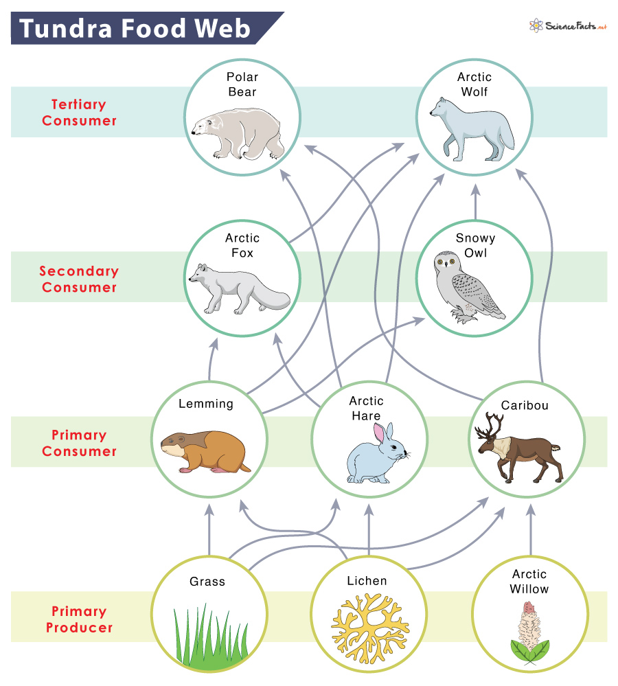

Figure 2. Simplified Tundra food web © sciencefacts.net

- Create a new food web to include one of the invasive species mentioned in the text above. What implications do you foresee happening?

Socioeconomic challenges
The potential wealth of resources in the Arctic provides opportunities for people, companies, and governments to increase economic activity. For example, with 240 species of fish including the Arctic Cod, the Arctic has always had a thriving fishing industry.

The table below shows the percentage of each Arctic nation’s GDP attributed to fishing as well as the percentage of the population directly employed in the industry.

Country | % GDP | % workforce
Kingdom of Denmark | 0.3 | 0.3
Greenland (part of Denmark) | 95 | 16
Iceland | 11 | 5
Russia | 0.3 | 0.8
Norway | 2.3 | 0.6
Sweden | 0.10 | 0.9
Canada | 21.1 | 0.2
USA | 1.1 | 1.2
Finland | 0.1 | 1.8

- Create a bar graph to represent the percentage of GDP and employment in the fishing industry for each of the Arctic nations.
- Analyse the graph to identify the importance of this industry to the economy.

Nevertheless, the increasing sea temperatures and overfishing threaten to reduce the quantity of fish available for commercial activity.

With the shrinking ice coverage, the Arctic has the potential to emerge as a treasure trove of natural resources (e.g. oil, gas, metals, etc.), providing new economic activity, jobs, and income. However, in addition to the environmental impact of such activity, it is essential to acknowledge the health implications of working and living alongside such industrial activity for local communities.

Political challenges
The Arctic polar region is no stranger to tensions arising between national states as well as their international partners. The establishment of the Arctic Council (1996) helped to create a sense of collaboration and unified activity not seen previously.

This newfound cooperation has declined following Russia’s invasion of Ukraine in February 2022. Tensions have increased in the area once again, highlighting the fragile stability of the Arctic environment. As accessibility within the Arctic improves, more countries want to stake a claim to its potential natural wealth, which will only increase the threat of future conflict.

Futures
The Arctic Council stands as a positive example of the way in which circumpolar nations can unite for the best interests of the Arctic. Yet, akin to regions like the Amazon, it is not just these countries who need to collaborate. It is the shared responsibility of all nations and industries to ensure that they are managing this precious, vital environment sustainably.

By looking at alternative energy sources, relying less on fossil fuels, monitoring our food sources, and reducing the demand for cheap imported goods, our global community can help conserve this environment for our future generations.

Further reading
- Geographical article, 2022 on the extraction of raw materials in the Arctic.
- Troubled waters by Discovering the Arctic
- WWF article on the Arctic under pressure
- Arctic Council’s report on terrestrial biodiversity

