Inorganic Nitrogen activity sheet 2

Specification links
AQA 3.1.6.2 Ecosystems and processes. Mineral nutrient cycling: Nature of terrestrial ecosystems and the inter-connections between climate, vegetation, soil, and topography which produce them. Ecosystem responses to changes in one or more of their components or environmental controls.

OCR Topic 3.4 – Future of Food. 1.b. Food is a precious resource and global food production can be viewed as an interconnected system: The physical conditions required for growing food including, air, climate, soil, and water.

Inorganic Nitrogen fertiliser
Nitrogen is an essential nutrient for plant growth, particularly for young plants that need to grow rapidly to establish themselves. Unfortunately, it is unavailable in its most prevalent form – atmospheric Nitrogen – however it can be manufactured and added to soil to increase fertility. Manufactured Nitrogen is called inorganic Nitrogen fertiliser.

Throughout the nineteenth and twentieth centuries world population increased exponentially from
1 billion in 1800 to 7.9 billion today. As early as 1898, British chemist Sir William Crookes recognised that farming was beginning to deplete the world’s stock of fixed Nitrogen – and that farmers were unable to replace it. Sir Crookes argued that chemists should determine how to feed the world’s growing population.

Figure 1 Inorganic Nitrogen fertiliser © VisualArtStudio Shutterstock

The Haber-Bosch process is a way to produce fertiliser on an industrial scale. Using ammonia as a basic building block, a German scientist called Fritz Haber first discovered the right conditions to make Nitrogen in 1909 whilst Carl Bosch, a German chemist and engineer, upscaled the process to an industrial scale. In 1913 the world’s first ammonia plant was opened, approximately producing 3,650 tonnes of ammonia per year. In 2021 ammonia production peaked at 276,140,000 and is expected to grow further still to 289,830,000 by 2030 according to Statista.

World use
Inorganic Nitrogen fertiliser has direct correlation with world population and has been called ‘one of the greatest inventions of the twentieth century’. It has underpinned an exponential increase in the amount of people on the planet – and has prevented mass starvation which Thomas Malthus in the C18, and Paul Ehrlich’s 1968 book The Population Bomb, previously warned was inevitable.

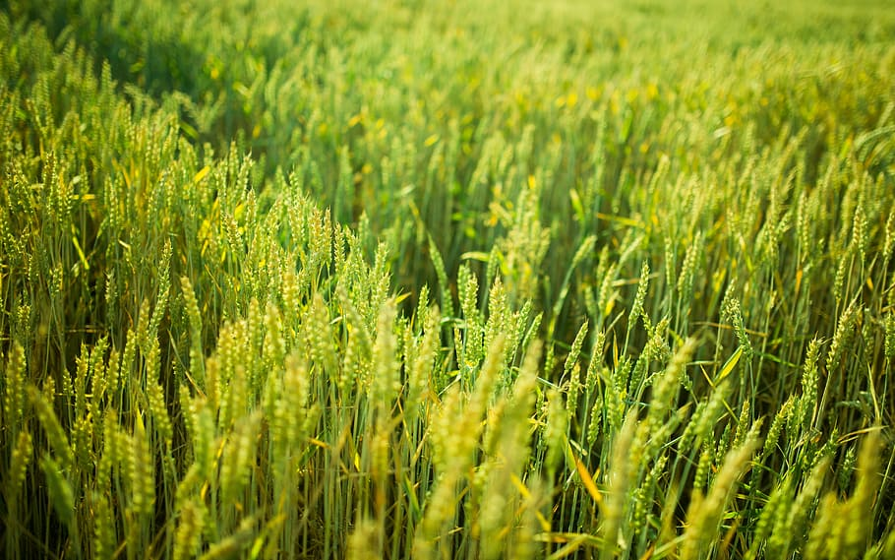
Figure 2 Nitrogen fertilizer now supports approximately half of the global population © Piqsels

As the world population is expected to continue to grow and peak around the middle of the twenty-first century maintaining healthy, productive soils is paramount. Below is a data table showing total world population and world population as fed by inorganic Nitrogen fertiliser.

Inorganic Nitrogen fertiliser has clearly been an essential part of world population growth because it has increased food availability. This synthetic Nitrogen has allowed crop yields to increase in arable farming. It has also enabled an increase in livestock numbers by increasing grain-feed and by being applied to grazing and forage grass, all of which supports more animals.

Inorganic Nitrogen is widely used across the world. In 2018, 117.5mt (million metric tonnes) were manufactured globally, with China being by far the largest producer. The US is the second largest with 13.6mt, followed by India 13.3mt. The top two producers are also the largest economies (measured by GDP). India is the world’s fifth largest economy.

According to the World Bank (in terms of application per hectare) Hong Kong SAR applied the most fertiliser of any country in 2018, using 3,573 kilograms per hectare of arable land. Malaysia was the second largest user with 2,106 kilograms per hectare, followed by Bahrain with 1,990.

Year | World population (bn) | Population supported without synthetic Nitrogen | Population fed by the Haber-Bosch process
1900 | 1.6 | 1,650,000,000 | 0
1910 | 1.7 | 1,741,250,000 | 8,750,000
1920 | 1.8 | n/a | n/a
1930 | 2.0 | 1,966,500,000 | 103,500,000
1940 | 2.3 | 2,139,000,000 | 161,000,000
1950 | 2.5 | 2,333,372,743 | 202,901,977
1960 | 3.0 | 2,638,894,898 | 394,317,628
1970 | 3.7 | 2,812,439,014 | 888,138,636
1980 | 4.4 | 3,120,888,074 | 1,337,523,460
1990 | 5.3 | 3,198,566,076 | 2,132,377,384
2000 | 6.1 | 3,441,203,914 | 2,703,803,075
2010 | 7.0 | 3,840,000,000 | 3,259,090,201
2015 | 7.3 | 3,839,164,586 | 3,543,844,234
Table 1 world population and the global population reliant on synthetic Nitrogenous fertilizers OWiD

UK farming
While the UK is not in the top 20 consumers of Nitrogen fertiliser worldwide, per hectare figures show that it is still widely used.

Just like world population growth, there is correlation between the rising UK population and the application rates of Nitrogen in kilograms per hectare. Inorganic Nitrogen fertiliser has been essential for the growing population of the UK throughout the twentieth and twenty-first centuries.

Year | UK population (m) | N all crops & grasses (kt N)
1965 | 54.3 | 565
1970 | 55.6 | 796
1975 | 56.2 | 984
1980 | 56.3 | 1268
1985 | 56.5 | 1580
1990 | 57.2 | 1582
1995 | 58.0 | 1348
2000 | 58.8 | 1268
2005 | 60.4 | 1061
2010 | 62.7 | 1016
2015 | 65.1 | 1049
2020e | 67.2 | 967
Table 2 Fertiliser usage from the British Survey of Fertiliser Practice page 48

A trial experiment into the impact of Nitrogen was carried out in 2021 by Omnia, a fertiliser and crop nutrition specialist. The project consisted of two locations; Helix East Anglia in Bury St Edmunds, Suffolk, and Helix National in Whiston, Northamptonshire. The trial was designed to calculate what the optimum amount of fertiliser is to achieve maximal yields, in tonnes per hectare (t/ha). The findings are outlined in Table 3 below.

Plot | Nitrogen application | Output
 |  | Helix Bury St Edmunds yield t/ha | Helix Whiston yield t/ha
1 | Untreated | 4.01 | 6
1 |  | 3.49 | 5.4
1 |  | 3.05 | 7.5
1 |  | 4.79 | 6.2
2 | 299kg/ha supplying 100kg/ha of nitrogen | 9.08 | 10
2 |  | 9 | 10.2
2 |  | 8.52 | 10.2
2 |  | 9.36 | 9.7
3 | 478kg/ha supplying 160kg/ha of nitrogen | 10.03 | 11.3
3 |  | 9.82 | 11
3 |  | 10.15 | 11.4
3 |  | 10.56 | 10.9
4 | 657kg/ha supplying 220kg/ha of nitrogen | 10.28 | 11.4
4 |  | 10.43 | 11.7
4 |  | 11.05 | 11.3
4 |  | 9.45 | 11.2
5 | 836kg/ha supplying 280kg/ha of nitrogen | 10.52 | 11.7
5 |  | 10.65 | 11.8
5 |  | 11.01 | 11.7
5 |  | 9.28 | 11.7
6 | 1015kg/ha supplying 340kg/ha of nitrogen | 10.59 | 12.1
6 |  | 11.28 | 12.1
6 |  | 10.09 | 12
6 |  | 10.77 | 11.7
Table 3 a Nitrogen fertiliser farm experiment between Bury St Edmunds, and Whiston © Rob Jewers, Omnia

The application of Nitrogen clearly shows an increase in yields. The trial experiment continued past the level for maximum yields – to confirm the optimum amount.

Pollution
However, the environmental impact of Nitrogen has been a long-term issue. Overuse of Nitrogen has led to the Nitrogen pollution of lakes and rivers, and groundwater sources have been contaminated.

In the UK this has led to around 55% of the land in England being designated as a Nitrate Vulnerable Zone (NVZs) by the Department for Environment, Food & Rural Affairs (DEFRA). In 2018 UNEP scientists announced a warning that the world needs to drastically cut back on synthetic fertilisers and double the efficiency of the Nitrogen used on farms (rather than applying it in a way that leads to Nitrogen runoff, when excess chemicals find their way into nearby water bodies). Farmers are now working hard to maintain food production whilst lowering their use of inorganic Nitrogen fertiliser.

Poole Harbour is an example of leeching leading to excessive nutrients entering an estuarine environment. In February 2022 farmers around Poole Harbour were instructed to half their use of Nitrogen as Nitrogen-tolerant species are thriving. Algae blooms have spread, at the expense of wild plants and grasses. The Environmental Agency reports that nitrogen entering the harbour, which is a site of special scientific interest (SSSI), has increased from 1,000 tonnes in the 1960s to 2,300 tonnes per year.
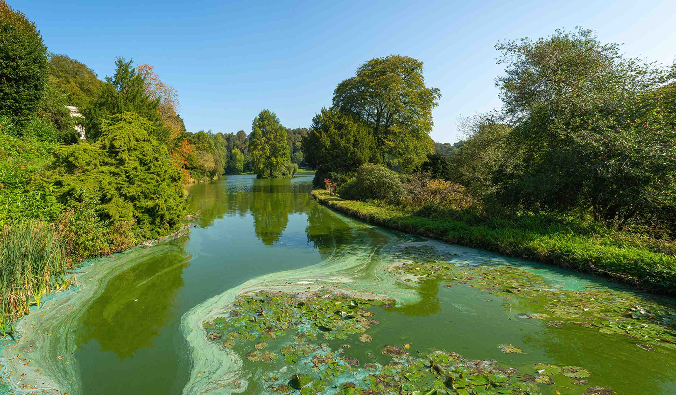
Figure 3 enriched Nitrogen levels cause phytoplankton and algal blooms to grow © Stefan-Kadar Shutterstock

Activity
- Create a stacked area chart to illustrate the data from Table 1. Follow the steps below.

  - Draw an x and y axis
  - The x axis is time from 1900 to 2010
  - The y axis is population from 0 to 8 billion
  - First draw the population fed by Haber-Bosch Nitrogen
  - Colour the area between the x axis and this first data line on the graph
  - Next draw the population fed without synthetic Nitrogen fertiliser
  - Finally draw the total world population line and shade a different colour

- What are the pros and cons of displaying data in a stacked area chart?

- Annotate your graph explaining why it supports the argument that inorganic Nitrogen fertiliser has been crucial for population growth. Consider the following for the twentieth century:

  - Chemicals

    - 1913 – the world’s first ammonia plant was opened
    - 1920 – the development of a synthetic insecticide, Lethane 384, marks the beginning of an acceleration in farm chemicals

  - New equipment

    - 1901 – first commercially successful petrol tractor is built by Dan Albone
    - 1917 – Henry Ford releases the popular and mass produced Fordson
    - 1927 – the Rust cotton picker removes seed cotton, leaving burrs on the plant
    - 1935 – tractor drawn all-crop harvester (succeeded by combine harvesters)
- Create a line graph to illustrate the data from Table 2.

  - Is the correlation between UK population and Nitrogen fertiliser positive or negative?
  - Which year saw the greatest increase in the use of Nitrogen fertiliser?

- Create a line graph to illustrate the trial experiment data in Table 3 for yields t/ha

  - The x axis is Nitrogen kg/ha
  - The y axis is yield t/ha
  - Draw a curving line of best fit
  - Lightly draw a line up from the x axis to identify the peak in yield t/ha. This is the optimum fertiliser level
  - Lightly draw a line across from the y axis to identify the point at which yield increase starts to slow. This is the economic optimum level

- Nitrogen is both very important and can be very damaging to nature. Research the information for both sides of the argument and make a list of the pros and cons.

- Due to Nitrogen pollution, there are more than 400 dead zones in the world’s oceans, the largest of which is in the Baltic Sea.

Study this world map and identify which regions have a high level of hypoxia.

Answers
- The stacked area chart is below.

Figure 4

Synthetic Nitrogen fertiliser has created a rapid growth in crop productivity, and it is estimated that it now supports approximately half of the global population.

It has enabled the lives of several million people and is an agricultural, technological, breakthrough in agricultural sciences.
- Below is a table of the positives and negatives of using a stacked area chart.

Positives | Negatives
Simple format | Ineffective with large number of groups
Excellent for spotting and analysing trends | Difficult to read individual values
Helpful for comparing 2 or more quantities | Oversimplification
Communicates multiple data points at once | A data group can dominate/obscure another
Table 4

- The fertiliser rate for achieving maximum yield is the highest level of nitrogen application: 1015kg/ha supplying 340kg/ha of nitrogen. However, the trial revealed the economic optimum to be 657kg/ha supplying 220kg/ha of nitrogen.

- The positives and negatives of Nitrogen are listed below.

Positives | Negatives
Adding artificial Nitrogen fertiliser increases agricultural yields | Greenhouse gas emissions during fertiliser manufacture
The enzymes (proteins) created from Nitrogen make up a large part of chlorophyll, which plants need for photosynthesis | Nitrous oxide emissions from fertiliser use
Nitrogen forms part of energy-transfer compounds via metabolism in plant cells | Wildflowers, woodlands, and soils can be damaged from excess Nitrogen
Plants which lack Nitrogen discolour and turn yellow, limiting fruit and flower growth | Nitrogen pollution can create hypoxic areas which impact upon fish and other aquatic life
Nitrogen is a significant component of plant protein, which all animals and plants need to grow, reproduce, and survive | Agricultural ammonia from the breakdown of manure and slurry combines with pollution from industry to create dangerous air particulates
The use of artificial Nitrogen fertiliser has supported exponential world population growth | It adds fertility but, over the long-term, the soil loses nutritional value
Table 5

- Much of the developed world has coastlines with hypoxic areas. There is a concentration of low and declining oxygen levels in coastal waters around Europe, particularly in the Baltic Sea, up both the US coastlines, and circling the islands of Japan.

Referenced years are harvest years e.g., 2020 refers to the 2019/20 cropping year – rather than calendar years. 2020e explains that the data for 2020 is an estimate.

