Seasonal Change in the Arctic

GCSE specification links

AQA
3.1.1.4 Climate Change. Climate change is the result of natural and human factors and has a range of effects.
3.1.2.4 Cold environments (polar and tundra) have a range of distinctive characteristics.

Edexcel A
2.2.2 The global climate was different in the past and continues to change due to natural causes.

Edexcel B
1.1.3 Global climate is now changing as a result of human activity, and there is uncertainty about future climates.

OCR
4.3a What is it like in Antarctica and the Arctic?

WJEC and Eduqas
5.1.2 What are the causes of climate change?

Key terminology
- Albedo effect – a measure of the extent to which solar radiation is reflected.
- Anthropogenic – the result of human activity.
- Carbon sink – a area which absorbs more carbon than it releases.
- Cryosphere – places on Earth where water freezes into show or ice.
- Permafrost – a permanently frozen layer on or under the earth’s surface.
- Run off – where water freely flows over the land into other bodies of water such as lakes, rivers and seas.
- Thermal expansion – how the volume of water increases when it gets warmer.

Arctic Cycles
The Arctic is an area north of 66.5°N. It is the northernmost region of Earth and is a place that has two main seasons; summer and winter, a natural cycle created by the axial tilt of the Earth. In some areas of the Arctic, the sun rises above the horizon in March until the Summer Solstice then slowly sinks again until it becomes dark in September.

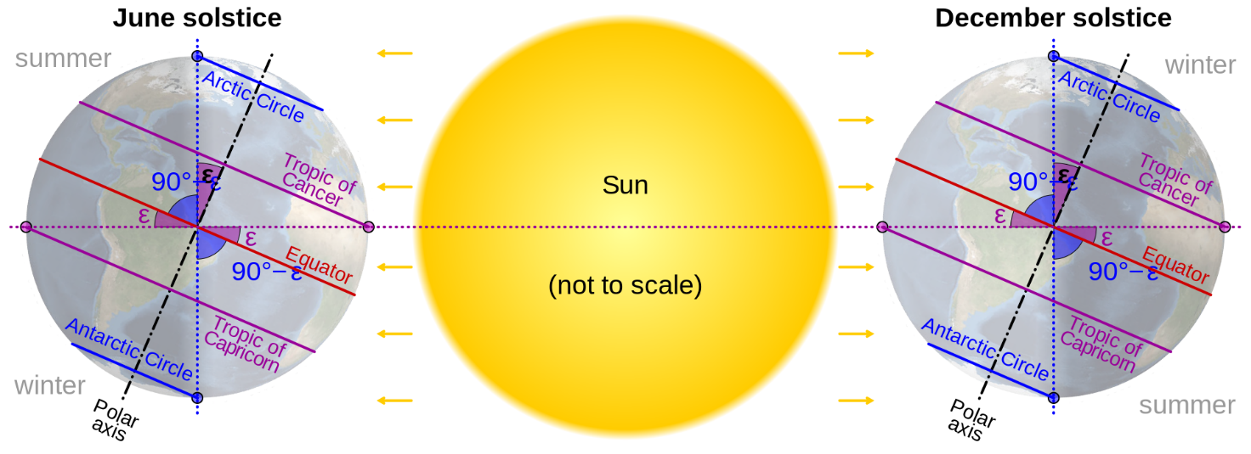
Figure 1: The Arctic cycles © By cmglee, NASA

The result of these seasonal changes means that in the winter, sea ice forms, and snow accumulates on top of land and sea ice expanding the Arctic’s icy reach connecting the different landmasses like an ice bridge. In the summer months, the sea ice melts and the ice on the land retreats to expose areas which support blooming flora. The wildlife and vegetation which call this place home have spent thousands of years adapting to the extreme climate. Any variations to these cycles could have devastating effects on the fragile ecosystem.

- Create a series of diagrams explaining how the sea ice grows and shrinks in relation to the Earth’s orbit around the sun.

Challenge: The Earth is also influenced by the Milankovitch Cycles (the tilt, wobble and changing orbit of the earth). Explain how these could affect seasonal changes in the Arctic.

Arctic Cycles and change
The Arctic cycles create a natural shift in the region which reflect the season it is in. However, with the influence of human activity on our climate, these changes have either been exacerbated or modified. The changes can influence the carbon and water cycles, sea level and the ecosystem.

Some examples are detailed in the table below.

 | Changes
Carbon Cycle | With increasing temperatures, the permafrost in Arctic regions is more likely to thaw releasing carbon dioxide and methane into the atmosphere. According to NOAA, the carbon contained in these sinks is almost twice as much as in the atmosphere today. It is also thought that between 65% and 70% of this carbon is found in the top three meters of the soil. Therefore, with increasing exposure, global warming could rapidly escalate.
Water changes | The IPCC has reported that there will be a 1-3% increase in precipitation globally from global warming while some places will experience increased droughts due to the shift in global water circulation. In the Arctic this could lead to wetter seasons with less ice forming in autumn. Increased runoff will potentially disrupt the food chain as sediment from the surface could clog up waterways, restricting the light needed for photosynthesis thus limiting the number of producers.
Cryosphere | There needs to be a layer of fresh water to enable sea ice to form. However, it is possible that the projected increase in fresh water entering the ocean may sink into the depths displacing warm, more saline water and undercutting the ice already formed.
Sea level change | The Greenland ice sheet is, according to the IPCC, melting at a faster rate than any of the ice sheets in the Arctic due to global warming. With direct run off from the land, global sea levels are set to increase by a minimum of 27cm. In addition, thermal expansion will also contribute to rising sea levels affecting nearly 600 million people who live in coastal zones which are less than 10 meters above sea level.
Regional climate change | The Arctic is warming three times as fast as the global average. This has a significant impact on the rate of which snow and ice is melting in the area. It has been observed that the biggest temperature increase is taking place in the autumn and winter which is when most of the snow falls, and ice accumulates. Ice receding on land exposes darker surfaces which absorb more of the sun’s energy rather than reflecting it through the albedo effect. That in turn heats the area even further.

- Rank the changes from the biggest (1) to the smallest (5) impact in your opinion. Make sure you justify your top and bottom choice.

Challenge: Would this choice be different if you were looking at a different scale i.e. global rather than local. Explain your reasons.

Further reading
- NOAA PMEL Arctic Zone
- Guardian article on the effects of the melting ice sheet in Greenland, 2022

