Careers with Geographical Information Systems
- GIS in practice – Esri UK
The following materials and activities are sourced from Esri UK and can be found at https://www.esri.com/en-us/what-is-gis/careers and https://careers-with-gis-esriukeducation.hub.arcgis.com/pages/schools

Careers with GIS

Esri have a fantastic bank of profiles exploring what GIS professionals do across a range of sectors and for a variety of employers. Each is presented in a visual way via an Esri Storymap and include education and career pathways as well as information about graduate programmes and career highlights. Examples include:
- Zoe Smith, Key Route Network Manager at Transport for West Midlands
- Jess Baker, Technical Relationship Consultant with the Ordnance Survey
- Marygrace Rowe, Data & GIS Officer at Plantlife International
- Chris Bean, GIS Analyst at The Rivers Trust
- Tom Gibson, GIS Officer at Sustrans
- Luke Phillips, Project Manager, Mapping Scotland’s Paths
- Adil Toorawa, GIS Consultant on HS2 for Arcadis
- Haley Clowes, Graduate Consultant at Esri UK
- Liz De Guzman, Data Curator at Esri UK

There are several ways these profiles could be used with students:

Individual profiles could be selected by the teacher to explore particular elements of the curriculum and how people use their geographical knowledge and skills in the workplace within that area. For example, Zoe Smith’s profile talks about a dashboard that she has helped to develop which shows real time information and planned engineering works in the transport system across the West Midlands:

“I was appointed and became a consultant working on the SingleView of the Network project. The aim of SingleView was to create one single resource that everyone can use to understand transport in the West Midlands region. Realtime updates of the current situation and information about planned works are all in once place that is easy to find….My dashboard is now displayed on a huge screen at TfWM’s new Regional Transport Coordination Centre and can be viewed online by TfWM managers from any location. The dashboard is also used by partners like National Highways, local authorities, transport providers and in the future emergency services, giving everyone the same overview of the entire region”

This allows students to see clearly how Zoe is influencing real world geography through her GIS work and follows her career pathway so students can see clearly how Zoe reached the role she currently has. Zoe started out as a civil engineering apprentice studying towards an HNC, so she is also a great case study to demonstrate to students that there are other pathways to a career in geography besides the university degree route. Find out more about apprenticeship routes that use geography.

Adil Toorawa’s profile explores his work as a GIS Consultant for Arcadis, working on HS2. Adil begins by talking about his educational pathway – a physical geography degree – then talks about his time in Syria where he used his GIS skills to help humanitarian efforts:
“I assisted the Syrian humanitarian response plan in data collection, analysis and developing applications which our field aid workers used to deliver aid in Syria….My research focussed on road network accessibility, and I had to present research findings to internal and external stakeholders”.

After his work in Syria, Adil worked in several different sectors using his GIS skills, including the energy sector (gas network project for National Grid), planning sector (providing geospatial solutions to the residential, commercial, rural, planning and development sectors for a Property Consultants) and his local council, providing spatial analysis and mapping requirements to the Strategic Growth and Planning and Development teams.

Adil now works on HS2, Britain's new high speed rail line being built from London to the North-West:
“..I pride myself on developing applications for our engineers so that data analysis and sharing is made easy. Web applications and dashboards are created to enable visualisation and integration of engineering data. It is vital that project data of high quality is accessible to support better decision making”

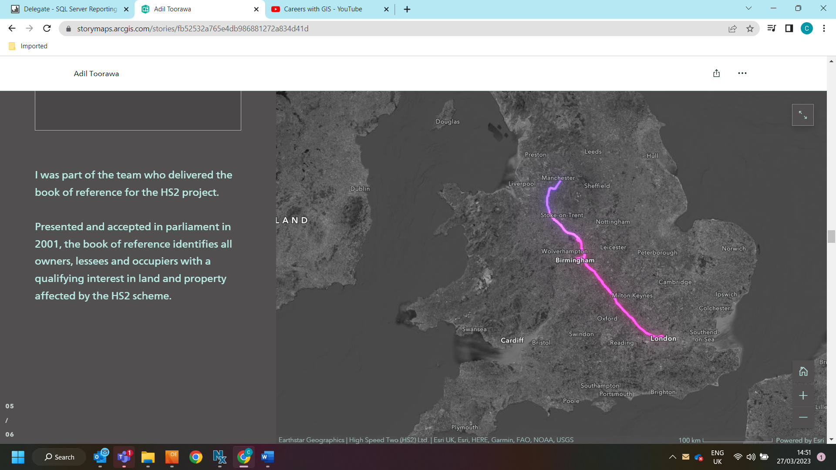

Adil is a perfect example for students of someone who has used their geographical knowledge to demonstrate their specific skills set across a variety of sectors. There is no doubt that Adil’s geographical background has enabled him to understand the needs of different groups and stakeholders across these very different sectors, allowing him to adapt and provide solutions across a range of projects. This shows students that a solid geographical foundation can enable employees to adapt to a range of sectors and scenarios, and that a degree in geography can open doors across a huge range of career areas.

Classroom display activity

Using the Esri bank of profiles, students could be encouraged to produce a ‘Careers using GIS’ or ‘Geography and GIS’ classroom wall display. Students should be tasked to look at the profiles and make notes about the types of jobs these people are doing and the skills they are using- the more specific the better (this research could be set for homework, and groups could be tasked to look at specific profiles to ensure a wide range are considered).

Students should then each produce a poster – this could be a generic ‘careers using GIS’ theme, or ‘how we use GIS in the real world’; alternatively you could ask students to produce a poster about a specific profile, so that the finished display contains an overview of each person’s job and how they use their geographical skills. The posters should show drawings, diagrams and examples of how these people use GIS in their jobs, as well as highlighting the skills they use and the areas of geography they are working in (for example, Adil’s poster may have the words ‘humanitarian aid’, ‘transport system’, ‘local government’, ‘planning’ and ‘energy sector’ on it, as well as listing some of the specific skills he will be using in his work such as ‘data analysis’, ‘mapping’ and ‘decision making’)

GeoMentors

Esri UK offers schools the opportunity to invite GIS professionals into their classroom to demonstrate careers with GIS and how GIS is used in the real world. They can provide assembly content, careers talks, one on one GIS tutoring for teachers and more. Mentors can be filtered by the sector they work in, then their rough location is revealed, allowing teachers to select a Mentor located close to them. Find out more or contact Esri UK at schools@esriuk.com.

