**Wādī** - a valley / ravine which is dry in certain seasons.

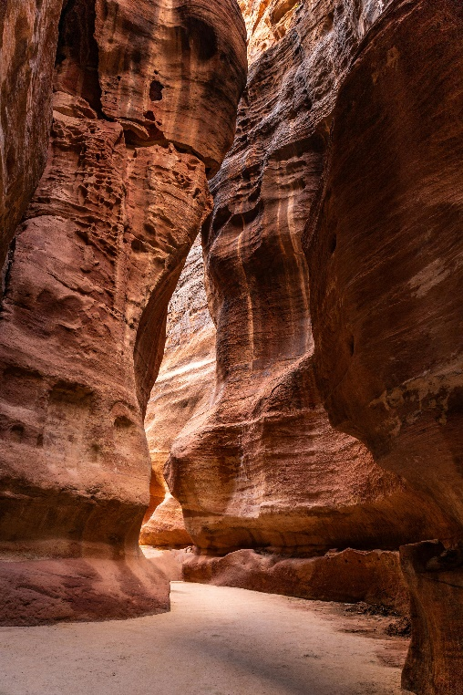

**Khawr (lagoon)** – a shallow body of water separated from a larger body of water by a land barrier.

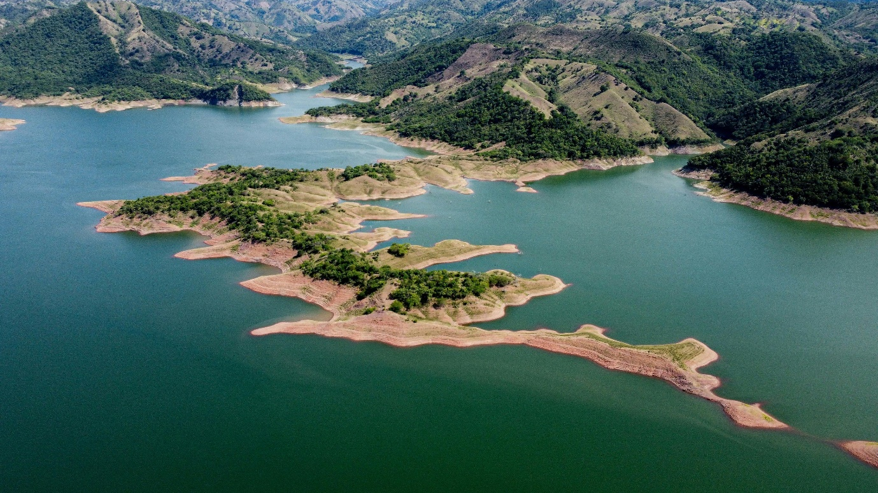

**Seasonal** – a regular point in the year when the weather changes. Some places have several seasons, some have two: wet and dry.

A sun and clouds with long shadow


**Khor Ruri** – a sand fort built along the khawr of the Wādī Darbāt.

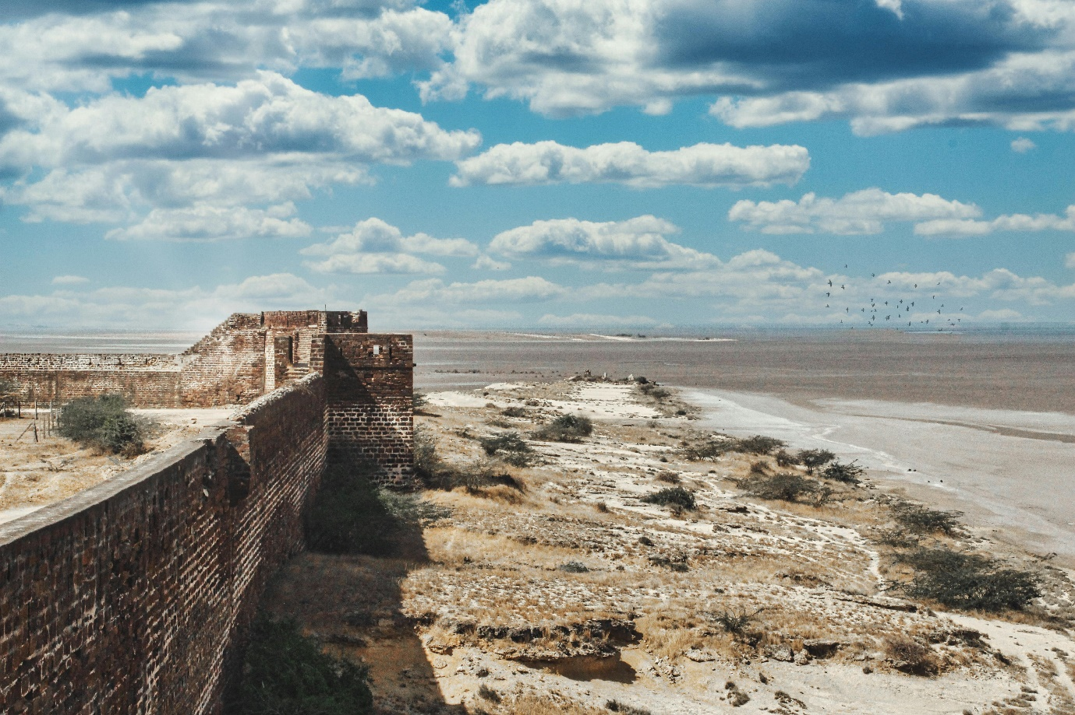

**Fieldsketch** – a skill which geographers use to record the place they are observing. This is usually done out in the field (outdoors).

