Water–energy–food nexus (Trisos et al., 2022)

The interdependencies in the water-energy-food (WEF) nexus, coupled with its high exposure to climate change, amplify WEF risks. Risks can be transmitted from one WEF sector to the other two with cascading risks to human health, cities and infrastructure. For example, increasing demand for water for agricultural and energy production is driving an increasing competition over water resources between food and energy industries which, among other effects, compromises the nutritional needs of local populations.

The Case in Africa
Drought events, such as in southern Africa during the 2015/16 El Niño, have been associated with major multi-sector impacts on food security (over 40 million food-insecure people and extensive livestock deaths) and reduced energy security through disruption to hydropower generation (associated in Zambia with the lowest rate of real economic growth in over 15 years).
The WEF nexus of the Nile and Zambezi River basins, which include many of Africa’s largest existing hydropower dams, have received the most attention. In these two regions, where socioeconomic development is already driving up demand, projections indicate that water scarcity may be exacerbated (made worse) by drying and increased flow variability. However, for Africa more widely, very few studies fully integrate all three WEF nexus sectors and rarely include an explicit focus on climate change.
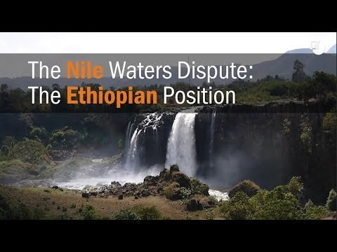
https://youtu.be/8qhRMg70ABk
Tasks
Suggest how water, food and energy security can be interdependent.

Explain how historical events have had an impact on the water – food – energy nexus in Africa.

Describe the situation along the Nile and Zambezi Rivers with regards to water and energy security.

Watch the video. Why do Ethiopia and Egypt have different viewpoints on the Grand Renaissance dam project?

Future risks in Africa

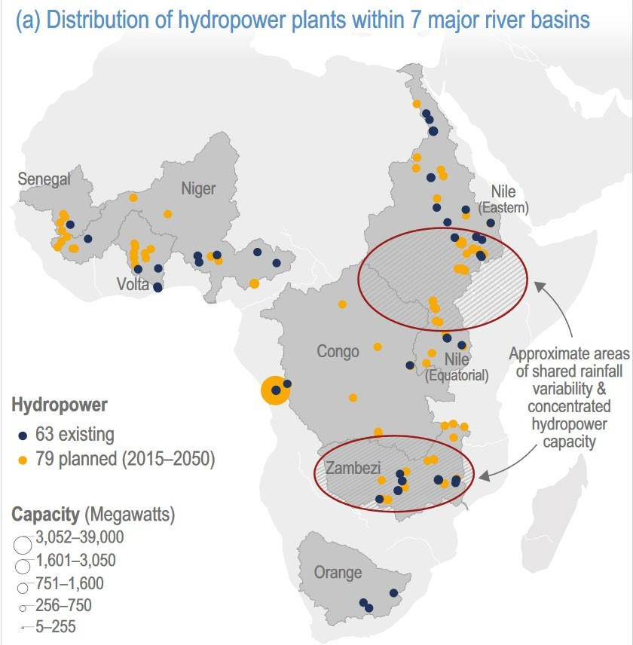Study the maps carefully. Complete the table below for the three drainage basins named.

 | Nile | Niger | Zambezi
No. Existing dams
No. Planned dams

What does this information show you about future water and energy demand in these basins?

In Africa, the climate risks that the water, energy and food sectors will face in the future are heavily influenced by the infrastructure decisions that governments make in the near term. The African Union’s Programme for Infrastructure Development (PIDA), along with other national energy plans (jointly referred to as PIDA+), aim to increase hydropower capacity nearly six-fold, irrigation capacity by over 60% and hydropower storage capacity by over 80% in major African river basins. The vast majority of hydropower additions would occur in the Congo, Niger, Nile and Zambezi River basins, and the majority of the irrigation capacity additions would occur in the Niger, Nile and Zambezi River basins. Climate change risk to the productivity of this rapidly expanding hydropower and irrigation infrastructure compound the overall WEF nexus risk. Future levels of rainfall, evaporation and runoff will have a substantial impact on hydropower and irrigation production.

What do the African Union (AU) aim to do with regards to energy security?

What risks does climate change pose to the AU’s plans?

Existing versus planned Hydropower

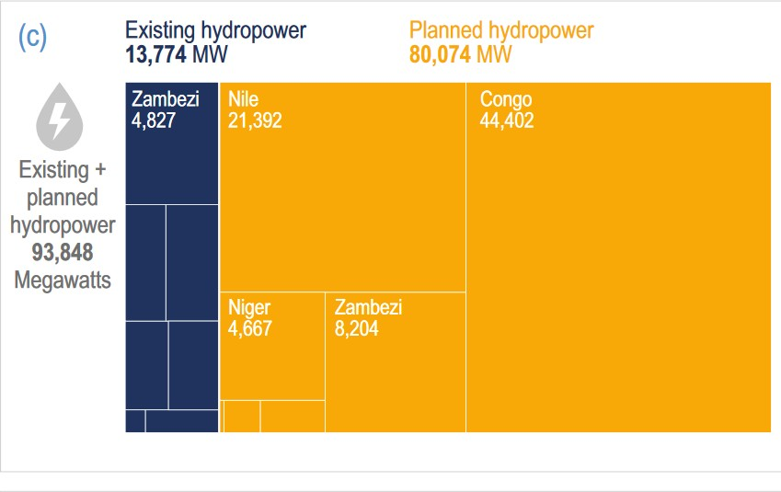
Climate models and Energy
Climate models disagree on whether climates will become wetter or drier in each river basin. Cervigni et al. (2015) modelled revenues from the sale of hydroelectricity and irrigated crops in major African river basins under different climate scenarios between 2015 and 2050. The study found that hydropower revenues in the driest climate scenarios could be 58% lower in the Zambezi River basin, 30% lower in the Orange basin and 7% lower in the Congo basin relative to a scenario with current climate conditions. Hydropower revenues in the wettest climate scenario could be more than 20% higher in the Zambezi River basin and 50% higher in the Orange basin.

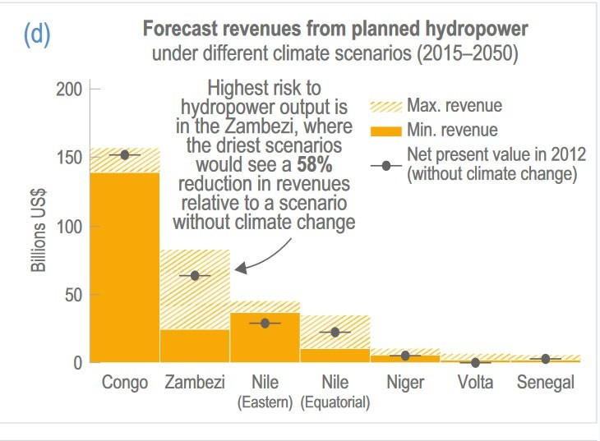

Climate models and Irrigation

Analyse the graphic opposite on existing and planned hydropower in Africa.

Explain what the climate models suggest for the sale of hydroelectricity for the driest and wettest scenarios.

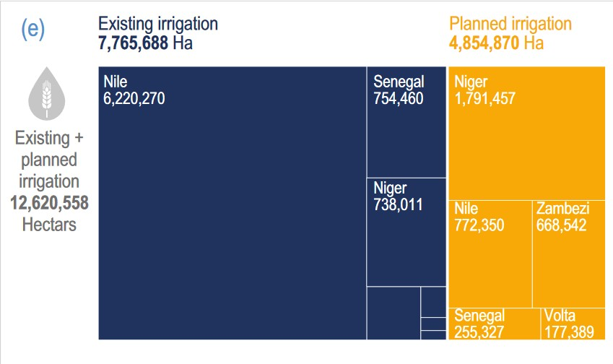
The biggest risk to the production of irrigated crops is in the eastern Nile where irrigation revenue could be 34% lower in the driest scenario and 11% higher in the wettest than in a scenario without climate change.
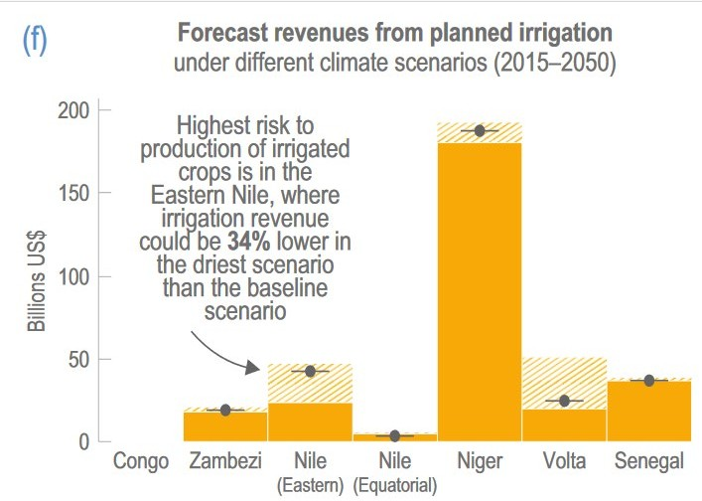

Studies have used the river basin as a unit of analysis to assess and present trade-offs between competing uses such as food, energy and water.
Yang and Wi (2018) considered the WEF nexus in the Great Ruaha tributary of the Rufiji River in Tanzania – the study was motivated by an observed decrease in streamflow during the dry season in the 1990s. They showed:
- Sensitivity of water availability for irrigated crop production to warming
- Sensitivity of hydropower generation and ecosystem health to changes in precipitation and dam development.
Understanding of these interlinkages can help identify risks and how multiple organisations can plan climate change adaptation actions. An integrated response can be enhanced through the inclusion of community-based organisations, such as water resource user associations and the wide range of other multi-sectoral actors involved in and affected by development decisions.
Analyse the graphic opposite on existing and planned irrigation in Africa.

Explain what the climate models suggest for the revenue from irrigation for the driest and wettest scenarios.

Evaluate how these models can be of use to manage the food, water and energy nexus in African river basins in the future.

All text and diagrams adapted from:
Trisos, C.H., I.O. Adelekan, E. Totin, A. Ayanlade, J. Efitre, A. Gemeda, K. Kalaba, C. Lennard, C. Masao,
Y. Mgaya, G. Ngaruiya, D. Olago, N.P. Simpson, and S. Zakieldeen, 2022: Africa. In: Climate Change 2022: Impacts, Adaptation and Vulnerability. Contribution of Working Group II to the Sixth Assessment Report of the Intergovernmental Panel on Climate Change [H.-O. Pörtner, D.C. Roberts,
M. Tignor, E.S. Poloczanska, K. Mintenbeck, A. Alegría, M. Craig, S. Langsdorf, S. Löschke, V. Möller, A. Okem, B. Rama (eds.)]. Cambridge University Press, Cambridge, UK and New York, NY, USA, pp. 1285– 1455, doi:10.1017/9781009325844.011
